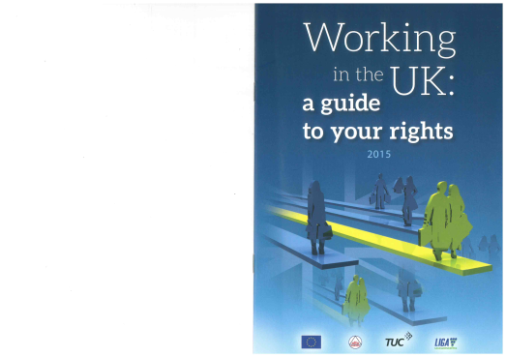

publication order form

stock code GE316

Working in the UK – a guide to your rights

These booklets for migrant workers in the UK give information on essential UK employment rights in seven language editions: English, Polish, Romanian, Bulgarian, Lithuanian, Spanish and Hungarian. They have been produced in partnership with union centres LIGA in Hungary and Cartel Alfa in Romania, with financial support from the European Union.

Prices **per copy** for these 16-page, A5 size publications are: **1 to 10 copies free and 11 to 100 copies 12p each.** You can mix and match the languages. The online version of the guide is available here: [www.tuc.org.uk/workingintheuk](http://www.tuc.org.uk/workingintheuk)

|  |  |  |
| --- | --- | --- |
| **Language** | **Quantity** | **Cost** |
|  |  |  |
|  |  |  |
|  |  |  |
|  |  |  |

*P&P free for the UK; for Europe add 25%; for the rest of the world add 35%.*

|  |  |
| --- | --- |
| **Total cost (inc p&p if applicable):**  £ | |
| Name: | | | Date: |
| Organisation/union branch if applicable: | | | |
| Address: | | | |
| Postcode: | Email: | | Tel: |

*Now choose one of the following four payment options:*

1. I enclose a cheque for

£



2. Please invoice me at the above address *(NB this option is only available for orders above £100)*

3. Please debit my Visa / Mastercard / Switch Card No:   
Valid from: Expiry date: Issue No: Security code:











Cardholder name: Date:   
Signature if faxing or posting back:







4. I have made a BACS payment of on (date) to Unity Trust Bank   
Sort Code 08-60-01 Account Number 50511125 Account Name: Trades Union Congress

£





*When paying by BACS you must give your organisation’s name* ***and*** *the stock code for this publication (shown at the top of this form) as the payment reference so that we can identify you. Please also complete and return this form to the address above so that our despatch team can send your goods.*