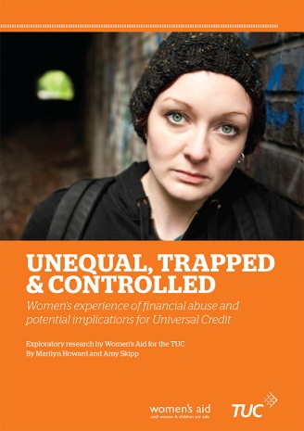

new publication order form

stock code ER283 ISBN 978 1 85006 966 9

Unequal, Trapped and Controlled

This report, written for the TUC by Women’s Aid, examines women's often under-reported experience of financial abuse and coercive control by their partners, and the potential implications for Universal Credit. Prices **per copy** for this 64 page, A4 size publication are:

|  |  |  |  |
| --- | --- | --- | --- |
| **Quantity** | **TUC member organisations** | **Educational/voluntary/  not-for-profit** | **Others** |
| Single copy | free | free | £5 (p&p free) |
| 2–10 copies | free | free | £4.50 ea (p&p free) |
| 11–50 copies | free | free | £4 ea (p&p free) |
| Over 50 copies | £15 per 50 or part thereof – to cover P&P | £15 per 50 or part thereof – to cover P&P | £3.50 ea (p&p free) |

*Bookshops/trade terms are available on single copy price. No orders accepted without payment, unless on account. This title may also be made available for dyslexic or visually impaired readers, on request, in an agreed electronic format or in accessible formats such as Braille, audiotape and large print, at no extra cost.*

|  |  |  |  |
| --- | --- | --- | --- |
| Send me copies | each priced at  £ | **Total (inc p&p if applicable):**  £ | |
| Name: | | | Date: |
| Organisation/union branch: | | | |
| Address: | | | |
| Postcode: | Email: | | Tel: |

*Now choose one of the following four payment options:*

1. I enclose a cheque for

£



2. Please invoice me at the above address *(NB this option is only available for orders above £100)*

3. Please debit my Visa / Mastercard / Switch Card No:   
Valid from: Expiry date: Issue No: Security code:











Cardholder name: Date:   
Signature if faxing or posting back:







4. I have made a BACS payment of on (date) to Unity Trust Bank   
Sort Code 08-60-01 Account Number 50511125 Account Name: Trades Union Congress

£





*When paying by BACS you must give your organisation’s name* ***and*** *the stock code for this publication (shown at the top of this form) as the payment reference so that we can identify you. Please also complete and return this form to the address above so that our despatch team can send your goods.*