TUC and FNV joint letter
EU referendum renegotiation strategy
26 November 2015
EU referendum: working with Dutch unions to defend workers’ rights
In January, the Dutch Government will take over the Presidency of the European Union, which will make them crucial to the EU renegotiation strategy of the UK government. Europe Minister David Lidington is travelling to the Hague today, Thursday 26 November, to see the Dutch Minister of Foreign Affairs, Bert Koenders.
The UK Government sees the Dutch as key allies for their approach of “European where necessary, national were possible”, but the Dutch government is a coalition of left and right, so Dutch trade union movement FNV have sent the following joint letter with the TUC to Bert Koenders to urge him not to give ground to the UK Government on workers’ rights – including the key issue of health and safety at work.
Dear Minister Koenders,

Upcoming Dutch Presidency and UK renegotiation demands
In view of the upcoming Dutch Presidency of the EU, the British TUC and Dutch FNV would like to express their support for the Dutch Government’s focus on better protecting workers’ rights in Europe and the principle of equality.
TUC and FNV welcome the concrete policy measures, amongst which an EU wide action plan against social dumping and a revision of the posting of workers Directive, announced by the Dutch minister for Social Affairs, Lodewijk Asscher.
From this perspective, the TUC and FNV would like to draw your attention to any attempt to use the UK’s EU renegotiation strategy to undermine workers’ rights or freedom of movement, and urge you to make clear that this will not be supported by the Netherlands.
We welcomed the fact that the British Prime Minister’s recent letter to European Commission President Tusk did not repeat calls to restrict social Europe or reduce workers’ rights, but we are concerned that the emphasis on so-called competitiveness and deregulation could still impact on those rights. Indeed, like the European Trade Union Confederation, we agree that we need to get Europe growing again, but that growth must be based on social justice to be sustainable. Therefore, we advocate an injection of demand into the European economy, as recommended by the G20 earlier this month.
Furthermore, the British government’s support for the Dutch government’s strategy of “Europe where necessary, national where possible” should not imply that workers’ rights, or the freedom of movement enshrined in the European treaties, should only become national competences.
Instead, TUC and FNV believe that Europe-wide standards in the social field are necessary to ensure the same level of minimum protection.
Since the carcinogens and mutagens Directive was first adopted 23 years ago, binding limit values have been set for just three substances (benzene, vinyl chloride monomer and hardwood dusts). TUC and FNV support the proposal made by several Member States (amongst which the Netherlands) to establish 50 binding limit values for carcinogen substances in use in European Union workplaces.
Any progress the upcoming Dutch Presidency is able to make on this Directive would exclude unfair competition between Member States by using lower safety standards for workers.
Indeed, both workers and employers have a shared interest in a stronger level playing field across Europe of modern labour market regulation and higher wages, because they would restore demand, foster productivity and address the exploitation and undercutting that fosters antagonism towards migrants and refugees.
TUC and FNV call on you to take the above mentioned points up in your forthcoming meeting with British Minister for Europe David Lidington MP and share them with your cabinet.
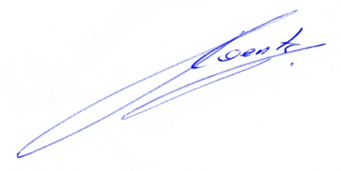
Yours sincerely,
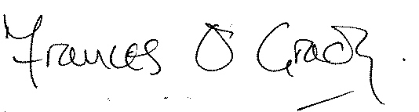
FRANCES O'GRADY TON HEERTS
TUC General Secretary President FNV

