Services and Steel: Challenging government failure in the public and private sector
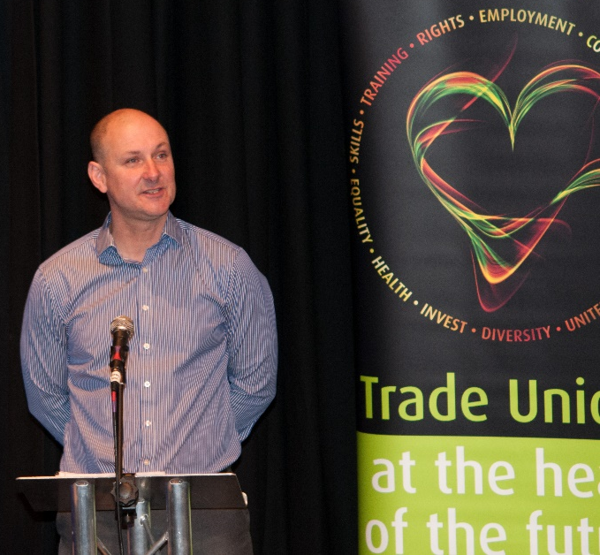
There was good attendance and participation at the TUC – Public Services and Steel Summit held in Stockton on Saturday 23rd January. Welcoming delegates, Simon Elliot, Chair of the Northern TUC [pictured left] said Teesside was the great chemical and industrial heart of Britain. The loss of so many jobs in such a short space of time is a devastating blow to an area which already has high levels of unemployment – and there are more job losses on the horizon.
Below is a brief and by no means exhaustive overview of some of the discussions and outcomes from the Summit.

Simon introduced Alex Cunningham MP for Stockton North. Alex commented that Stockton Arts Centre is here as a result of public investment. As austerity bites harder and council budgets are slashed further, recent Local Government Association analysis indicates that inevitably the gap between council income and expenditure will grow. We need a different tax regime, one that does not allow multi-national companies such as Google to avoid paying their taxes, in spite of making billions of pounds of sales in Britain. We also need the resources to pursue those companies that breach the law – not close down HMRC offices. The Labour Party has a tough job ahead of it – the campaigning must start now, we can’t wait until the election campaign comes around – sofa socialists are no use to us. We need to get back to a country that believes in public expenditure.
Professor Karel Williams, Centre for Research on Socio-Cultural Change (CRESC) gave an illuminating presentation on outsourcing and the ‘foundational economy’ which generated a good debate. In a very comprehensive presentation, Karel set out the outline for discussion:
- Outsourcing, the foundational economy and government blame shifting
- Problem: Profit taking on public service contracts, without investment or market risk
- Problem: Fast growing conglomerates are unstable because they cannot control their portfolios of contracts
- State and corporates are co-dependent: state’s role is to attract bidders for contracts, not plan and co-ordinate services; locks out the citizen.
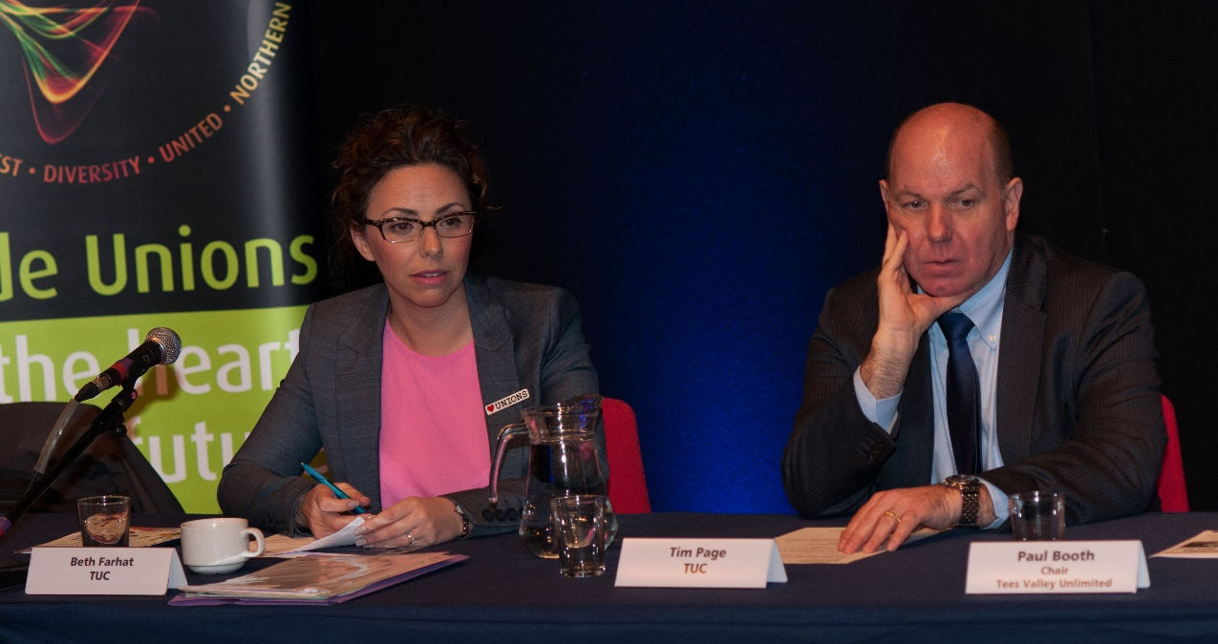Introducing the afternoon session, Beth Farhat, Northern TUC Regional Secretary [pictured above with Tim Page] remarked on the latest government figures which show the jobless total in the region has fallen by 5,000 to 104,000 – but the North East is still top of the pile. Much is expected of Combined Authorities to deliver and create more and better jobs – with less resources – under the guise of the ‘Northern Powerhouse’. Our vital public services need to be protected; we need investment in infrastructure and skills and resources to attract inward investment to the region. An active industrial policy should be at the heart of our economic plan.
Following Beth, Tim Page, TUC Policy Officer spoke about the need to activate industrial policy and the important role trade unions have to play. In the 1970s Britain was the ‘workshop of the world’ as successive governments believed in industrial policy. A truly effective industrial strategy should develop the role of trade unions as social partners. We cannot continue to buy cheap today and rely on imports at whatever price while skills are being lost to the region.
Delegates welcomed Paul Warren, Chair of the multi-union committee, SSI Steelworks. Paul spoke about the human cost associated with the closure and the help and support available. There are a number of agencies working together, linking through the task force to provide practical help and support to workers facing redundancy and their families. Funding is available for FE college courses and there is money available through the safety net fund.
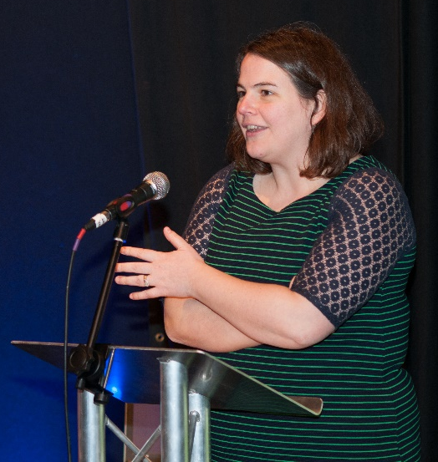
Delegates were able to participate in workshops before resuming to hear from Jude Kirton-Darling MEP who spoke about the global perspective. Jude is part of the steel task force, chaired by Jeremy Corbyn. One of the main arguments – that the EU is to blame for the losing steel industry – is completely bogus. She had met recently with the compliance policy minister and there has been no approach by the UK government to apply for state aid. EU rules do not prohibit state aid but there are certain rules. There is a global crisis in steel and due to its nature, it is difficult to get a picture of what is happening in China. Of all the dumped steel from China, 94% is coming into the UK. Reform is needed to stop China dumping cheap steel on the markets. Need to build alliances across key industrial regions in the UK; put manufacturing back on the agenda and build up the labour movement.
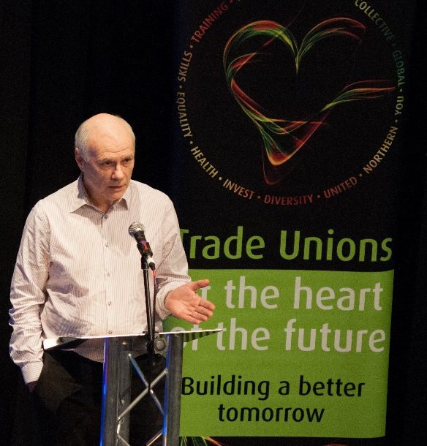
Final speaker of the day was Paul Booth, Chair of Tees Valley Unlimited. Paul is also Chairman of SABIC UK Petrochemicals. Paul paid tribute to the quality and integrity of the SSI workforce as the truth emerged of the scale of the job losses. There are new jobs coming into the area through firms such as Sirus and Hitachi and we continue to attract industries to the Tees Valley. The steel industry needs to be properly restructured and supply chains rebuilt to make it work. We need industrial solutions based on a circular economy concept with a primary focus on competitive energy. Key projects for us are carbon capture, storage and conversion, waste-to-power and rebuilding the energy, oil and gas supply chain. Collaboration is key to delivering a sustainable economic recovery plan that will benefit those affected by recent job losses.
Neil Foster, TUC Policy and Campaigns Officer summed up the day. Thanking all contributors: Karel’s very interesting presentation revealed the parasitical side of outsourcing; Tim, importance of an industrial strategy; Jude – the global impact of the cuts; Alex, learn the lessons of history and what can be achieved under adverse conditions; Paul talking positively about the relationship between employer and trade unions.
The trade union movement has 6m members – let’s increase that number, support http://heartunions.org/

