Rwandan trade unionists pledge support for the promotion of employment rights of people with disabilities.
The activities under the Employment Support Programme for Workers with Disabilities in Rwanda, supported by TUC Aid, commenced in April with a three-day workshop held at the national trade union centre – CESTRAR-, Kigali, Rwanda.
The workshop attended by ten participants from affiliates of CESTRAR was part of a series of activities designed under the Project to raise awareness of the rights of people with disabilities as enshrined in Rwanda’s constitution, UN conventions on persons with disabilities and promoted under the policies and programs implemented by the Rwandan Government to uplift the standard of living of people with disabilities. The participants were introduced to the concept of disability, popular perceptions of persons with disabilities in Rwandan society and the difficulties faced by persons with disabilities at workplace. They were also informed of different approaches to disability based on medical and social models and their implications for people with disabilities, their families and wider society. The material for the use of awareness-raising and lobbying activities and for the training of disability champions was developed and plans are underway for more workplace-based action on disability.
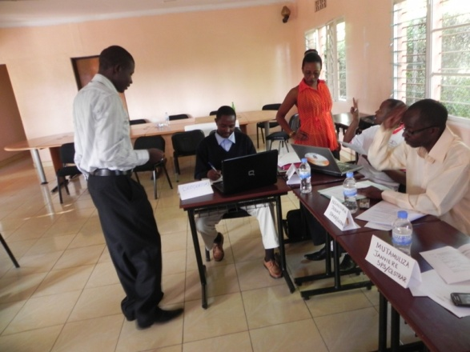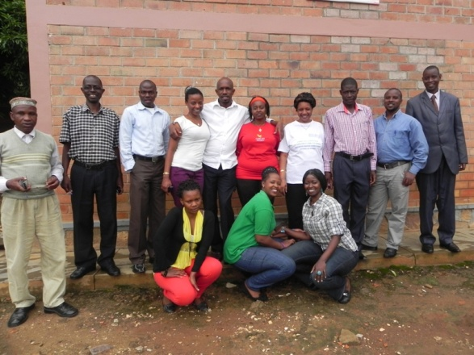
The Workshop recommended, inter alia, that
- Strategies and mechanisms be put in place to build self-esteem and confidence among people with disabilities;
- Trade unions implement programmes to address their specific needs and concerns;
- Trade unions develop capacity building programmes to inform and educate workers with disabilities on their rights in line with the country’s legislation and UN Conventions on persons with disabilities;
- Partnership and cooperation between organizations representing people with disabilities be promoted.
The Project, implemented by Disability Aid Abroad, a Northern Ireland Charity, in partnership with CESTRAR, builds on the achievements of similar initiatives by the DAA in Tanzania and Uganda with financial support from TUC Aid and other Solidarity Support Organizations.

