Defending employment rights of disabled people in Rwanda
A joint initiative by TUC Aid and Disability Aid Abroad (DAA) – Northern Ireland charity - has been successful in raising awareness of employment rights of disabled people in Rwanda and in securing support from local trade unions, East Africa Trade Union Confederation (EATUC) and the Government of Rwanda for further initiatives in the region.
The Employment Support Programme for Disabled Workers in Rwanda was launched in partnership with CESTRAR – national trade union centre - in Rwanda in 2013, following the successful implementation of similar programmes in Tanzania and Uganda. Project activities included a number of workshops aimed at raising awareness of the rights of disabled people and training of disability champions and were attended by disabled workers, trade union officials and representatives from the Ministry of Labour in Rwanda and the National Council for Persons with Disabilities (NCPD). Consensus has emerged on the need for amendments to union constitutions and collective bargaining agreements (CBAs) with a view to including provisions on disabled workers and establishing a disabled workers’ committee in the CESTRAR. A training workshop held in April 2015 provided the participants with an opportunity to assess the rights and entitlements of disabled workers currently enjoyed by them in contrast to those under existing laws in Rwanda and explore ways and means of facilitating their effective enforcement. It was revealed that:
- Disabled workers faced discrimination in recruitment.
- Their rights and entitlements were ignored in general.
- No facilities were provided for them at workplace and that
- They were given only menial tasks, if at all.
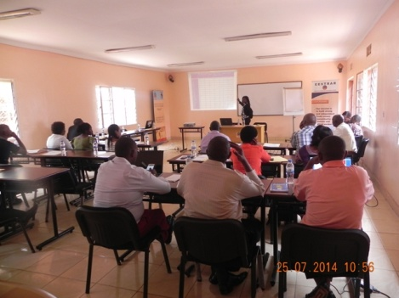
The project completion report submitted to TUC Aid in July 2015 highlights some of the key outcomes of the project and sets out future plans for promoting the rights of disabled people in East Africa:
- 65 people attended awareness-raising workshops on the rights of workers with disabilities.
- 25 disability champions were trained.
- The 25 disability champions will reach out to disabled workers and their employers as well as 300 trade union leaders.
- The project has brought together the government, civil society, trade unions and other stakeholders dealing with issues concerning persons with disabilities.
- The government of Rwanda has pledged support for Rwandan trade unions in their efforts to protect employment rights of workers with disabilities.

It is envisaged that CESTRAR will develop a National Employment Support Project for Disabled People in partnership with the National Council for Persons with Disabilities (NCPD). DAA plans to invite a member of CESTRAR and NCPD to the UK and Ireland later this year on an educational visit. Discussions are underway to implement similar initiatives in Ethiopia and Zambia in collaboration with the ILO.

