Women claim the night as march and rally comes to Newcastle

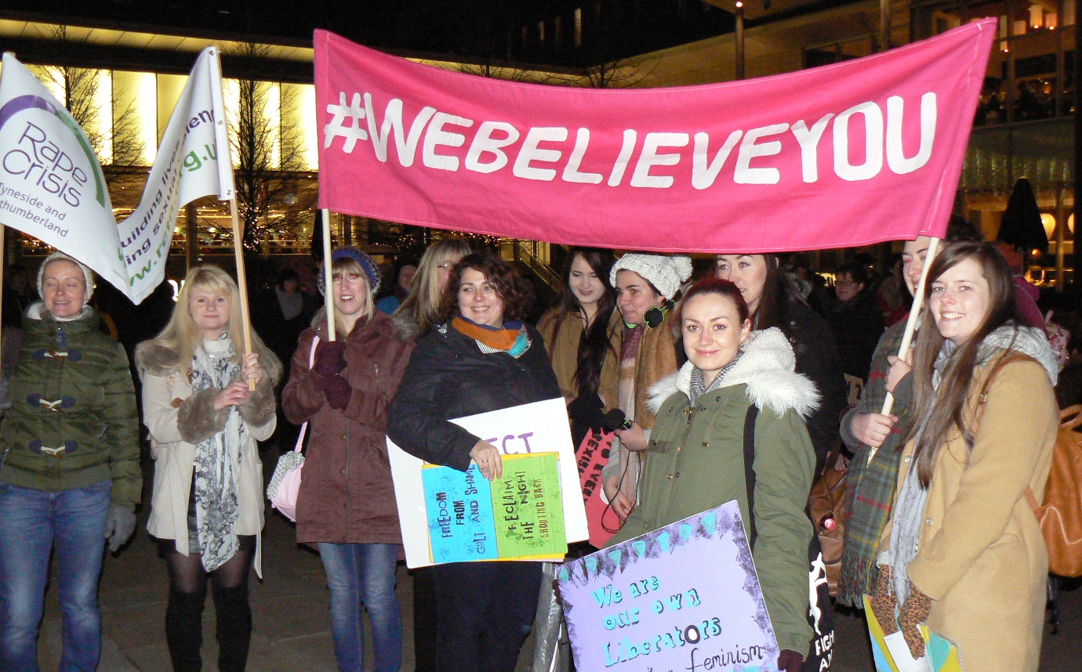
There was a great crowd at the ninth annual Reclaim the Night march and rally organised by the Northern TUC Women’s Group on Saturday 21st November. On a bitterly cold night around 150 supporters turned out to mark the United Nations International Day to End Violence Against Women.

A permanent fixture and supporter of the event, once again the march was led by the fantastic Bangshees all–women drumming group who really got the crowd warmed up as the procession made its way up Northumberland Street – with banners waving and whistles blowing, we certainly got ourselves noticed!.

Arriving at Sport Central for refreshments attendees were welcomed by Julia Charlton, Chair of the Women’s Group. In her remarks Julia said it was fantastic to see so many young people and students supporting the event. Many of us have been inspired by ordinary women who joined together to win a better future for themselves and their daughters. Women like the Bryant & May Matchgirls winning fair pay for women and our own Emily Wilding Davison who gave her life to ensure future generations of women got the right to vote. It is fitting that we remember them at this event because the struggle goes on and as statistics show, women bear the brunt in times of austerity.

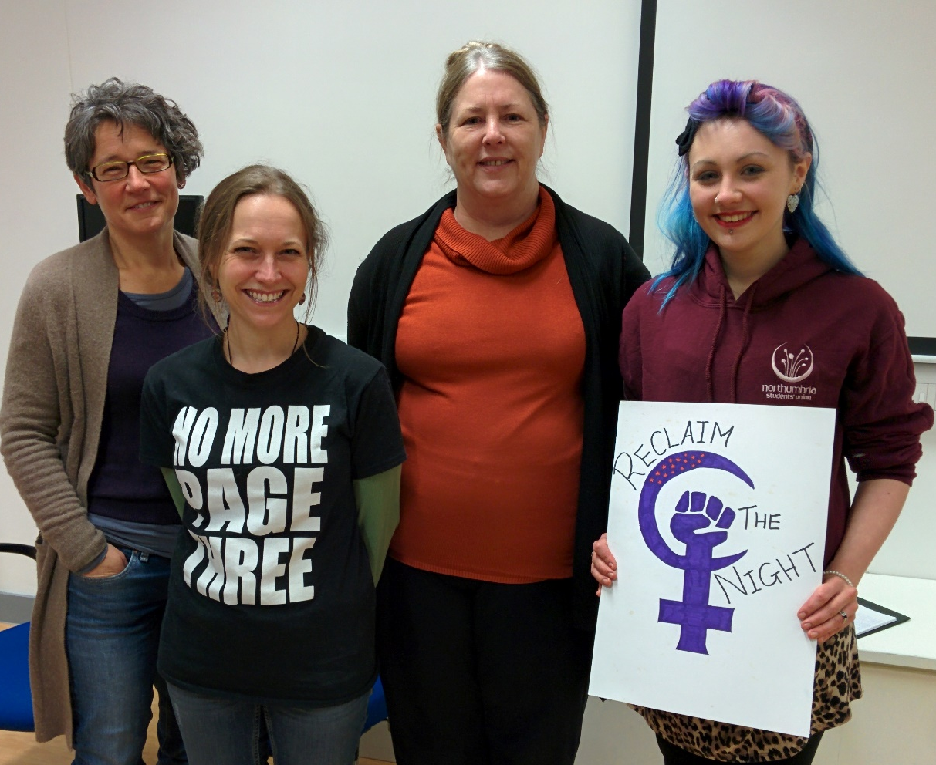

Julia then introduced our first speaker, Dr Ruth Lewis a Senior Lecturer and Programme Leader in Sociology at Northumbria University. With colleagues at Northumbria University, Ruth is working to address ‘lad culture’ to try to make students’ experiences of university safe, welcoming and respectful. Unfortunately ‘lad culture’ or ‘laddism’ is not a new phenomenon. It affects mainly young women students and can be defined as a group or ‘pack’ mentality residing in activities such as sport and heavy alcohol consumption, and ‘banter’ which is often sexist, misogynist and homophobic. Research by the NUS shows that 1 in 7 women students (14%) has been the victim of serious sexual assault or serious physical violence while at university or college and 68% have been subject to verbal or physical sexual harassment. Some universities are taking an educational approach and promoting the idea of enthusiastic consent and bystander intervention while others are struggling to take it seriously. There has been an increase in student feminist societies and a real re-birth and resurgence against these types of activities – campaigning for change, and that is to be welcomed.

Our next speaker was Jenni Yuill, a local activist and teacher based in Hartlepool. She joined No More Page 3 HQ in 2014. Jenni began by giving a bit of background to the No More Page 3 campaign which began in 2012 when Lucy-Anne Holmes bought a copy of the Sun for its coverage of the Olympics. She was struck by the fact that the biggest image of a woman in the paper was not Jessica Ennis who had just won a gold medal but a young woman posing topless. Lucy wrote a letter to the editor of the Sun asking him to remove the Page 3 feature and started a petition which by 2015 had gathered 215,000 signatures. The Sun ran its last Page 3 feature in January 2015 after a one day revival amidst lots of media speculation: there has been no more page 3 since that day.

Jenni went on to say (as women) we have a right to take up space, to challenge how we are portrayed in the media and that what we say and what we do does matter. It’s ridiculous that we do not have equal representation in Parliament, it’s about claiming those spaces, not reclaiming as we never had them in the first place. When ordinary people stand together in solidarity we can make our voices heard and claim our human right for equality.

Our final contributor was Lizi Gray, women student’s rep at Northumbria University. Lizi described her first experience of university life when viewing the stalls at Fresher’s Week. She was horrified to see the explicit sexist nature of some of the information on display. As a result of complaints the guidelines for stalls has been revised by the University. Proof that campaigning can produce results.

Thanks were extended to all who attended, the wonderful Bangshees for their support and enthusiasm, our speakers, contributors, the TUC for organising the event and Sport Central for making us all feel welcome.

