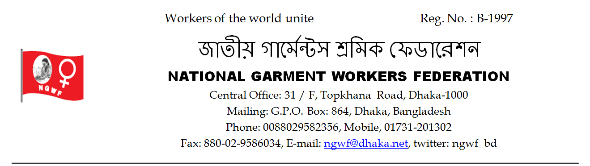
সুত্রঃ Date: 24.04.2016

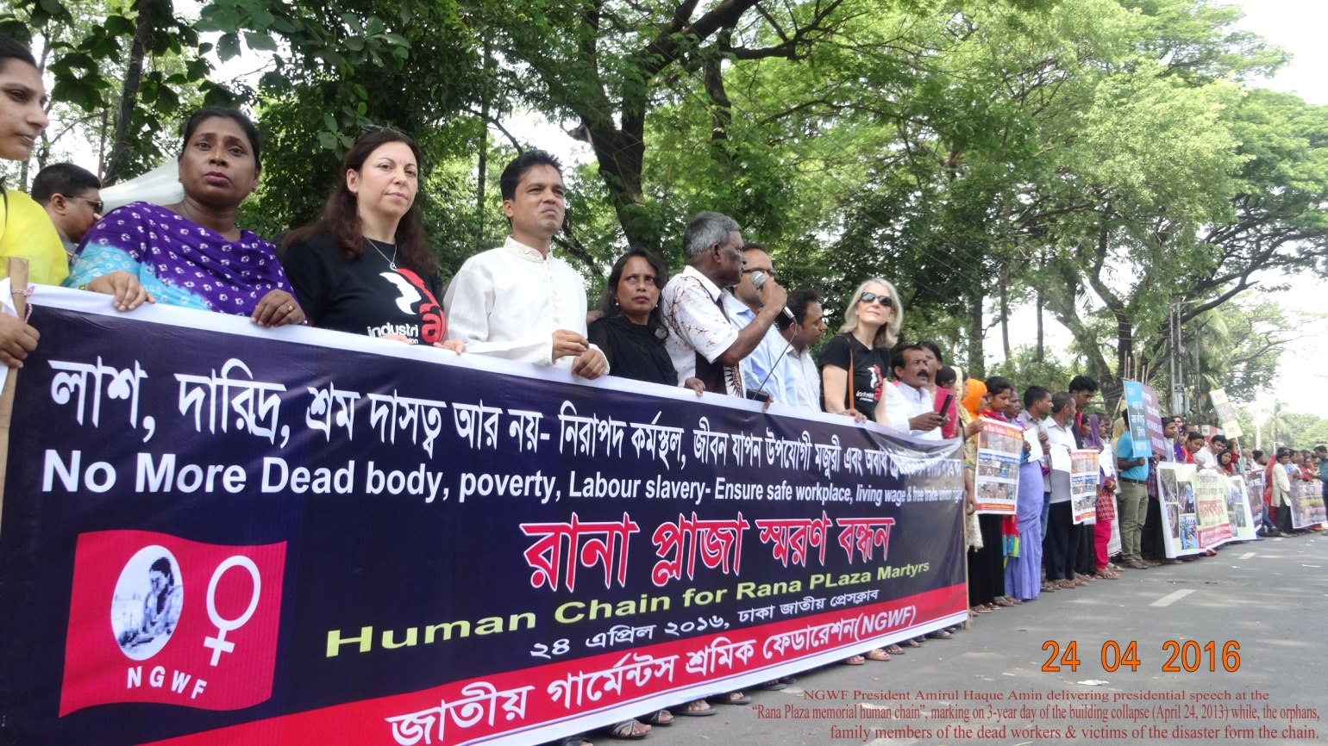

5-point demands rose from Rana Plaza memorial human chain in Dhaka city
Three orphan children, who lost both of their parents in Rana Plaza collapse, lighted candle lights
Orphan children, who lost both or either of their parents in Rana Plaza collapse, members of dead workers family & victims pleaded for joint actions of trade union, factory owners including BGMEA, government & buyers to prevent massacre like Rana Plaza.
They demanded for rehabilitation of all victim workers of Rana Plaza & to provide long-term medical treatment to injured workers.
They made these calls from “Rana Plaza memorial human chain” in front of National Press Club in Dhaka city on 3-year of Rana Plaza disaster today. National Garment Workers Federation (NGWF) organized the program. It may be noted here that Rana Plaza building collapsed on April 24, 2013 killing 1138 garment workers & injuring over 2,500. The “Rana Plaza memorial human chain” was formed to pay tributes to all those workers. NGWF President Amirul Haque Amin presided over the program.
The “Rana Plaza memorial human chain” program was formed by orphan children, who lost both or either of their parents in Rana Plaza collapse, members of dead workers family & victims. Three orphan children, who lost both or either of their parents in Rana Plaza disaster, Bijoy, Parvez & Md Korban alighted three candle light marking 3-year of the building collapse.
Parvez was carrying a festoon written— “No more death at workplace like that of my parents” while, Bijoy was holding a festoon that says, “I want judicial trial of all those who were responsible for my mother’s death” and the festoon carried by Korban written—“ I want exemplary punishment of persons responsible for my parents’ killing.”
Many of those, who came to participate in the program, became emotional as they saw orphan children carrying such festoon & placards.
Those spoke on this program included NGWF General Secretary Ms Safia Parvin & central leaders Ms Nurun Nahar, Mohammad Faruque Khan, Ms Arifa Aktar, Md Kabir Hossain, Md Rafiqul Islam Rafiq, Mrs Ranu Begum, Ms Parvin Aktar and Md Kashem.
Those given solidarity speech at the program included General Secretary of Youth Alliance Sabbah Ali Khan Collins, President of Students Alliance Abul Kalam Azad, General Secretary of Ekota Garment Workers Federation Kamrul Hasan & General Secretary of Bangladesh Garment Sramik Sanghati Federation Ms Smrity Aktar (Shahida).
5-point demands were rose from the program. The demands are: 1) All those responsible for killing workers in Rana Plaza should be tried & punished exemplary, 2) All Injured & victim workers of Rana Plaza should be rehabilitated & provided follow up medical treatment, 3) Everybody including buyers, factory owners, BGMEA, Government & trade union should their efforts together in order to prevent repetition of Rana Plaza like disaster, 4) No more dead body, poverty & slave labour—ensure safe workplace, living wage & free trade union right and 5) Before all other things life of the workers should be given importance side by side with business, profit & employment.

Press Secretary
NGWF

