### Northern TUC launches new Asbestos Support and Campaign Group Website

Today the Northern TUC Asbestos Support and Campaign Group (ASCG) have launched their new website <http://www.ascg.org.uk/> aimed at promoting the service and offering information, guidance and practical support for asbestos sufferers and their families/carers.

The Group, a partnership between Northern TUC, Macmillan Cancer Support and sustainable growth organisation Tadea UK, provides support, advice and information (including help with benefit entitlements) to people living with the effects of asbestos poisoning, their families and carers in the North East and North Cumbria. People helped by the group have diagnosed asbestos-related diseases such as mesothelioma, asbestosis and lung cancer and other workplace cancers.

In the last 12 months alone the Northern TUC ASCG has secured a total of £1.7 million for 162 local asbestos victims and their families.  The Group helps its client’s access much needed practical and financial support, from applying for a Disabled parking badge to accessing welfare payments and compensation. With the launch of the website, we are hoping even more people will be able to benefit from the Group and its services.

[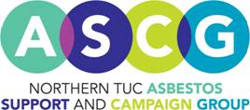](http://www.ascg.org.uk/)