Labour would offer financial incentives as part of the Living Wage deal
More than 70 people attended the second Northern Living Wage Summit which took place during Living Wage Week on Thursday 6th November at the Centre for Life in Newcastle. Local Authorities, voluntary organisations, employers and trade unions were all represented at the Summit. In her opening remarks, the Chair, Gill Hale welcomed the fact that the number of living wage employers is growing rapidly but recognised that there needs to be a far greater commitment to paying the living wage from both government and employers.
Beth Farhat, TUC Regional Secretary began her presentation by saying how encouraging it was to see more employers who are paying the living wage (and businesses that may be considering it) in the audience on the day. She also mentioned that the gender pay gap is widening and as equal pay day comes around again a woman working full-time now earns on average £5,200 less a year than a man. As prices are rising faster than earnings, workers are struggling to make ends meet and the use of food and clothing banks is on the increase. There needs to be a full and frank debate in the lead up to the general election. She cited an example of a PCS member she had spoken with recently whose pay ‘increase’ amounted to £1.72 per month in the last 7 years. The issue of procurement practices also needs tackling in terms of lifting pay and employment standards. Let’s get unions and employers working together to lift pay for their employees; put pressure on the government for fairer funding formulas for our Councils and get collective bargaining back on the table.
Matt Stripe HR manager from recently accredited employer Nestle described their journey to becoming a living wage employer. Nestle employs around 9,000 people so it was quite a challenge to get all employees through the process. So why did Nestle decide to become a living wage employer? They wanted to visibly demonstrate how much employees are valued and to make Nestle a good place to work. Raising the living standards of the workforce benefits individuals and the communities in which they live and work. Becoming a living wage employer has benefitted the workers and the company with better staff retention rates, less absenteeism and increased productivity. This could not have been achieved without the support and commitment of both Nestle and the unions – GMB, UNITE and USDAW – working together. It’s an intense journey but utterly worthwhile. Brian Golding, GMB and chair of the trade union national forum added that for the cleaning and catering staff who are predominantly women (and can be the sole wage earner), the living wage is a real boost to earnings and morale.

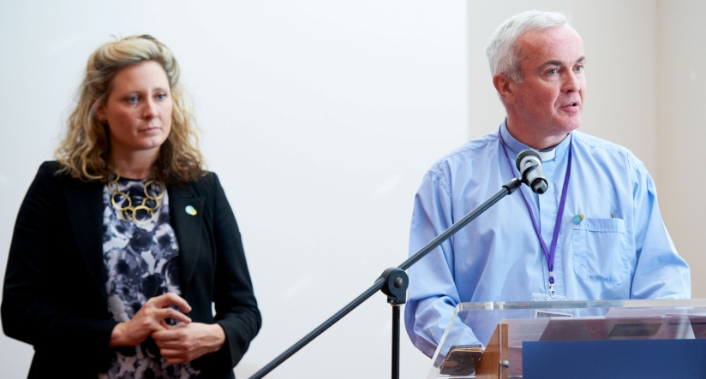
We were pleased to welcome back Sarah Vero of the Living Wage Foundation. Sarah said how great it was to be able to announce that the number of living wage accreditations has gone up year on year with 1,000 accreditations so far in 2014. This was a mix of large and small businesses and it was good to see living wage employers Hodgson Sayers and Enspec at the event. Wages are at an all-time low with rates back to 1977 level. Twenty two per cent of people in this country earn less than the living wage and there is growing public support to increase the minimum wage to a living wage, making the living wage the new legal minimum. Britain is predicted to be the highest growing economy behind the US. Sarah then introduced the Reverend Simon Mason, one of the first community leaders to be involved in the living wage campaign. Simon gave a moving account of the work he had been involved in as a mental health chaplain working with some of the most vulnerable people in society. Working as a community organiser in East London he started campaigning to get construction companies to employ more local people, highlighting the issue of low wages and lobbying for a living wage clause in all public construction contracts. He is rightly proud of his achievement in challenging Sir John Bond at the HSBC AGM as to why he was not paying his cleaners a living wage – and 13 years later his tenacity bore fruit as HSBC are now an accredited living wage employer.
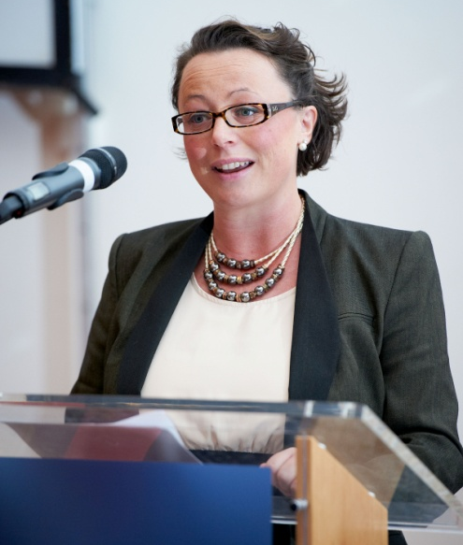
Our keynote speaker, Catherine McKinnell, Shadow Economic Secretary to the Treasury began by saying we have a huge amount to be proud of and celebrate. In her own constituency Sage and Nestle are accredited living wage employers. Although there have been recent falls in unemployment figures, levels in our region remain the highest in the country. Some 5.2 million people, 22% of the working population earn less than the living wage and it’s no surprise to learn that 60% earning less than the living wage are women. There are 600,000 more children living in poverty and twice as many poor children are living in working households. So what would a labour government do? We are committed to tackling the issue of low pay, ensuring small businesses are able to get through the living wage process without burden. Labour would offer businesses and employers financial incentives to pay their staff £7.85 an hour as part of the Living Wage deal. She added that people involved in the scheme could claim back their increase in tax revenue from the Treasury for the first year and support would be there to ensure bosses take up the offer. Long-term, she said more people receiving the higher wage would mean the Government would have to spend less on social security and tax receipts. Labour also pledge to take on the issue of a national minimum wage and the broader issue of low pay. It’s also about consumer choice. Workers deserve fair treatment and a fair price for their labour.

Some of the questions put to the panel included:
- Is there a differential between ages for living wage rate? Living wage applies to all over the age of 18 years, employers should be ‘age blind’.
- Do all MPs pay their staff a living wage? Wages are set by an independent pay body. Look at contractual arrangements.
- What defence have those involved in football given for not paying support staff such as catering and cleaners a living wage? Excuses range from it’s on our list to we can’t pay them one rate and another club pay something different, would cause problems. Living Wage Foundation would be delivering a letter to the Football Association on this issue.
- Do people claiming benefits lose out if receiving the living wage? Majority of benefits (excluding carers’ allowance) work on taper system. Some people may be only marginally better off but nobody should be worse off.
Our final speaker before moving to the workshops was James Ramsbotham, Chief Executive of the North East Chamber of Commerce who spoke about the link between low pay and low skills. James began by saying our region is the only region that makes a profit for this country, we are a real wealth creator. We have the fastest increase in GCSEs in the country and the fastest growth in productivity. It’s not just a simple case of increasing pay. We need to invest in the individual to upskill the workforce.
Delegates then participated in two workshops:
- Working with debt: causes and effects of debt in the North East, facilitated by Alison Baxter of FINCAN and,
- Child Poverty and Pay, facilitated by Robin Beveridge of the Child Poverty Commission.

Figure 1 L-R: Catherine McKinnell, Mark Heginbottom, Matt Stripe, Sarah Vero, Beth Farhat, James Ramsbotham, Gill Hale & Brian Golding

