North East Equality Awards 2016 – Applications are OPEN!

Applications for this year’s North East Equality Awards are OPEN. Application forms for all categories can be found at http://www.equality-ne.co.uk/projects/awards/2016
The TUC believes that everyone should have fair and equal treatment to help develop his or her potential, free from discrimination, and that life chances of all people can be transformed through learning, throughout their working lives. Equality of opportunity should be available to the entire workforce, regardless of age, gender, race, religion, sexual orientation or any disability.
This is the third year that the TUC and unionlearn have supported the regional Equality Awards and is proud to do so. This award is about giving affiliated trade unions and the work that officers, activists, and members carry out on a daily basis a platform to demonstrate how valuable their contribution is to the equality and diversity agenda.
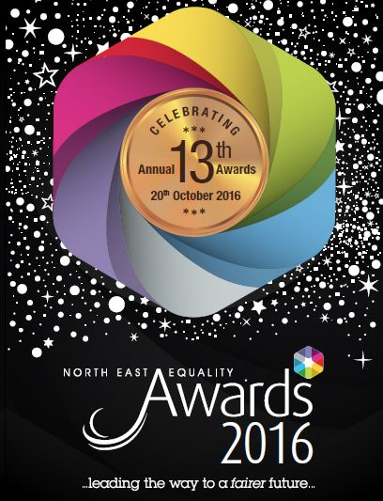
The winner of this award will be the Union Representative or trade union organisation/project who has pro-actively and demonstrably promoted equality for members in the workplace and/or beyond.
The award is open to nominations for:
- Shop Stewards
- Health and Safety representatives
- Union Learning Reps (ULRs)
- Union workplace projects
- Union Branches
The closing date for nominations is Friday 19th August.

