Nanofibres – the next Asbestos?.

Union health and safety reps gathered at Newcastle Civic Centre on Tuesday 1st April to discuss the health and safety implications involved in the production and use of nanomaterials.

Attendees were welcomed by Edwin Jeffries, Chair of the Northern TUC Health and Safety Forum who introduced the first speaker, Vicki Stone, Professor of Toxicology, Director of Nanosafety Research Group, Heriot-Watt University.

In her opening remarks, Vicki said she spends a great deal of her time talking to other scientists, regulators and government bodies and that she welcomed the opportunity to address a trade union audience for the first time. Her first experience of working in a dusty atmosphere was in a factory that produced powdered diet milk shakes where the dust was so thick you couldn’t see clearly and you knew which flavour you were making when you blew your nose!. In a detailed and comprehensive presentation, Vicki covered:
Figure 1: L-R, Jude Kirton-Darling, Edwin Jeffries, Vicki Stone

- how the body can react to nanoparticles
- the effects of air pollution
- How small is nano?
- the effects of exposure to nanomaterials
- the ‘healthy worker’ effect

Nanotechnology is the manipulation of materials at the nanoscale. Many products of nanotechnology are nanoparticles. BSI 2001 Terminology for nanomaterials recommended definition is:

- Nanoscale 1-100nm
- Nano object at least 1 dimension – 1-100nm
- Nanopaticiles all 3 dimensions 1-100nm

Key messages: the body possesses efficient mechanisms for removing non-self particles including bacteria and workplace dust. However these defences can malfunction and some particles have the ability to kick-start this malfunction via inflammation and oxidative stress – we need to understand which particles cause problems, and why.

There are many uses and benefits of nanomaterials covering a very wide spectrum of substances and the types of industries that might use nanotmaterials are vast. These include: food and food packaging, medicines/diagnostics, cosmetics, stain resistant clothing. It shouldn’t be assumed that all nanomaterials are a huge risk, not all nanoparticles are the same, they vary in their risk.

Vicki advised that there is money being invested and the European Commission has commissioned research to improve understanding and maximise the potential of nanotechnology with minimum risk. She is currently bidding for funding for a research project which would be useful to get trade union input and she will contact the TUC as details emerge.

The Chair thanked Vicki and introduced the next speaker, Jude Kirton-Darling , ETUC Confederal Secretary and Labour candidate for 2014 Euro elections to represent the North East.

Jude explained her role as ETUC Confederal Secretary included health and safety, industrial policy and sustainable development. In her presentation she covered what is happening at the European level around worker protection in relation to nanotechnology. Working with consumer groups and environmentalists a code of conduct was adopted for responsible nanosciences and nanotechnologies. More recently, the Commission has developed two regulatory reviews and a definition of nanomaterials. Currently in a position without a European Health and Safety Strategy and a number of member states have no national strategy either. She is working with the government representative in Europe in calling for a European Health and Safety Strategy. Nanotechnology is one of the ETUC’s three key priorities looking for a clear approach in terms of new and emerging risks. The other two are: Making progress in the prevention of musculoskeletal disorders and Mental health: too often neglected. European Parliament working closely with the trade union movement, developed asbestos European timeline for removal of asbestos from all public buildings. Jude finished by saying the legislation and rights we fought for and developed over last 30 years are being undermined by private employer organisations and government.

The chair thanked speakers and delegates for their attendance and contributions and appreciation to Thompsons Solicitors for supporting the event.

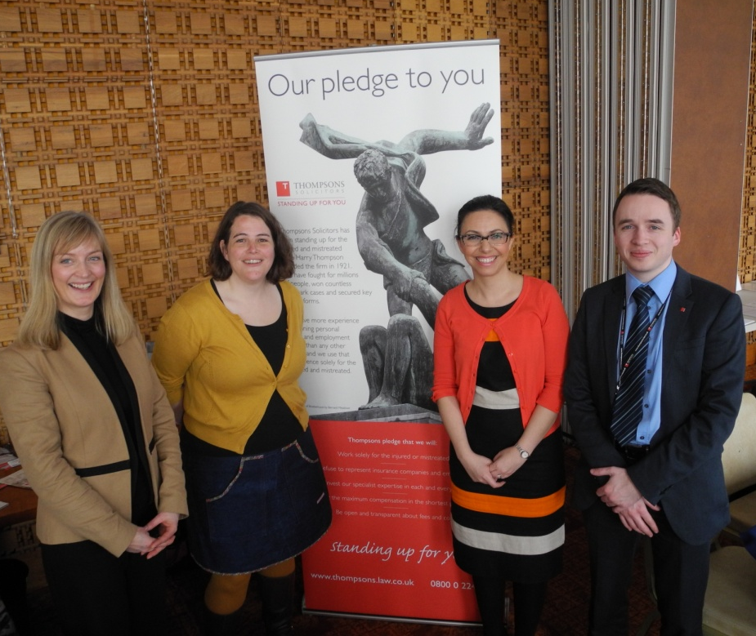
Figure 2: L-R, Vicki Stone, Jude Kirton-Darling, Beth Farhat TUC Regional Secretary
and David Robinson, Thompsons

