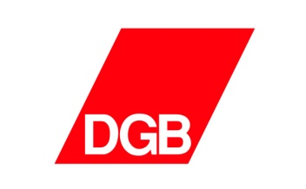

UK proposals for EU renegotiation
Joint DGB-TUC statement

Having regard to the UK Prime Minister's letter to the Council President last week proposing reforms to the relationship between the UK and the EU, we, the leaders of the trade union movements of Germany and Great Britain, urge the governments, political representatives and business leaders in our countries to:

1. Recognise that the success of the European Union as a political as well as economic project depends on a balance of economic and social measures - Europe must not just be a free trade area, but provide working people with decent work, including more and better jobs, health and safety and respect at work, good quality public services and social protection. A sustainable investment initiative to create high quality, high skill, high wage jobs in developing the physical & social infrastructure of Europe could create 11 million jobs and tackle youth unemployment and the threat of deflation. We need to ensure that all trade agreements are fair agreements, with decent labour standards at their heart.

2. Recognise that for Europe to respond to the needs and wants of its people, working people must have a voice that is taken into account at work and in decisions about the future of work and Europe. That must require greater democracy at work, including but not limited to rights to information and consultation, and a greater say through workers on boards, collective bargaining with employers and social dialogue with employers and governments at national and European level.

3. The call for competitiveness and better regulation such as the REFIT initiative should not be allowed to reduce the protection of workers' health and safety, consumer protections or sustainable environmental policies. In a European labour market that is constantly evolving, workers' rights to fair and equal treatment, defence against arbitrary management decisions and economic dislocations should be modernised and updated by agreement with social partners.

4. Indeed, workers and employers have a shared interest in a stronger level playing field across Europe of modern labour market regulation and higher wages, because they would restore demand, foster productivity and address the exploitation and undercutting that fosters antagonism towards migrants. Stronger wage growth and better regulation of the labour market would be a more effective way to address popular concerns about benefits for migrant workers than discrimination which we believe would only pave the way for benefit cuts for all working families.

Europe must address the refugee crisis by working together. That is the best way for member states to meet their international obligations to help those fleeing oppression, sexual violence and persecution. Now Europe's far-right politicians are seeking to exploit the fear, grief and anger that people feel following the terrorist attacks in Paris, which caused such a terrible loss of life and injuries, to stir up opposition to helping refugees. But closing our borders to refugees - men, women and children, who have often been victims of the very same terror and violence that we all want to stop - is not the answer. At this time of all times, we must stand together and speak up for our values of compassion, solidarity and democracy.

Trade Unions stand for a social Europe, for economic success and global competitiveness based on a high floor of social rights and skills. We jointly pledge to support a social protocol to the European Treaties to restore balance to the European economy. Globalisation cannot be prevented, and should not be passively accepted: it needs to be shaped and controlled so that it serves the interests of all of the people.

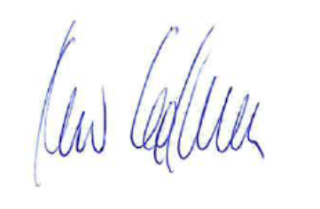
Frances O’Grady Reiner Hoffman
General Secretary President
Trades Union Congress Deutscher Gewerkschaftsbund

