Somali trade unionists develop work plan to improve pay and working conditions in the informal sector

A trade union workshop was held in Mogadishu, Somalia, with financial support from TUC Aid in January to explore ways and means of improving pay and working conditions of informal sector workers. The event organized by the Federation of Somali Trade Unions (FESTU) – affiliate of the International Trade Union Confederation (ITUC) was attended by twelve trade union officials from FESTU affiliates.
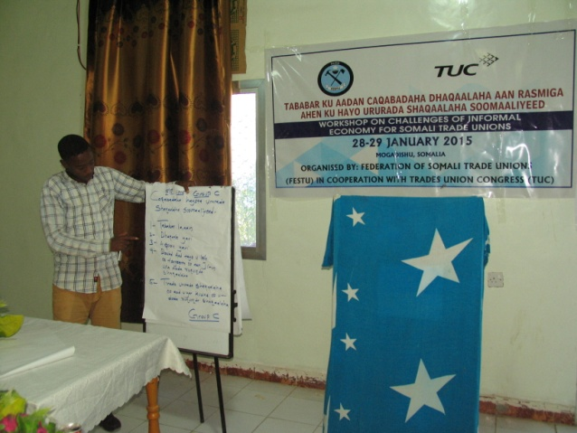
The participants assessed the key findings of a survey on pay and working conditions in the informal sector conducted prior to the workshop, stressed the importance of awareness-raising on workers’ rights and entitlements, trade union education, health and safety at work and gender equality and agreed on the need for action on the recommendations. In a detailed discussion on challenges facing the informal sector, the participants noted, among other issues, that:
- There was no legal framework for the recognition of informal sector workers.
- Their pay and working conditions were not in compliance with the provisions in the labour code.
- There were no opportunities for training and skills development.
- There was no social protection or insurance.
- The use of child labour was widespread.
- Many informal sector workers had little formal education and lived in abject poverty.
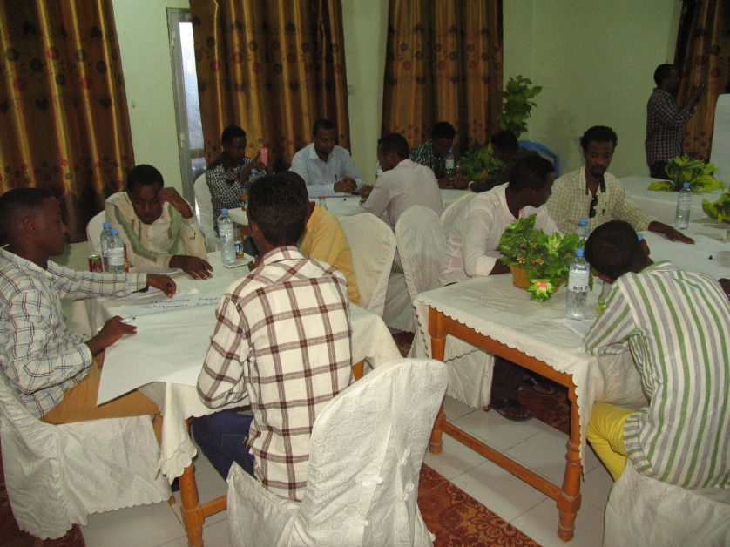
The Workshop made recommendations on the need for effective action by FESTU and its affiliates through advocacy and lobbying of the government and relevant agencies on effective measures to improve pay and working conditions of informal sector workers. Informal sector workers in Somalia who make up about 94% of the labour force include domestic workers, street and market vendors, agricultural workers, day labourers etc. The agreed work plan is to be implemented by February 2016.

