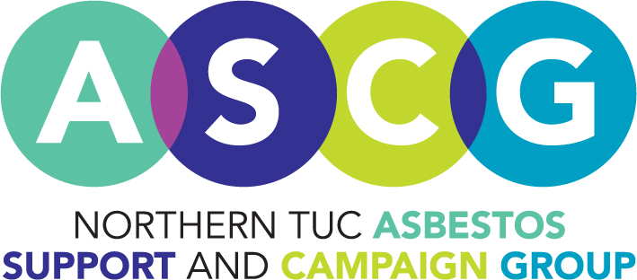

**Industrial benefits adviser**

**18.5 hours (Job share)**

**Salary £23,953 pro rata**

Experienced benefits adviser required to join Northern TUC Asbestos Support Group, partnership with West View Advice Centre and Macmillan. Your job will include visiting clients suffering from asbestos related diseases, supporting them to access the help they are entitled to.

Applicants should have practical experience working with vulnerable clients, delivering a range of welfare benefits advice on a home visit basis focussing on IIDB and PWCA.

Travel across the North East and occasionally North Cumbria, successful applicant could be based in Newcastle or Hartlepool.

Closing date: 19th August

Further information and to apply contact Val Evens, **01429 271294,** [Val@wvarc30.org.uk](mailto:Val@wvarc30.org.uk)

