Health and Safety Reps discuss Gender and Occupational Safety and Health
More than 60 Health and Safety reps attended the Health & Safety Forum event held on Tuesday 18th October in Newcastle.
In her introduction, Beth Farhat, TUC Regional Secretary, said today’s event is one in a series organised by the Forum in response to requests from workplace health and safety reps. Past Forums have covered topics including asbestos in public buildings; mental health awareness; and the impact of the trade union bill on health and safety. She was delighted to welcome an all women panel of speakers to address colleagues today and extended a warm welcome to our colleagues attending from Cumbria.
Beth then introduced the speakers. First up was Sue Ferns, Deputy General Secretary, Prospect. In May 2016, Prospect, the Women’s Engineering Society (WES) and Women into Science and Engineering (WISE), the TUC and the Institution of Mechanical Engineers Support Network undertook a survey to review the women’s experience of wearing Protective Personal Equipment (PPE). The results of the survey
“Women’s Personal Protective Equipment: One size does not fit all”showed that whilst users appear to think that some items of PPE have improved in the last seven years, progress is far too slow. Many took the time to comment that the survey was much needed and that the findings must be acted on. The survey was conducted on-line and received 3086 responses, 54% of which were from union members. The survey also looked at employer responsibility for PPE including cleaning, maintenance and storage; and is it a good fit? is it designed for women? And asked the question – what would make it better? It was also recognised that men also complained about their experiences of PPE and that any improvements in addressing common issues would benefit everyone.
Reps shared their experiences of PPE and agreed that this should be part of the negotiating agenda and that decision makers needed to be held to account.
The next contribution came from Julie Cook, National Officer for Wales TUC. Julie spoke about the work the Wales TUC are doing around the menopause and work. Through consultation with reps it was discovered that workplaces were not tackling certain issues in a way that helped workers. Wales TUC wanted to investigate further how Welsh employers are responding to this issue and what the experiences of women in the workplace are. They developed a short survey, the questions designed to be direct and difficult to misinterpret. [The findings of the survey are available in the “Menopause interim report” which was included in the packs for delegates.]

Whilst it is recognised the report and findings relate to participants from Wales it has raised a number of issues which will be relatable to women outside of Wales. Julie advised that the Wales TUC is more than happy to share findings in order to achieve a positive difference to workplaces outside of Wales.
A number of union reps including from UNISON and the NUT advised that menopause is included in their workplace health policies. Julie said she would welcome any supporting information unions could send to help inform their research.
Our final contribution came from Scarlet Harris, TUC Women’s Equality Officer. Scarlet spoke about the research the TUC undertook in collaboration with the Everyday Sexism project in response to the paucity of up-to-date, quantitative data on sexual harassment in the workplace.

Whilst many reps deal with sexual harassment cases on a day to day basis, unions and women’s organisations are in no doubt that sexual harassment remains as widespread a problem as ever, there has been little in the way of empirical data to quantify the problem. At the beginning of this year the TUC commissioned a YouGov poll of 1,533 women who were in work or who had been in work at some point in their lives. The findings from the survey is outlined in the report “Still just a bit of banter? Sexual harassment in the workplace 2016”. The report explores both nature and the scope of the problem and shines a light on an issue which is too often overlooked and underestimated.

The report includes a series of recommendations. First of all, government needs to do more…
- Abolition of employment tribunal fees
- Reinstatement of third party harassment legislation
- Reinstatement of employment tribunal powers to make wider recommendations
- Reinstatement of Statutory Equality Questionnaire
- Recognition and facility time for union equality reps
- Extend full range of statutory employment rights to all workers, regardless of employment status or type of contract

Employers need to do more too…
- Decent jobs
- Training
- Clear policies
- Implementation and enforcement of policies

And finally, unions can do more…
- One of the key findings from the research is that only 1% of those who experienced sexual harassment reported it to their union
- We need to make it clear to all members that sexual harassment is union business and that unions take a zero tolerance approach
- Training
- Workplace campaigns
- Negotiating workplace policies

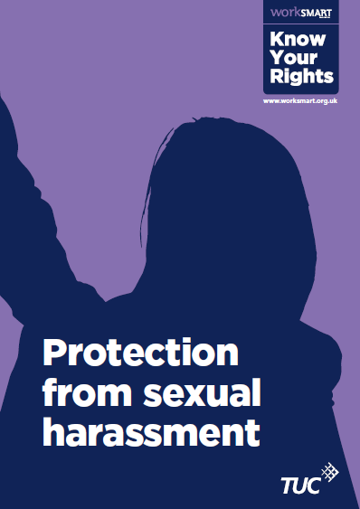
Resources the TUC have produced include a “Know your rights” leaflet and “Tackling sexual harassment in the workplace – A TUC guide for trade union activists”. An eNote and webinar is also being developed. Everyday Sexism are also developing a new website which will direct people to the TUC website for further information about joining a union.

In discussion a rep commented that men are subjected to sexual harassment in the workplace too. The issues of sexual harassment in schools was also raised.

Rounding up Beth thanked all for their contributions. As a speaker was unable to attend for the item on the GOSH checklist, it was hoped to organise this as a bite size briefing at a later date. She drew attention to the “Women and Leadership” course the Northern TUC Women’s Group had organised in conjunction with Trade Union Education and made reference to the “Asbestos Support and Campaign Group’s Fourth Year Annual report” which was available for delegates to take away.

