Unions review progress in rebuilding trade union structures and institutions in Haiti.

Trade unions in Haiti assessed the progress in the implementation of the Roadmap adopted in April 2010 in Santo Domingo in an evaluation workshop held in Port au Prince from 3 to 5 December 2013. The event brought together representatives from the Trade Union Confederation for the Americas (TUCA), Haiti, ILO, Solidarity Support Organisations (SSOs) in the UK, Italy, France, Belgium, USA, Canada (Quebec) and trade union representatives from the Dominican Republic. TUC Aid is providing financial support for the implementation of a common initiative in partnership with Institut Syndical International (ISI) in Italy. TUCA General Secretary Victor Baez, also, took part in the workshop.

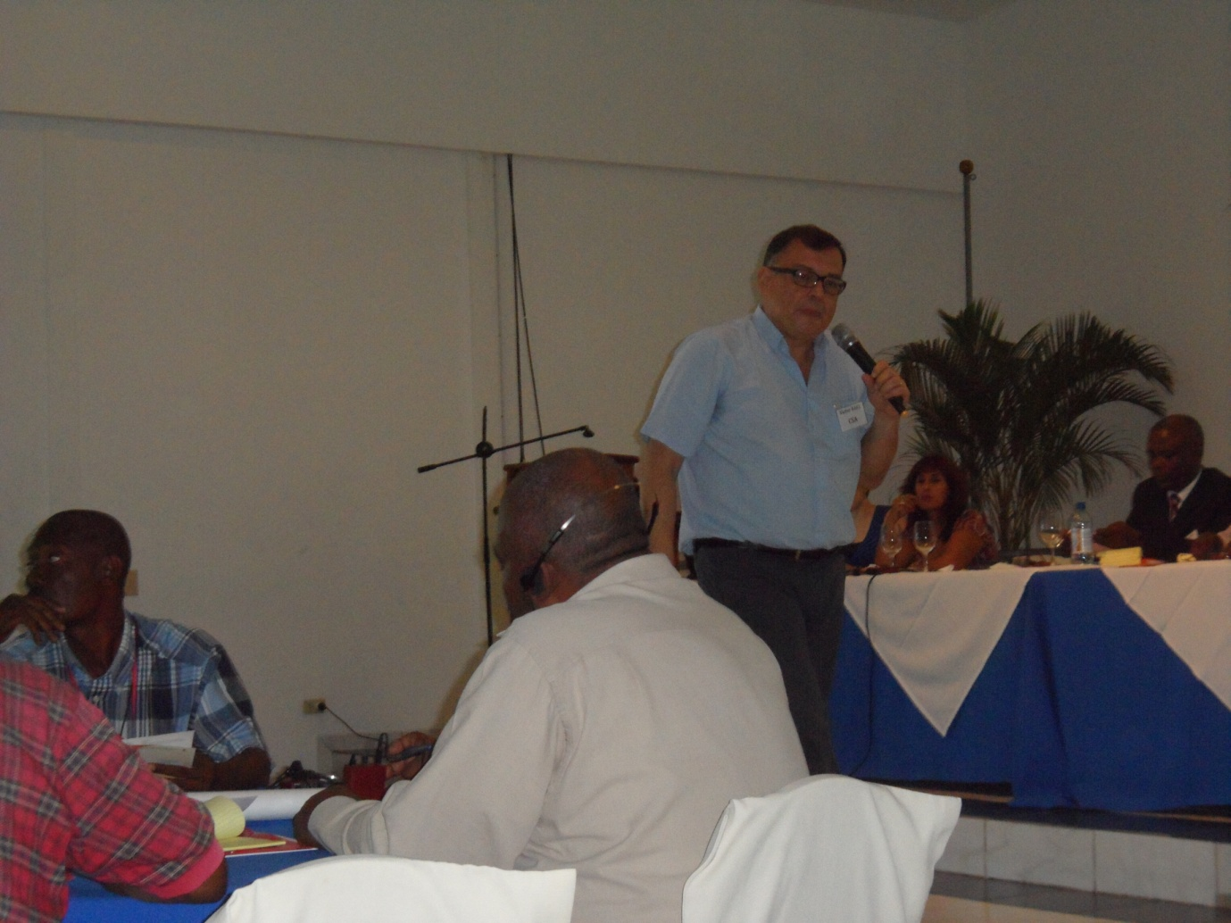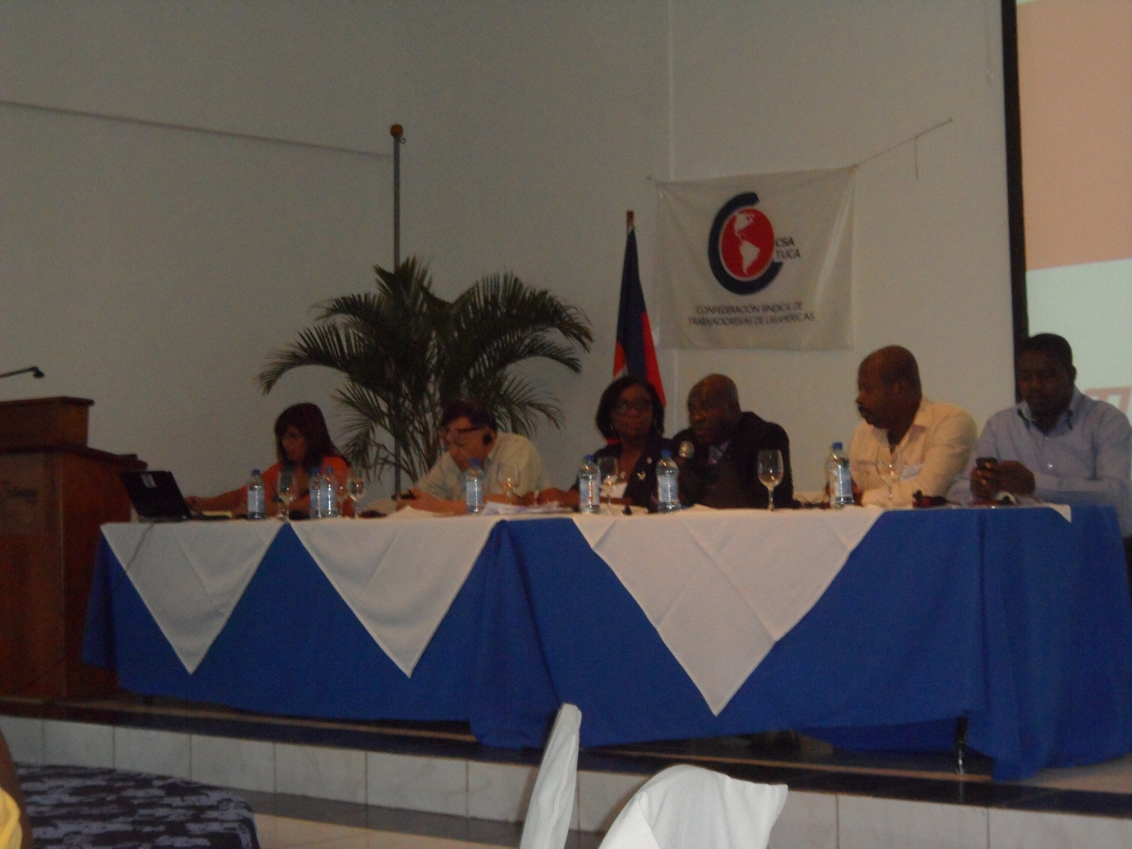

Professor Camille Chalmers, director of the Haitian Platform Advocating an Alternative Development (PAPDA), in his presentation on the socio-economic situation, highlighted poverty and inequality, which characterised the Haitian society. The Gini coefficient for Haiti, according to him, was 0.66 – highest in the world. He added that the formal sector of the economy had been shrinking with the informal sector now accounting for nearly 95% of economic activity in Haiti.

According to the Progress Report submitted to TUC Aid by Kattia Paredes Moreno, TUCA Project Coordinator, 17 company-level unions have been set up in the textile sector with 24 factories employing some 30,000 workers. The Coordination Syndicale Haïtienne (CSH) has formed a Moto-taxi Drivers' Union in Mirebalais which has recruited 230 members. The construction union affiliated to the Confédération des Travailleurs du Sector Public (CTSP) has won recognition from the Ministry of Social Affairs and Labour. Its membership currently stands at 90 and is on the increase. Plans are underway to unionise street vendors as part of organising workers in the informal sector. In addition,
- Some 240 trade union officials have been trained in various aspects of trade union work including organising, recruitment, servicing members etc.
- Training and education material has been produced in Creole.
- A training video on unionisation has been produced in French and Creole.
- Trade union representatives have been elected to various public bodies responsible for social security, employment and pay.
- Two collective bargaining agreements have been signed in the textile sector.
- An Inter-union Women’s Committee has been set up.
- The work on the Labour Law reforms continues with trade union participation and technical support from the ILO.
- There has been progress in joint work by Haitian trade unionists coordinated through the TUCA, for instance, on May Day celebrations, campaign on the minimum wage, Labour Law reforms etc.

The ITUC-TUCA was also instrumental in organising a meeting with representatives from the entire Haitian trade union movement in order to elect three workers' representatives to the Conseil Supérieur des Salaires (CSS) - body responsible for setting the minimum wage in Haiti. The CSS set the minimum wage at USD 5.23 per day -12% rise- on 29 November 2013, despite persistent demands from Haitian unions for a much higher increase.

Another tripartite body, the Conseil d’Administration des organisms de Sécurité Sociale (CAOSS – Governing body of Social Security Organisations) was set up at the end of August. Three workers’ reps from the Haitian trade union movement sit on the CAOSS. A seminar on social protection was held on 21-22 November. The establishment of focal points in each trade union organisation capable of contributing to the development of a social protection model that includes all workers is envisaged in order to strengthen the current initiatives to advance on decent work and social protection.

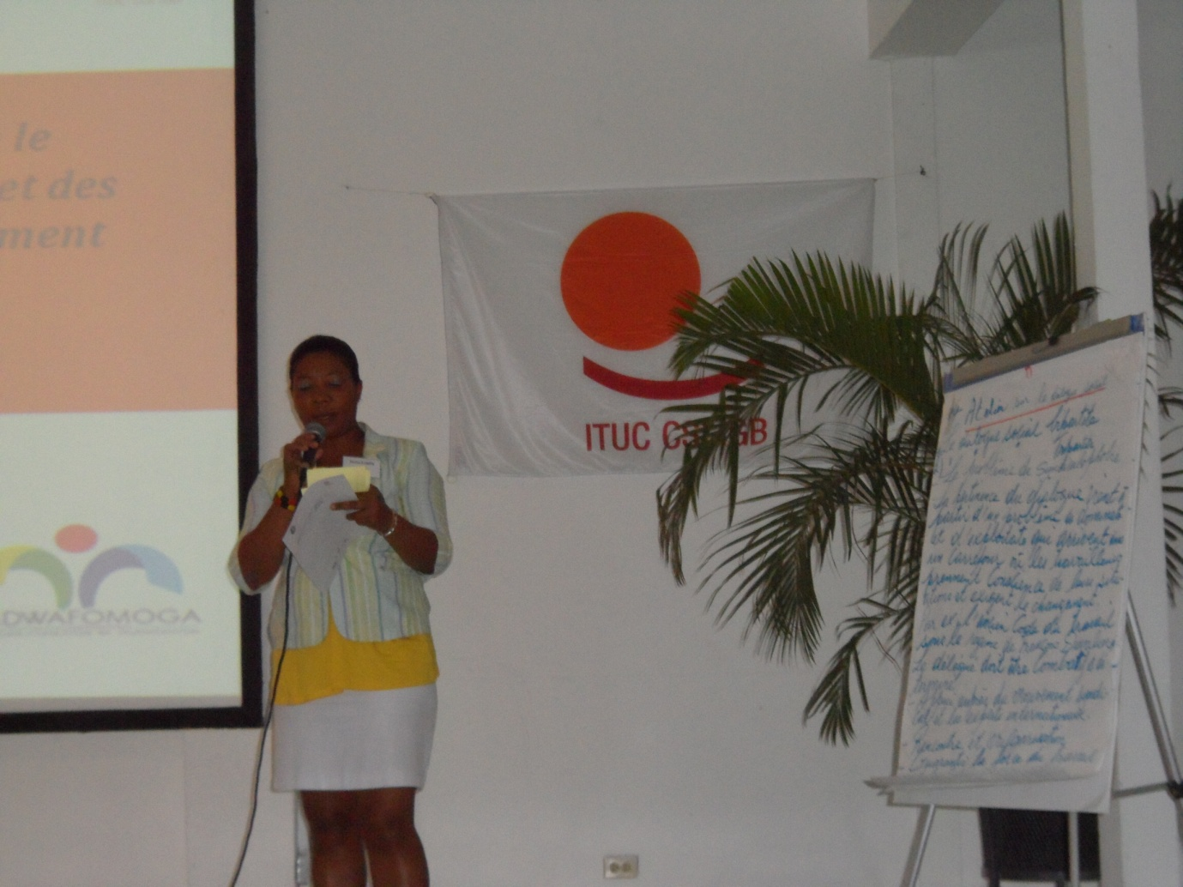
Haitian trade unionists produced an action plan/programme through five working groups which focussed on issues of concern to them and in line with the Roadmap developed and adopted in the Trade Union Summit held in Santo Domingo in April 2010. The Roadmap also underscores the need for strengthening institutions and structures supportive of good governance, observance of human rights and workers’ rights and trade union participation in reconstruction and development.

