Defending workers’ rights in banana plantations in Guatemala
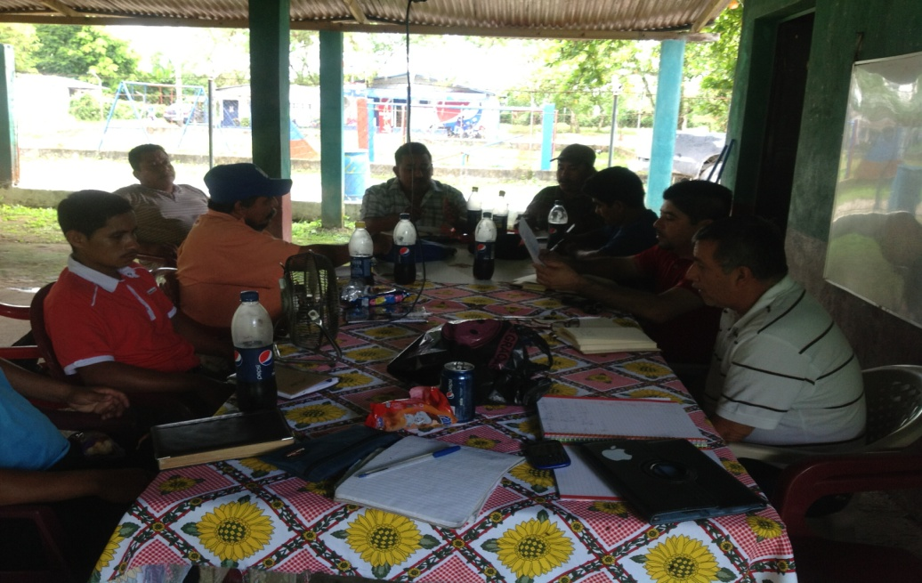
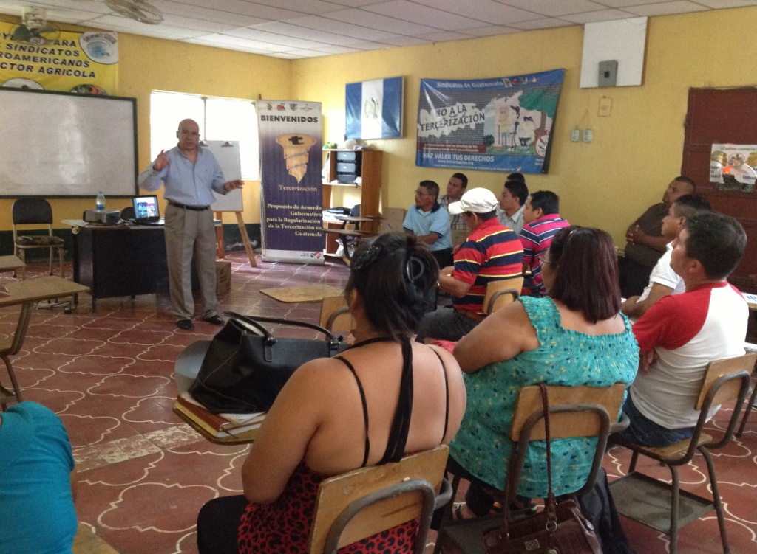
TUC Aid, in partnership with BananaLink, is building the capacity of trade unions in the banana plantations in Guatemala through a programme of training and education. The first training workshop organised under the joint initiative launched early this year took place in July with a focus on bargaining strategies and negotiating practices, followed by two other workshops on social dialogue in August in Izabal. SITRABI leaders and those of its affiliates have improved their knowledge and skills necessary for collective bargaining and social dialogue and are putting them into practice. The unions in the sector have been able to negotiate new social and economic clauses benefitting their members, specially, women workers.
Organising workers in the South

An intensive programme has been underway to organise workers in the plantations in the South Pacific with dialogue being established with one of the major producers – Grupo Agroamérica. A mapping exercise of the living and working conditions of workers in the region, supported by the AFL-CIO Solidarity Center, has revealed precarious living conditions and very long working days.

Banana Industry Roundtable in Izabal

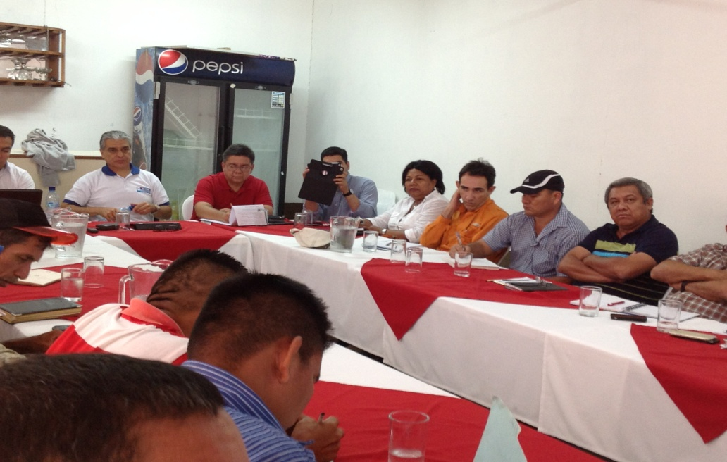
Following considerable efforts by SITRABI and COLSIBA leadership, the unions have succeeded in getting the Labour Ministry to set up the banana industry round table. The first meetings were held in Morales with the participation of the Minister, Deputy Minister and representatives of almost all the companies operating in Izabal. The roundtable aims at addressing outstanding problems in the local industry in order to facilitate dialogue and collective bargaining for the benefit of workers. Contact with workers in the South Coast confirms interest in organising workers in order to secure respect for basic human rights and workers' rights and to improve social and economic conditions in the industry in the region.

The TUC Aid - BananaLink joint initiative supported by UNITE, has benefitted Guatemalan trade unionists in the banana industry, including 26 members of the executive committees of key unions and some 1500 workers in smaller sister unions working in companies supplying to Del Monte in the Bobos District. There have been exchanges of expertise and experience with trade union organisations in the region as well as those (SITRATERCO – Chiquita Workers’ Union) in Honduras.

Work is in progress to transform SITRABI - an enterprise union - into an industry trade union. It is also expected that labour law reforms will be initiated through the tripartite commission on international relations to ensure the respect for freedom of association while appropriate training will continue for union officials serving in working groups. The system of collection of union dues will also be improved in order to ensure financial viability.
Challenges
Violence against unions and workers has been a major obstacle. Nonetheless, the threats to SITRABI leadership have diminished in recent months, making possible organising initiatives in the South. There is little interest on the part of some trade union leaders in participating in training workshops and in the industry round table.

Achievements/recommendations
Communication has significantly improved with the Labour Ministry and other public authorities. Formal complaints regarding violations of workers’ rights have been lodged with the Labour Inspectorate in Bandegua (Del Monte) and national producers. The unions have also filed a formal case in the labour courts concerning violations of the Collective Agreements covering Arapahoe, Carolina and Primavera plantations in the Bobos district and the failure to hand over union fees deducted at source and to pay employers' contributions to Social Security.

COLSIBA continues to support the union education process, social dialogue and the organising work in the Pacific South, along with other organisations like IUF, Trade Union Confederation for the Americas (TUCA), AFL-CIO and others. SITRABI has been able to employ a full-time organiser in the South to strengthen the education and organising work there.

BananaLink and TUC Aid invite trade unions in Europe to visit the Project to see the progress in training and education and support continuity in project activities.

