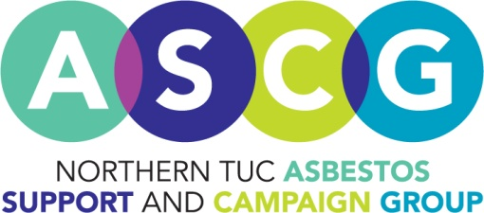

Benefits Advice for people affected by Cancer
In conjunction with Macmillan Cancer Support we are offering this bite size briefing which will give an overview of the work being undertaken by the Northern TUC Asbestos Support and Campaign Group. The briefing will also give an insight into the benefit entitlements for those affected by cancer, including both patients and carers.
The briefing will include:
- An outline of the service the ASCG provides
- Who can claim Industrial Injuries Benefit and Compensation for asbestos related diseases
- Basic guide to benefits
Date: Tuesday 20th May
Time: 1pm-3pm
Venue: TUC Regional Office, Newcastle upon Tyne
Register: Melanie Lowden, mlowden@tuc.org.uk, tel: 0191 2323175

Benefits Advice for people affected by Cancer
In conjunction with Macmillan Cancer Support we are offering this bite size briefing which will give an overview of the work being undertaken by the Northern TUC Asbestos Support and Campaign Group. The briefing will also give an insight into the benefit entitlements for those affected by cancer, including both patients and carers.
The briefing will include:
- An outline of the service the ASCG provides
- Who can claim Industrial Injuries Benefit and Compensation for asbestos related diseases
- Basic guide to benefits
Date: Tuesday 20th May
Time: 1pm-3pm
Venue: TUC Regional Office, Newcastle upon Tyne
Register: Melanie Lowden, mlowden@tuc.org.uk, tel: 0191 2323175

