**Wales TUC - May 2015 – Issue 20**

**All Wales Trade Union Equality Network Newsletter**

Another packed edition of the All Wales Equality Network Newsletter, this edition gives details of meetings, FREE Wales TUC run courses on becoming a Trade Union Equality Rep along with the most recent updates, news articles and much more.  If you would like your news to appear in future editions of this newsletter please email Nicola Savage at[**nsavage@tuc.org.uk**](mailto:nsavage@tuc.org.uk)

**Sign up to the All Wales Equality Network Newsletter** [**here**](http://eepurl.com/CxcgP)

**Dates of next All Wales Equality Network Meetings**

If you would like to join the **All Wales Equality Network** and meet, network and learn from Trade Union Equality Reps from across the Private and Public sectors in Wales join us at one of the meetings below.  The network is open to union members who have an interest in Equality and those who wish to become Trade Union Equality Reps in Wales.

Please email Nicola Savage at [**nsavage@tuc.org.uk**](mailto:nsavage@tuc.org.uk)

# Joint meetings - All Wales Equality Network and Networks of Excellence July 2015

Joint meetings of the Networks of Excellence and All Wales Equality Network meetings. These will be all day events and will include speakers, interactive workshops and workplace action planning....

Merthyr - Tuesday 7th July 2015 - Theatre Soar, Pontmorlais West CF47 8UB

Brecon - Wednesday 8th July 2015 – The Leisure Centre, Penlan, Brecon, Powys LD3 9SR

Wrexham - Wednesday 16th September - Venue TBC

**Our focus will be mental health & the aging workforce and include speakers from Gofal and Older People Wales.**

**Email** [**nsavage@tuc.org.uk**](mailto:nsavage@tuc.org.uk) **to book your place**

# All Wales Network Equality meetings October 2015

**October 2015**

Llandudno – Friday 16th October 2015

1030-1300 Venue Cymru, The Promenade, Llandudno, Conwy LL30 1BB

Aberystwyth – Monday 19th October 2015

1400-1630 National Library, Penglais Road, Aberystwyth, Ceredigion SY23 3BU

Cardiff - Wednesday 21st October 2015

1030-1300 Unite House, Cathedral Road, Cardiff CF11 9SD

# All Wales Network Equality meetings January 2016

**January 2016**

Swansea - Wednesday 20th January 2016

1030-1300 Unite the Union, High St, Swansea SA1 1LF

Colwyn Bay – Thursday 21st January 2016

1030-1300 Coleg Llandrillo. Llandudno Road, Rhos on Sea, Colwyn Bay LL28 4HZ

Aberystwyth – Friday 22nd January 2016

1030-1300 National Library, Penglais Road, Aberystwyth, Ceredigion SY23 3BU

**Email** [**nsavage@tuc.org.uk**](mailto:nsavage@tuc.org.uk) **if you or any of your colleagues would like to attend any of the above All Wales Network Equality meetings.**

**TUC e-notes**

## TUC Education eNotes

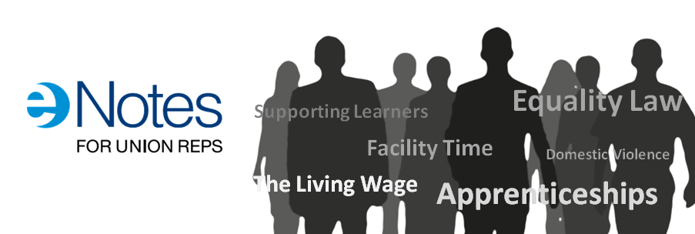

eNotes are a great resource to help reps keep up to date on key workplace issues. Each eNote is a self-contained module that contains a mixture of text, video and quizzes. They last between 20 and 45 minutes and can be returned to as many times as you like.

* **NEW:**Fit for Work
* Industrial Partnerships
* Work-related Upper Limb Disorders
* Domestic Violence
* Building a Stronger Workplace Union
* Facility Time
* Bargaining for Skills
* A Living Wage
* Apprenticeships
* Equality Law
* Supporting Mid-life development
* Additional Paternity Leave
* Understanding Universal Credit
* Climbing Frame
* Supporting Learners
* Vulnerable Employment
* The Sick Note
* European Works Councils

**More info here:** [**http://bit.ly/1zonfJ2**](http://bit.ly/1zonfJ2)

**Become a Trade Union Equality Rep - Free courses available now**

These are the latest courses available for those who would like to become a Trade Union Equality Rep.  This is a FREE course and it’s interesting, inspiring and will help you to make a difference at work.  It’s also a great learning opportunity for you and you will be supported in your new role by the Wales TUC and by your union.  Give it a go!

**Devolved Public Sector in Wales**

The Wales TUC has developed a new 6-day training course specifically for those working in the devolved public sector in Wales who would like to become trade union equality reps. The role of the trade union equality

rep in the public sector is supported by the Welsh Government and all devolved public sector workplaces and as such has been allocated additional facility time to allow trade union equality reps to carry out their role effectively. This new course is available at venues across Wales, and is offered one day per week over six weeks.

**\*\*Courses can be tailored for non-devolved, private and third sector organisations\*\***

**Find your Credit union**

Several unions have credit unions but if your union doesn’t, find out where your nearest credit union is here:

<http://www.findyourcreditunion.co.uk/home>

Don’t keep it to yourself; let your members, colleagues, friends and family know about the advantages of a credit union.

Credit unions are authorised by the Prudential Regulation Authority, regulated by the Financial Conduct Authority and Prudential Regulation Authority. All deposits in credit unions are protected by the Financial Services Compensation Scheme up to £85,000.

**Consultation documents**

## [Welsh Government Draft Equality Objectives for 2016-2020](http://gov.wales/consultations/people-and-communities/draft-equality-objectives-2016-2020-consultation/?lang=en)

**[This twelve week consultation seeks views on what should be the Welsh Government’s Equality Objectives to be included in its Strategic Equality Plan 2012-16.](http://gov.wales/consultations/people-and-communities/draft-equality-objectives-2016-2020-consultation/?lang=en)**

Welsh Government will be running workshops in their offices across Wales during the consultation period.  Dates and venues are listed below.  If you would like to attend please get in touch by using the booking form via the link above.

Spaces are limited and will be allocated on a first come basis.

* 9 June – Rhufoniog A1.21, Llandudno Junction
* 15 June – Conference room 6, Cathays Park, Cardiff
* 19 June – Cothi, Penllergaer, Swansea

**Please submit your comments by 10 July 2015**

**WAVE Wales - Check out the Equal Pay Barometer**

Men’s annual average earnings are £22,921 but women’s are only £16,412. This is because so many women work part time and this work is concentrated in low paying jobs.

This simple barometer, based on a labour market survey in Wales will show you the jobs that men and women do in employment and self employment whether full or part time, and how much they get paid for it.

Visit the @WAVEWales @CUWave Equal Pay Barometer to see what men and women earn in the jobs they do <http://ow.ly/BEiFU> #letstalkaboutpay

**Public Health Wales launches information for transgender community**

Public Health Wales has launched information resources on screening services specifically for the transgender community. The resources include a leaflet, frequently asked questions, a series of short films and an information card. These were produced in partnership between the Screening Division of Public Health Wales, Transgender Awareness Wales, FTM Wales, Unique Transgender Network and the NHS Centre for Equality and Human Rights.

All of this information is available on the Screening for Life website [www.screeningforlife.wales.nhs.uk](http://www.screeningforlife.wales.nhs.uk).

**Union Learning Reps – Network dates**

ULR Network Dates

*Save the date!*

Tuesday 7 July Merthyr Tydfil

Wednesday 8 July Brecon

Friday 10 July Carmarthen

Tuesday 14 July Swansea

Wednesday 15 July Colwyn Bay

The theme for the July meetings will be Equality and Learning. Equality Reps will be invited to join with ULRs in particular at the Merthyr, Brecon and Colwyn Bay meetings.

Come along and find out how to make learning accessible to all. Book your place contact Bernice [Bwaugh@tuc.org.uk](mailto:Bwaugh@tuc.org.uk)

**WEA Cymru Workplace Learning – New Course – now recruiting for…**

Mental Health Awareness 1 Day Course –

OCN accredited

Venue: WEA Cymru Office  9 Coopers Yard,  Curran Road, Cardiff CF10 5NB

Day & times: Thursday  18th June 2015 9.30am – 4pm

The course will look at:

* Understand attitudes to mental health
* Understand the causes of mental ill health
* Recognise factors that promote mental well being
* Recognise support agencies

To enrol please contact:  [William.powell@weacymru.org.uk](mailto:William.powell@weacymru.org.uk)  *tel*: 01495 369869

Course fees:  £55 per person  (this includes OCN certification)  Tutor: Sue Carlick

Teas / coffees available.      Sorry, there is no parking at this venue.

If your workplace is covered by a WULF project you may be eligible for help with course fees.

**Looking for a Board position?**

**What are public appointments?**

Our public bodies need board members who reflect Welsh society - people from all walks of life. Public appointments are usually for members of committees which advise, monitor and take decisions on public services across Wales, both locally and nationally.

You can apply to organisations that include:

* public bodies, eg Arts Council of Wales, National Museum Wales
* regulatory bodies, eg Care Council for Wales, General Teaching Council for Wales
* advisory and specialist bodies, eg Advisory Panel on Substance Misuse, Welsh Food Advisory Committee

You could help run these organisations and offer advice, drawing on your own experience. Some positions are unpaid, but most will cover your expenses.

Some appointments processes are regulated by the [Commissioner for Public Appointments](http://publicappointmentscommissioner.independent.gov.uk/).

**Anyone can apply:** [**Public Appointments – Welsh Government**](https://cymru-wales.tal.net/vx/lang-en-GB/mobile-0/appcentre-3/brand-2/candidate/jobboard/vacancy/7/adv/)

The Welsh Government acknowledges the importance of developing and growing bilingual capabilities in public appointments in Wales, and welcomes applications from candidates who demonstrate their capability to work in both English and Welsh.

The Welsh Government believe public bodies should have board members who reflect Welsh society - people from all walks of life - to help them understand people's needs and make better decisions.

That is why the Welsh Government is committed to increasing diversity and encourages applications from Lesbian, Gay, Bisexual and Transgender, Black Minority Ethnic, Women and Disabled people.

**Shelter – Work it out Project**

The Work it Out project promotes housing and debt advice information to people who **are in employment** and who would not normally seek assistance through traditional advice routes, thus preventing homelessness and raising understanding of the issues.

We are offering this service because:

* People in employment are least likely to be connected into a network of support or help services in the same way as are care leavers, single parents and people with disabilities.
* Given the reduction in public spending in Wales and the full impact of welfare reform on individuals it is likely that as more people face changes in their working conditions, the need for independent information and advice will be increased.

Free, expert housing advice, tools and downloads

If you have an urgent housing problem call 0845 075 5005.

If your problem is not urgent, browse the website, <http://www.sheltercymru.org.uk/get-advice/get-advice-online/> which contains information on a huge range of housing related issues. If you need more help, you can email us your enquiry.

Information can go on the workplace intranet and/or newsletters. Leaflets can be posted to ULRs for distribution (free).

Llion Bevan [llionb@sheltercymru.org.uk](mailto:llionb@sheltercymru.org.uk) 01792 469400

**Mental Health First Aid**

**Mental Health First Aid training 'for everyone'**

Front line workers particularly often have to deal with people with experience of mental distress but lack the skills and confidence to support them appropriately.   
  
With **1 in 4** of us affected by mental health problems each year, people across Wales are being offered a short training course to deal more effectively with these challenges. In an ambitious project, funded by the Welsh Assembly Government, The 12 hour course does not train you to be a therapist, counsellor or mental health professional but it will teach you to:

* Give initial help to someone experiencing a mental health problem
* Deal with a crisis situation or the first signs of someone developing mental ill-health.
* Guide people towards appropriate help.

**Future - MHFA 2 Day Course Dates 2015**

Swansea – June **15th 16th** 19 High Street Swansea, SA1 1LF

Cardiff – June **29th 30th** **Venue to be confirmed**

North Wales – July **16th 17th** 64, Chester Street, Flintshire CH6 5DH,

**Please Note:**

**If anyone has a venue to hire for the June (Cardiff) event please call:**

**Sue Carlick on 0790 334 3997**

# Wales TUC - Mental health and work

Gofal has been working with the Wales TUC to develop a workers' guide to mental health and wellbeing. This was launched at the Wales TUC Equalities Conference in April 2014 and distributed to trade union equality representatives from a range of organisations. The booklet is available in [English](http://www.gofal.org.uk/uploads/Policy_documents/Wales_TUC/Gofal_Wales_TUC_-_info_booklet_-_Eng_-_web.pdf) and in [Welsh](http://www.gofal.org.uk/uploads/Policy_documents/Wales_TUC/Gofal_Wales_TUC_-_info_booklet_-_Cym_-_web.pdf).

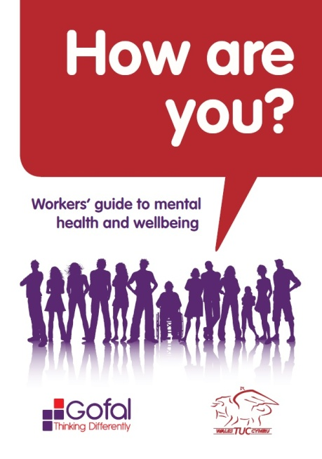     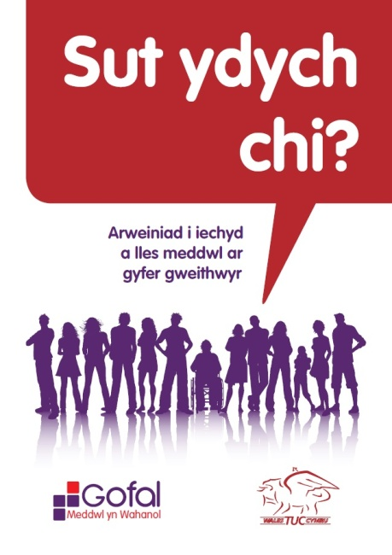[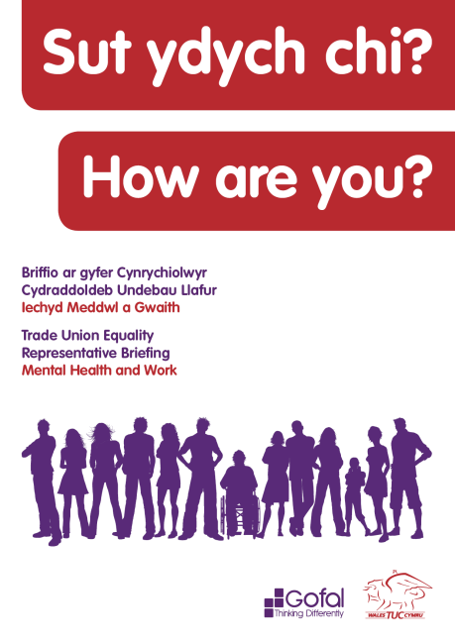](http://www.gofal.org.uk/uploads/Policy_documents/Wales_TUC/Gofal_Wales_TUC_toolkit_-_Eng_-_WEB.pdf)

In September 2014 at the Wales TUC mental health conferences in north and south Wales we launched a comprehensive mental health briefing for trade union representatives.

The toolkit was developed by Gofal in partnership with the Wales TUC and there were several opportunities for trade union representative to feed into this process.

It provides information about mental health, talking tips and how to access help and support. It also includes a number of tools to help trade union reps to improve mental health and wellbeing in the workplace.

The briefing is available in [English](http://www.gofal.org.uk/uploads/Policy_documents/Wales_TUC/Gofal_Wales_TUC_toolkit_-_Eng_-_WEB.pdf) and in [Welsh](http://www.gofal.org.uk/uploads/Policy_documents/Wales_TUC/Gofal_Wales_TUC_toolkit_-_Cym_-_WEB.pdf).

**World Mental Health Day 10th October 2015**

## "Dignity in Mental Health" is the theme for this year's World Mental Health Day, which takes place on 10 October 2015.

## The annual event is focused on global mental health education, awareness and advocacy and we'll soon be announcing a full programme of activities and support.

<http://www.mentalhealth.org.uk/our-work/world-mental-health-day/world-mental-health-day-2015/>

***.***

‘***On Balance’ Diversifying Democracy in Local Government***, the Diversity in Democracy Project

In response to the Report of the Expert Group ‘***On Balance’ Diversifying Democracy in Local Government***, the Diversity in Democracy Project has been developed with an aim to increasing the diversity of candidates standing at the next local government elections in 2017.

The Diversity in Democracy programme will provide a mentoring, shadowing and training opportunity for people from under-represented groups in Wales for a period of 12 months.

Mentees will be provided with the skills and confidence to stand for election through a programme of one-to-one mentoring with Councillors, and shadowing opportunities with Council Officers.

Anyone over the age of 18 with UK residency, can be a Councillor, whether you work full or part-time, are unemployed or in education.

We are looking for people from across Wales who are interested in working within their community to make a positive difference to the lives of local people.

If you have a keen interest in community issues, along with a passion to represent the views and opinions of individuals, you may be just the person we are looking for!

The Mentoring Programme will begin in July 2015 and is expected to run for a minimum of twelve months.

For further information, click on the following link [**www.gov.wales/diversityindemocracy**](http://www.gov.wales/diversityindemocracy) where you will find various documents, including a guide to Mentoring and a Mentee Application Form, which you can download or complete online.

If you would like an informal discussion regarding the Programme and/or the role of Mentee, please contact Project Co-ordinator, [catherine.kennedy@wales.gsi.gov.uk](mailto:catherine.kennedy@wales.gsi.gov.uk) 02920 801048.

**Cross Party Group on   
Women in the Economy**

**Christine Chapman AM cordially invites you to**

**Who Cares?**

This session will explore caring roles in the family and discuss how workplaces can better support those with caring responsibilities.

Topics will include work-life balance, parental roles and the new shared parental leave legislation.

Carers Wales will join the group to talk about how best to support carers in the workplace and we will be joined by a number of individuals who will share their personal experiences.

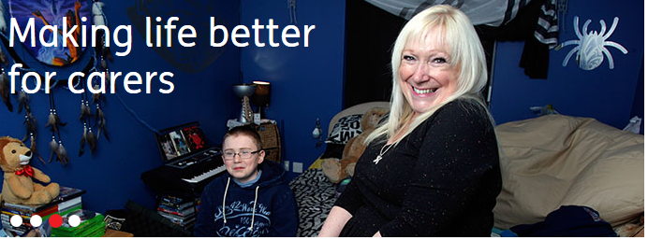 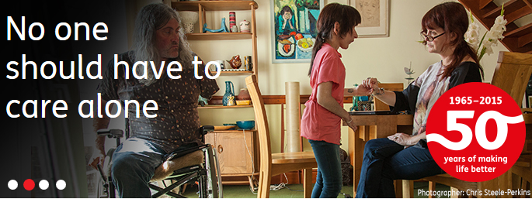

Wednesday, 3rd June 2015

12.15 – 13.30 pm

(Sandwiches will be provided from 12.15 pm)

Conference Room 24, Ty Hywel

Join us to take action on women’s equality in Welsh workplaces

RSVP to Anne Howells at [anne.howells@chwaraeteg.com](mailto:anne.howells@chwaraeteg.com)



 **Shaping the Future   
Equality and Human Rights Exchange Conference June 10th 2015**

**Llandrindod Wells**

**Keynote Speakers:**

Dr. Helen Mott, University of West England and Bristol Fawcett Society will set out her approach to equality and human rights impact assessments.

Sue Bent, Directory Coventry Law Centre will share her experiences of using impact assessments to secure the future of the Law Centre

Kate Clayton-Hathway, Oxford Brookes University asks 'Is the Public Sector Equality Duty making a difference to peoples lives?'

Dr. Kristi Long, NHS Education Scotland will talk about her work to implement the Public Sector Equality Duty in Scotland

**This conference will:**

* explore new approaches to equality, human rights and social justice impact assessments
* consider how impact assessments can lead to positive outcomes
* increase your understanding of how decisions may impact on people
* help you to challenge discrimination and human rights abuses
* help you to protect and promote equality and human rights
* share successful ways to drive change

Attendance at the conference is free. If you would like to reserve a place please download our online form [*here*](https://www.equalityhumanrights.com/about-us/devolved-authorities/commission-wales/equality-and-human-rights-exchange/conference-2015-shaping-future) and email it to us at

[**wales@equalityhumanrights.com**](mailto:wales@equalityhumanrights.com)

If you have any questions or would like to discuss the conference please contact us on **02920 447710.**

**Cross Party Group on Faith:**

**'God and sex - Faith communities tackling pornography'**

Cross Party Group on Faith

***God and sex – faith communities tackling pornography***

*Guest speakers: Shereen Aziz-Williams, The Henna Foundation and Karin Cooke, The Naked Truth Project and Porn Scars*

*Chair: Darren Millar AM*

Wednesday 8 July 2015

12:00 – 13:15

Media Briefing Room, Senedd Building

*To reserve a seat, email Jim Stewart on* [*j.stewart@eauk.org*](mailto:j.stewart@eauk.org)

Sent on behalf of Darren Millar AM, Chair of the Cross Party Group on Faith

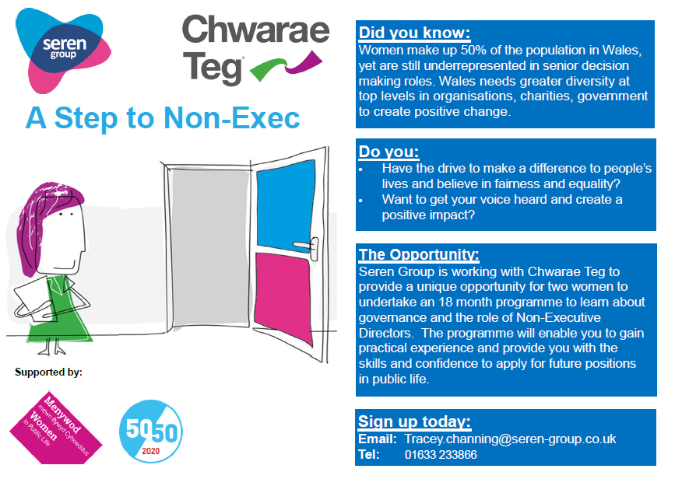

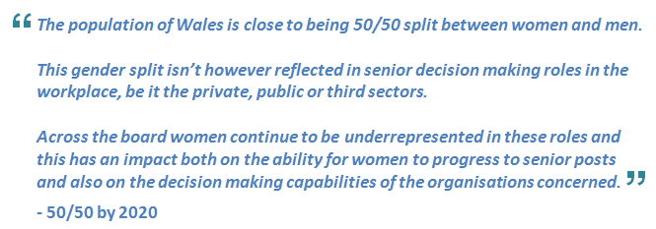

With this in mind [Seren Group](http://www.seren-group.co.uk/) and [Chwarae Teg](http://www.cteg.org.uk/a-step-to-non-exec/) have created an exciting opportunity aimed at encouraging more young women (aged 18-25), into Non-Executive Director roles, providing a programme of shadowing opportunities that will take place over 18 months.  We will give you practical experience and training on governance and the role of a Non-Executive Director by participating.

**Applications are invited by 8th June 2015**

For more information and details on how to apply please visit: <http://www.cteg.org.uk/a-step-to-non-exec/>

**Chwarae Teg Bursaries – Helping Women Achieve and Prosper**

|  |
| --- |
| Helping Women Achieve and Prosper |
| Our vision is to see a Wales where women achieve and prosper, we believe that there are hundreds of women across Wales who want to succeed but sometimes they need a helping hand along the way. This is where the Chwarae Teg bursary can help bring these ambitions to life. Prosper The Prosper bursary is for a business run by a woman who is looking to expand her enterprise.  It could be anything from a set of tools for the workshop, a potter’s wheel for the shed or putting it towards getting that vintage camper-van so you can travel to pop-up food festivals in style!  The bursary is for up to £500, available to help buy equipment. Achieve The Achieve bursary is for a woman looking to undertake an educational course to further her career.  Whether the course is formal such as GCSE’s, A-Levels, or NVQ’s or if it’s more specific to your career you can apply for the Achieve bursary.  The bursary provides up to £500 to put towards the course of your choosing. [Apply Today](https://go.madmimi.com/redirects/1432046055-2a72498b20795de064f0f305d407638f-2b74087?pa=30404076782) |

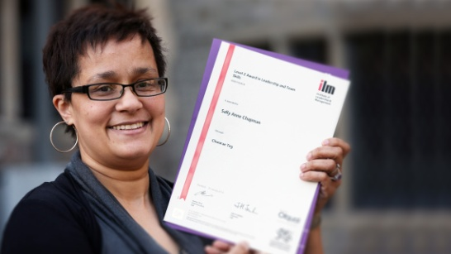 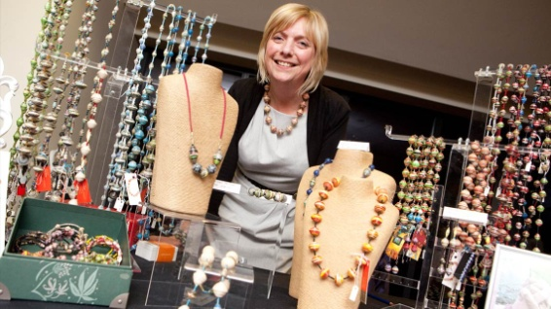

|  |
| --- |
| Stonewall Cymru - A message from Andrew White, Director   [**Your priorities for LGBT equality in Wales**](http://stonewall.us8.list-manage.com/track/click?u=80f234ec11c28a7a8408eaaea&id=a4795a8aee&e=2fcbebeadb)   We know there is still much to do before lesbian, gay, bisexual and trans (LGBT) people can live free from discrimination and enjoy true equality in Wales. That’s why we would like [your help](http://stonewall.us8.list-manage.com/track/click?u=80f234ec11c28a7a8408eaaea&id=82ae164421&e=2fcbebeadb) to campaign on the issues important to you. In 2016, there will be elections to the National Assembly for Wales, which has powers over education, health, housing, economic development, sport and other areas. We want to hear about what you think the next Welsh Government should prioritise.   So if you haven’t done so already, we would be extremely grateful if you could take the time to fill in [our new survey](http://stonewall.us8.list-manage.com/track/click?u=80f234ec11c28a7a8408eaaea&id=bedb26c1ee&e=2fcbebeadb) before it closes and pass it on to your friends. It should only take 10 minutes, and it is completely anonymous. Your voice is our most powerful asset, and the information we get from this survey will directly shape our work over the coming year with political parties to improve experiences of LGBT people in Wales.  Best wishes  https://gallery.mailchimp.com/80f234ec11c28a7a8408eaaea/images/d4dcc848-dfe6-45fe-ad79-b2069158453a.jpg  [@A](http://stonewall.us8.list-manage1.com/track/click?u=80f234ec11c28a7a8408eaaea&id=24522cdad7&e=2fcbebeadb)[ndrewGwyn](http://stonewall.us8.list-manage.com/track/click?u=80f234ec11c28a7a8408eaaea&id=cf2a6f156c&e=2fcbebeadb)  P.S. You can support our work in Wales by becoming a [friend of Stonewall Cymru](http://stonewall.us8.list-manage.com/track/click?u=80f234ec11c28a7a8408eaaea&id=fb42ade9be&e=2fcbebeadb), donating your time as a valued [volunteer](http://stonewall.us8.list-manage2.com/track/click?u=80f234ec11c28a7a8408eaaea&id=ab20bc1233&e=2fcbebeadb) or joining our growing fundraising team at events all over the country. |

**EHRC Wales logo no background.png**

**Is Wales Fairer?**

**8th July 2015**

**10.00am - 3.30pm**

**University of South Wales,**

**Conference Centre,**

**Treforest**

**The Equality and Human Rights Commission in Wales would like to invite you to attend a conference to share the early findings of 'Is Wales Fairer?'**

To book go [online](https://iswalesfaireraywcymrundecach.eventbrite.co.uk/)

'Is Wales Fairer?' is the follow up to our 2011 review, ['How Fair is Wales?'](http://www.equalityhumanrights.com/sites/default/files/publication_pdf/how_fair_is_wales.pdf) and its companion ['Human Rights Review'](http://www.equalityhumanrights.com/about-us/our-work/human-rights/human-rights-review) of 2012.

'Is Wales Fairer?' will provide the first opportunity to measure progress in equality and human rights over the past five years. It will examine six areas: health; safety, security and right to life; home and family life; education and learning; work and income; and participation in society.

The conference will provide you with the opportunity to:

* hear about the big equality and human rights challenges facing Wales
* identify next steps in tackling the challenges
* discuss how the challenges can help to identify the new strategic objectives of public bodies

Attendance at the conference is free.

If you have any questions or would like to discuss the conference please contact the EHRC on 029 2044 7710



### We’re excited to invite you to WEN Wales’ Annual Conference and AGM.   Our theme this year is: Women and Unpaid Care.

Our [recent research](http://wenwales.us8.list-manage1.com/track/click?u=6e5ee9551ab72b3e504505e3f&id=2febaf7ccc&e=590743fdc9) shows Women in Wales are paying a high price for caring.  Too often, carers in Wales are suffering economic hardship, isolation and poor health.  As women provide more unpaid care than men in Wales, this issue has a profound impact on women’s lives.  
  
WEN Wales will be campaigning about the issue of unpaid care between now and the Assembly elections next year.  We want to raise the profile of the issue to ensure that our women carers in Wales are valued and protected.  This conference is a chance for you to get involved with this campaign at its outset.   Let us know how caring impacts your life or the lives of women you know and inform us what would make a difference.   
  
**Women and Unpaid Care, WEN Wales Annual Conference and AGM**  
  
Place: Orangery at Margam Park, Neath Port Talbot  
Date: Saturday 13th June  
Conference:  11.00– 14.30  
AGM: 14.30 – 15.30  
  
Lunch provided and children are welcome.  
[**Tickets available for free here**](http://wenwales.us8.list-manage1.com/track/click?u=6e5ee9551ab72b3e504505e3f&id=66251c6c40&e=590743fdc9)

|  |  |
| --- | --- |
| |  | | --- | |  | |
|  |

**Free courses with Glyndwr University**

introduction to

humanities

15-17th June 2015

Join our dynamic Humanities department for a short course in English, History and Creative Writing!

This course will give you a taste of what studying each of these subjects would be like through a range of workshops and a visit to a nearby country house. We will provide all the materials and the course is **FREE!**

Successful completion will give you a Certificate of Continuing Education and 20 Higher Education credits.

**No previous qualifications required. Minimum age 18, no maximum age!**

Glyndŵr University, Wrexham

Contact Sarah Gaffney on **01978 293575** or **s.l.gaffney@glyndwr.ac.uk** to book your **FREE** place today!

**Equalities Calendar**

|  |  |
| --- | --- |
| 1 June | Wesak (Buddah Day) (Buddhist) |
|  |  |
| 16 June | Martyrdom of Guru Arjan Dev (Nanakshahi calendar) (Sikh) |
| 15 June – 21 June  20 June  15 June – 21 June | World Refugee Week  World Refugee Day  Men’s Health Week |
| 21 June | Father's Day |
| 18 June –  17 July | Ramadan (start of Muslim fast) |
|  | |
| 4 July | Independence Day (USA) |
| 9 July | Martyrdom of the Bab (Baha'i) |
| 12 July | Asala - Dharma Day (Buddhist) |
| 13 July | Lailat al Qadr (Muslim) |
| 17 July | Eid-Ul-Fitr (Muslim) |
| 18 July | Nelson Mandela International Day |
| 30 July | International Day of Friendship |