**Wales TUC - July 2015 – Issue 22**

**All Wales Trade Union Equality Network Newsletter**

Another packed edition of the All Wales Equality Network Newsletter, this edition gives details of meetings, FREE Wales TUC run courses on becoming a Trade Union Equality Rep along with the most recent updates, news articles and much more.  If you would like your news to appear in future editions of this newsletter please email Nicola Savage at[**nsavage@tuc.org.uk**](mailto:nsavage@tuc.org.uk)

**Sign up to the All Wales Equality Network Newsletter** [**here**](http://eepurl.com/CxcgP)

**Dates of next All Wales Equality Network Meetings**

If you would like to join the **All Wales Equality Network** and meet, network and learn from Trade Union Equality Reps from across the Private and Public sectors in Wales join us at one of the meetings below.  The network is open to union members who have an interest in Equality and those who wish to become Trade Union Equality Reps in Wales.

Please email Nicola Savage at [**nsavage@tuc.org.uk**](mailto:nsavage@tuc.org.uk)

# Joint meetings - All Wales Equality Network and Networks of Excellence July 2015

These will be all day events and will inc

lude speakers, interactive workshops and workplace action planning....

Wrexham - Wednesday 16th September - Room B07, Glyndwr University, Mold Road, Wrexham  LL11 2AW  [Phone](https://www.google.co.uk/search?rlz=1C2WLXA_enGB572GB572&biw=1366&bih=635&q=glyndwr+university+phone&stick=H4sIAAAAAAAAAGOovnz8BQMDgx0HnxCnfq6-gXFZWXyBln52spV-cn5OTmpySWZ-nn52Xn55TmpKemp8QWJeak6xfkZicXxBRn5eqhWYnPT0U85HVf_jPxWXvpRKZf7y-VKnLABhGTdGWwAAAA&sa=X&sqi=2&ved=0CJYBEOgTMBVqFQoTCMP57urM7sYCFbQI2wodmgcOWA): [01978 290666](javascript:void(0))

**Our focus will be mental health & the aging workforce and include speakers from Gofal and Older People Wales.**

**Email** [**nsavage@tuc.org.uk**](mailto:nsavage@tuc.org.uk) **to book your place**

# All Wales Network Equality meetings October 2015

**October 2015**

Llandudno – Friday 16th October 2015

1030-1300 Venue Cymru, The Promenade, Llandudno, Conwy LL30 1BB

Aberystwyth – Monday 19th October 2015

1400-1630 National Library, Penglais Road, Aberystwyth, Ceredigion SY23 3BU

**LOCATION TBC** - Wednesday 21st October 2015

1030-1300

# All Wales Network Equality meetings January 2016

**January 2016**

Swansea - Wednesday 20th January 2016

1030-1300 Unite the Union, High St, Swansea SA1 1LF

Colwyn Bay – Thursday 21st January 2016

1030-1300 Coleg Llandrillo. Llandudno Road, Rhos on Sea, Colwyn Bay LL28 4HZ

Aberystwyth – Friday 22nd January 2016

1030-1300 National Library, Penglais Road, Aberystwyth, Ceredigion SY23 3BU

**Email** [**nsavage@tuc.org.uk**](mailto:nsavage@tuc.org.uk) **if you or any of your colleagues would like to attend any of the above All Wales Network Equality meetings.**

**Wales TUC Equality Forum Leads**

LGBT – Phil Dixon ATL

BME – Steve Wakefield UNITE

Women – Beth Davies NYU and Jane Setchfield NASUWT

Disability – Steffan ap Dafydd NUT

Youth - TBC

**Please email** [**nsavage@tuc.org.uk**](mailto:nsavage@tuc.org.uk) **for contact details**

**Wales TUC want your stories...........**

From the good, the bad to the ugly if you have a story to share about your role as a Trade Union Rep we’d love to hear from you.

What experiences have you had as a Trade Union Rep both in and out of your workplace?

Have you influenced any decisions on workplace policies or practices?

What are the biggest challenges you’ve faced as a Trade Union Rep?

Has your Trade Union involvement influenced your work or social activities within your local communities? And if so, how?

And achievements? Proudest moments?

Please get in touch

Email: [nsavage@tuc.org.uk](mailto:nsavage@tuc.org.uk) or call me on 02920 347010

**Pregnancy Discrimination**

# Acas statement on EHRC research on maternity & pregnancy discrimination

**Friday 24 July 2015**

Acas has put out a statement in response to the Equality and Human Rights Commission's (EHRC) research on pregnancy and maternity discrimination today:

Acas Head of Equality Steve Williams said:

"It is clear from this valuable research that businesses need to treat all their workers fairly as this will help them stay within the law.

"We have published a new guide today on [**Pregnancy and maternity discrimination**](http://www.acas.org.uk/index.aspx?articleid=5271). From next month we are also launching a series of equality guides to help employers and managers identify, tackle and prevent discrimination in the workplace.

"Acas fully supports the Commission's #worksforme awareness initiative to help employers manage pregnancy and maternity."

# [54,000 women a year suffer pregnancy discrimination but only a handful enforce their rights](http://touchstoneblog.org.uk/2015/07/tens-of-thousands-of-women-a-year-suffer-pregnancy-discrimination-but-only-a-handful-enforce-their-rights/)

24 Jul 2015, by [**Sally Brett**](http://touchstoneblog.org.uk/author/sally-brett/) in [**Equality**](http://touchstoneblog.org.uk/category/equality/)

**Pregnancy Discrimination**

The Equality Act 2010 makes it unlawful to discriminate, or treat workers unfavourably because of their pregnancy, or because they have given birth recently or are breastfeeding.

Discrimination arises when a woman is treated unfavourably because of her pregnancy, pregnancy related illness or she exercises the right to statutory maternity leave.

## Key points

* It is unlawful to discriminate against an employee because they are pregnant or have a pregnancy related illness, this covers the protected period which ends when maternity leave ends or when an employee returns to work.
* Pregnancy and maternity discrimination is automatic discrimination, and there is no need to provide a male comparator.

**More Information here:** [**http://www.acas.org.uk/index.aspx?articleid=5271**](http://www.acas.org.uk/index.aspx?articleid=5271)

**And here:** [**The Maternity and Parental Leave etc. Regulations 1999**](http://www.legislation.gov.uk/uksi/1999/3312/contents/made)

**And here:** [**EHRC #worksforme**](http://www.equalityhumanrights.com/about-us/our-work/key-projects/managing-pregnancy-and-maternity-workplace)

**TUC e-notes**

## TUC Education eNotes

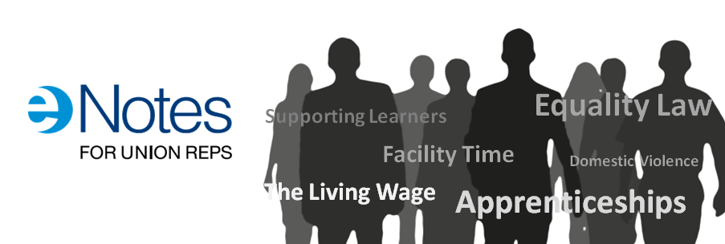

eNotes are a great resource to help reps keep up to date on key workplace issues. Each eNote is a self-contained module that contains a mixture of text, video and quizzes. They last between 20 and 45 minutes and can be returned to as many times as you like.

* NEW: Supporting Learners into Higher Learning
* NEW: Migration
* NEW: Fit for Work
* Industrial Partnerships
* Work-related Upper Limb Disorders
* Domestic Violence
* Building a Stronger Workplace Union
* Facility Time
* Bargaining for Skills
* A Living Wage
* Apprenticeships
* Equality Law
* Supporting Mid-life development
* Additional Paternity Leave
* Understanding Universal Credit
* Climbing Frame
* Supporting Learners
* Vulnerable Employment
* The Sick Note
* European Works Councils

**More info here:** [**http://bit.ly/1zonfJ2**](http://bit.ly/1zonfJ2)

**Become a Trade Union Equality Rep - Free courses available now**

These are the latest courses available for those who would like to become a Trade Union Equality Rep.  This is a FREE course and it’s interesting, inspiring and will help you to make a difference at work.  It’s also a great learning opportunity for you and you will be supported in your new role by the Wales TUC and by your union.  Give it a go!

**Devolved Public Sector in Wales**

The Wales TUC has developed a new 6-day training course specifically for those working in the devolved public sector in Wales who would like to become trade union equality reps. The role of the trade union equality

rep in the public sector is supported by the Welsh Government and all devolved public sector workplaces and as such has been allocated additional facility time to allow trade union equality reps to carry out their role effectively. This new course is available at venues across Wales, and is offered one day per week over six weeks.

**For more information visit:** [**http://bit.ly/1Ikd0JE**](http://bit.ly/1Ikd0JE)

**Find your Credit union**

Several unions have credit unions but if your union doesn’t, find out where your nearest credit union is here:

<http://www.findyourcreditunion.co.uk/home>

Don’t keep it to yourself; let your members, colleagues, friends and family know about the advantages of a credit union.

Credit unions are authorised by the Prudential Regulation Authority, regulated by the Financial Conduct Authority and Prudential Regulation Authority. All deposits in credit unions are protected by the Financial Services Compensation Scheme up to £85,000.

**WAVE Wales - Check out the Equal Pay Barometer**

Men’s annual average earnings are £22,921 but women’s are only £16,412. This is because so many women work part time and this work is concentrated in low paying jobs.

This simple barometer, based on a labour market survey in Wales will show you the jobs that men and women do in employment and self employment whether full or part time, and how much they get paid for it.

Visit the @WAVEWales @CUWave Equal Pay Barometer to see what men and women earn in the jobs they do <http://ow.ly/BEiFU> #letstalkaboutpay

**Public Health Wales launches information for transgender community**

Public Health Wales has launched information resources on screening services specifically for the transgender community. The resources include a leaflet, frequently asked questions, a series of short films and an information card. These were produced in partnership between the Screening Division of Public Health Wales, Transgender Awareness Wales, FTM Wales, Unique Transgender Network and the NHS Centre for Equality and Human Rights.

All of this information is available on the Screening for Life website [www.screeningforlife.wales.nhs.uk](http://www.screeningforlife.wales.nhs.uk).

**Looking for a Board position?**

**What are public appointments?**

Our public bodies need board members who reflect Welsh society - people from all walks of life. Public appointments are usually for members of committees which advise, monitor and take decisions on public services across Wales, both locally and nationally.

You can apply to organisations that include:

* public bodies, eg Arts Council of Wales, National Museum Wales
* regulatory bodies, eg Care Council for Wales, General Teaching Council for Wales
* advisory and specialist bodies, eg Advisory Panel on Substance Misuse, Welsh Food Advisory Committee

You could help run these organisations and offer advice, drawing on your own experience. Some positions are unpaid, but most will cover your expenses.

Some appointments processes are regulated by the [Commissioner for Public Appointments](http://publicappointmentscommissioner.independent.gov.uk/).

**Anyone can apply:** [**Public Appointments – Welsh Government**](https://cymru-wales.tal.net/vx/lang-en-GB/mobile-0/appcentre-3/brand-2/candidate/jobboard/vacancy/7/adv/)

The Welsh Government acknowledges the importance of developing and growing bilingual capabilities in public appointments in Wales, and welcomes applications from candidates who demonstrate their capability to work in both English and Welsh.

The Welsh Government believe public bodies should have board members who reflect Welsh society - people from all walks of life - to help them understand people's needs and make better decisions.

That is why the Welsh Government is committed to increasing diversity and encourages applications from Lesbian, Gay, Bisexual and Transgender, Black Minority Ethnic, Women and Disabled people.

**Mental Health First Aid**



**‘’MHFA Training is for everyone'’**

Front line workers particularly often have to deal with people with experience of mental distress but lack the skills and confidence to support them appropriately.   
  
With **1 in 4** of us affected by mental health problems each year, people across Wales are being offered a short training course to deal more effectively with these challenges. In an ambitious project, funded by the Welsh Assembly Government, The 12 hour course does not train you to be a therapist, counsellor or mental health professional but it will teach you to:

* Give initial help to someone experiencing a mental health problem
* Deal with a crisis situation or the first signs of someone developing mental ill-health.
* Guide people towards appropriate help.

**Interested...**

**2 Day MENTAL HEALTH FIRST AID COURSE**

**Cost £85 per person**

**9.30 – 4.30**

This session is open to everyone so please Call Sue Carlick and find out how you can enrol in this fantastic Programme.

**Please Note:** If you are applying for funding to pay for your course fees Please contact your ULR at your workplace to find out about WULF Funding or alternatively call - Project Officer Sue Da’Casto- 02920 022759 or e-mail [Sue.DaCasto@unitetheunion.org.uk](mailto:Sue.DaCasto@unitetheunion.org.uk) or Deri Bevan - 02920 347010 or e-mail [dbevan@tuc.org.uk](mailto:dbevan@tuc.org.uk)

Tel Sue Carlick: [SueCarlick@hotmail.co.uk](mailto:SueCarlick@hotmail.co.uk) - 07903343997

**Future - MHFA 2 Day Course Dates 2015**

Cardiff – August **13-14th**– 1 Cathedral Rd Cardiff CF11 - 9SD

North Wales – September Venue to be confirmed

Cardiff – October **19-20th** - 1 Cathedral Rd Cardiff CF11 - 9SD

North Wales – November – **3-4th** - 64, Chester Street, Flintshire CH6 - 5DH

Cardiff – December – **3-4th** - 1 Cathedral Rd Cardiff CF11 - 9SD

**World Mental Health Day 10th October 2015**

## "Dignity in Mental Health" is the theme for this year's World Mental Health Day, which takes place on 10 October 2015.

## The annual event is focused on global mental health education, awareness and advocacy and we'll soon be announcing a full programme of activities and support.

<http://www.mentalhealth.org.uk/our-work/world-mental-health-day/world-mental-health-day-2015/>

# Wales TUC - Mental health and work

Gofal has been working with the Wales TUC to develop a workers' guide to mental health and wellbeing. This was launched at the Wales TUC Equalities Conference in April 2014 and distributed to trade union equality representatives from a range of organisations. The booklet is available in [English](http://www.gofal.org.uk/uploads/Policy_documents/Wales_TUC/Gofal_Wales_TUC_-_info_booklet_-_Eng_-_web.pdf) and in [Welsh](http://www.gofal.org.uk/uploads/Policy_documents/Wales_TUC/Gofal_Wales_TUC_-_info_booklet_-_Cym_-_web.pdf).

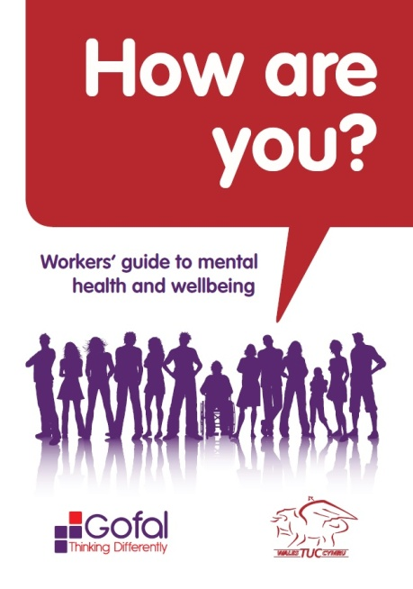     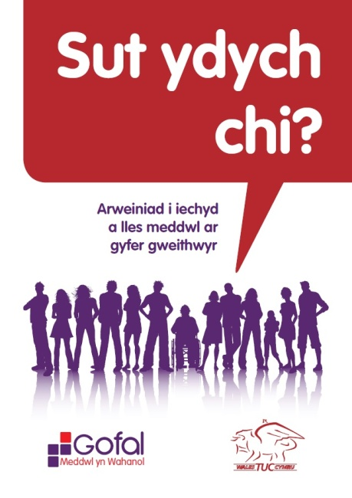[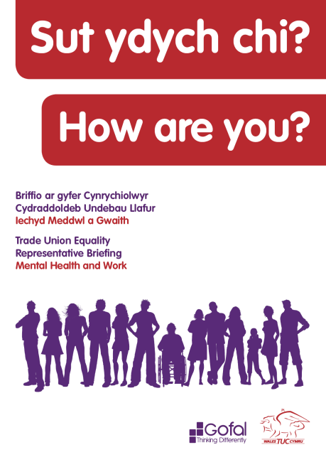](http://www.gofal.org.uk/uploads/Policy_documents/Wales_TUC/Gofal_Wales_TUC_toolkit_-_Eng_-_WEB.pdf)

In September 2014 at the Wales TUC mental health conferences in north and south Wales we launched a comprehensive mental health briefing for trade union representatives.

The toolkit was developed by Gofal in partnership with the Wales TUC and there were several opportunities for trade union representative to feed into this process.

It provides information about mental health, talking tips and how to access help and support. It also includes a number of tools to help trade union reps to improve mental health and wellbeing in the workplace.

The briefing is available in [English](http://www.gofal.org.uk/uploads/Policy_documents/Wales_TUC/Gofal_Wales_TUC_toolkit_-_Eng_-_WEB.pdf) and in [Welsh](http://www.gofal.org.uk/uploads/Policy_documents/Wales_TUC/Gofal_Wales_TUC_toolkit_-_Cym_-_WEB.pdf).

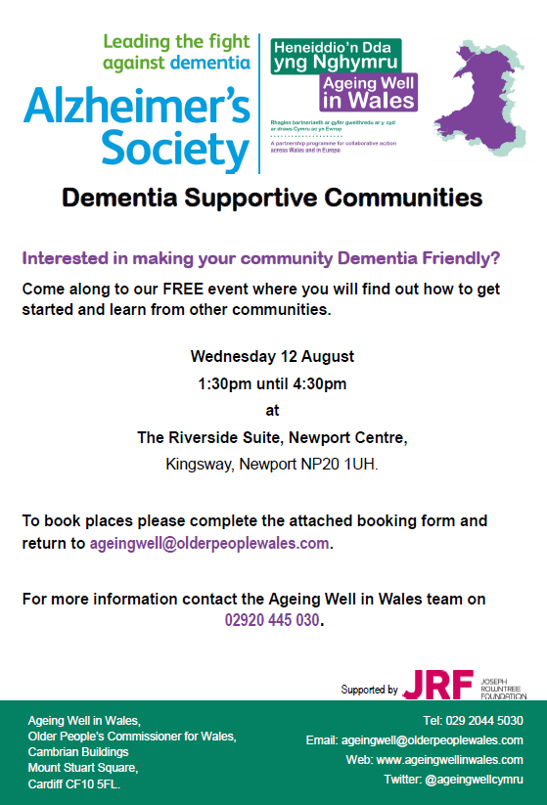

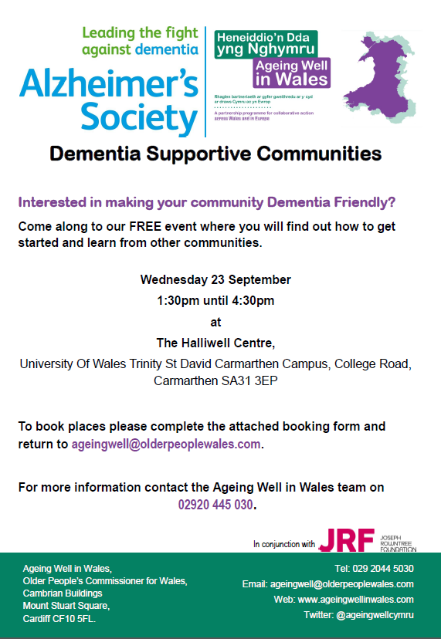

**Show Racism the Red Card – SRtRC’s Black & White Ball**



**Health & Safety of Migrant Workers – TUC Guide**

The TUC has produced a new guide on health and safety and migrant workers.

It is available on the TUC site at:

<https://www.tuc.org.uk/migrantworkershealthandsafety>

**EHRC Exchange Autumn Events**

**Equality and Human Rights Exchange Autumn Events**

As we come to the end of another school year and the holiday season kicks off in earnest EHRC wanted to give you some advanced notice of our forthcoming autumn events around “Is Wales Fairer?”

It’s been a very busy and interesting year, with two conferences over the last 6 weeks. The reports from Shaping the Future and Is Britain Fairer? will be available on their website over the summer.

EHRC are very much looking forward to seeing you at the autumn events.

**Swansea September   30th 2015**

**Caerphilly October      15th 2015**

**Bangor October          21st 2015**

Further details will follow in the coming weeks.

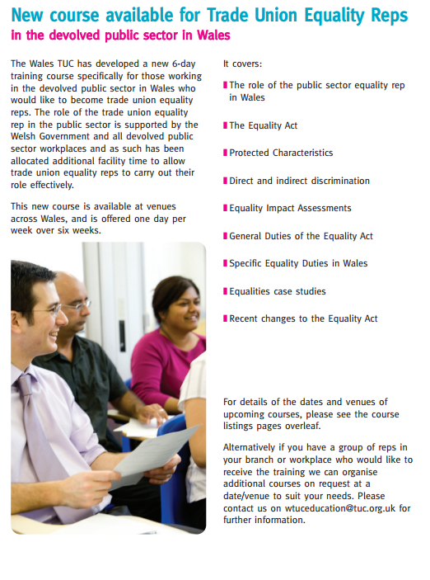

**Book Prescription Wales**

Book Prescription Wales is a scheme that aims to help people with mild to moderate emotional problems to make use of high quality self-help books that have been specially selected by psychologists and counsellors working in Wales.

You can find out more here:

<http://gov.wales/docs/dhss/publications/130815booken.pdf>

You can find the list of recommended books here:

<http://www.wales.nhs.uk/sitesplus/documents/888/current%20booklist.pdf>

**Trade Union Bill**

The government is introducing fundamental reforms to modernise trade union law. Reforms introduced by the Trade Union Bill will:

* ensure that strike action only ever takes place on the basis of clear and representative mandates, through new thresholds that strike ballots must meet
* improve transparency and oversight of trade unions
* require reasonable notice of strike action, and give employers greater chance to prepare for industrial action and put in place contingency plans

## Consultations

The government is consulting on a number of issues connected with the bill.

### [Ballot thresholds in important public services](https://www.gov.uk/government/consultations/ballot-thresholds-in-important-public-services)

* + 15 July 2015
  + Open consultation

### [Hiring agency staff during strike action: reforming regulation](https://www.gov.uk/government/consultations/hiring-agency-staff-during-strike-action-reforming-regulation)

* + 15 July 2015
  + Open consultation

### [Tackling intimidation of non-striking workers](https://www.gov.uk/government/consultations/tackling-intimidation-of-non-striking-workers)

* + 15 July 2015
  + Open consultation

**Government Consultation – Closing the Gender Pay Gap**

## [Closing the Gender Pay Gap - Government Consultation](https://www.gov.uk/government/uploads/system/uploads/attachment_data/file/444716/Gender_Pay_Gap_Consultation.pdf)

# Consultation description

This consultation seeks views on the Government’s manifesto commitment to require larger employers to publish gender pay information. These regulations will cover private and voluntary sector employers in England, Scotland and Wales with at least 250 employees.

The consultation also seeks views on wider action that can be taken to inspire girls and young women, modernise workplaces and support older working women.

The Government Equalities Office commissioned [research](https://www.gov.uk/government/publications/company-reporting-gender-pay-data) into the extent to which employers across Great Britain with 150 or more staff collect, report and publish data on pay by gender, and into the awareness and impact of the [Think, Act, Report scheme](https://www.gov.uk/think-act-report).

PDF, 381KB, 35 pages

<https://www.gov.uk/government/uploads/system/uploads/attachment_data/file/444716/Gender_Pay_Gap_Consultation.pdf>

## This file may not be suitable for users of assistive technology.

If you use assistive technology and need a version of this document in a more accessible format, please email [enquiries@culture.gov.uk](mailto:enquiries@culture.gov.uk?body=Details%20of%20document%20required%3A%0A%0A%20%20Title%3A%20Closing%20the%20Gender%20Pay%20Gap%20-%20Government%20Consultation%0A%20%20Original%20format%3A%20pdf%0A%0APlease%20tell%20us%3A%0A%0A%20%201.%20What%20makes%20this%20format%20unsuitable%20for%20you%3F%0A%20%202.%20What%20format%20you%20would%20prefer%3F%0A%20%20%20%20%20%20&subject=Request%20for%20%27Closing%20the%20Gender%20Pay%20Gap%20-%20Government%20Consultation%27%20in%20an%20alternative%20format). Please tell us what format you need. It will help us if you say what assistive technology you use.

**WG Consultation – Furthering Equality for Transgender People**

[Welsh Government action plan to further equality for transgender people](http://gov.wales/consultations/people-and-communities/equality-transgender-people-consultation/?status=open&lang=en)

The purpose of this consultation is to seek views on the Welsh Government’s Transgender Action Plan. We want to identify and address areas of discrimination, improve access to public services and tackle social stigmatisation, harassment and bullying for transgender people in Wales.

**Please submit your comments by 11 September 2015**