**Wales TUC - April 2015 – Issue 19**

**All Wales Trade Union Equality Network Newsletter**

Another packed edition of the All Wales Equality Network Newsletter, this edition gives details of meetings, FREE Wales TUC run courses on becoming a Trade Union Equality Rep along with the most recent updates, news articles and much more.  If you would like your news to appear in future editions of this newsletter please email Nicola Savage at[**nsavage@tuc.org.uk**](mailto:nsavage@tuc.org.uk)

**Sign up to the All Wales Equality Network Newsletter** [**here**](http://eepurl.com/CxcgP)

**Dates of next All Wales Equality Network Meetings**

If you would like to join the **All Wales Equality Network** and meet, network and learn from Trade Union Equality Reps from across the Private and Public sectors in Wales join us at one of the meetings below.  The network is open to union members who have an interest in Equality and those who wish to become Trade Union Equality Reps in Wales.

Please email Nicola Savage at [**nsavage@tuc.org.uk**](mailto:nsavage@tuc.org.uk)

# Joint meetings - Networks of Excellence July 2015

Joint meetings of the Networks of Excellence and All Wales Equality Network meetings.

These will be all day events and will include speakers, interactive workshops and workplace action planning.....

Merthyr - Tuesday 7th July 2015 - Theatre Soar, Pontmorlais West CF47 8UB

Brecon - Wednesday 8th July 2015 – The Leisure Centre, Penlan, Brecon, Powys LD3 9SR

Wrexham - Wednesday 16th September - Venue TBC

Further information and an Agenda to follow

**Registration information is to be confirmed.  Watch this space!**

# All Wales Network Equality meetings October 2015

**October 2015**

Llandudno – Friday 16th October 2015

1030-1300 Venue Cymru, The Promenade, Llandudno, Conwy LL30 1BB

Aberystwyth – Monday 19th October 2015

1400-1630 National Library, Penglais Road, Aberystwyth, Ceredigion SY23 3BU

Cardiff - Wednesday 21st October 2015

1030-1300 Unite House, Cathedral Road, Cardiff CF11 9SD

# All Wales Network Equality meetings January 2016

**January 2016**

Swansea - Wednesday 20th January 2016

1030-1300 Unite the Union, High St, Swansea SA1 1LF

Colwyn Bay – Thursday 21st January 2016

1030-1300 Coleg Llandrillo. Llandudno Road, Rhos on Sea, Colwyn Bay LL28 4HZ

Aberystwyth – Friday 22nd January 2016

1030-1300 National Library, Penglais Road, Aberystwyth, Ceredigion SY23 3BU

**Email** [**nsavage@tuc.org.uk**](mailto:nsavage@tuc.org.uk) **if you or any of your colleagues would like to attend any of the above All Wales Network Equality meetings.**

**TUC e-notes**

## TUC Education eNotes



eNotes are a great resource to help reps keep up to date on key workplace issues. Each eNote is a self-contained module that contains a mixture of text, video and quizzes. They last between 20 and 45 minutes and can be returned to as many times as you like.

* **NEW:**Fit for Work
* Industrial Partnerships
* Work-related Upper Limb Disorders
* Domestic Violence
* Building a Stronger Workplace Union
* Facility Time
* Bargaining for Skills
* A Living Wage
* Apprenticeships
* Equality Law
* Supporting Mid-life development
* Additional Paternity Leave
* Understanding Universal Credit
* Climbing Frame
* Supporting Learners
* Vulnerable Employment
* The Sick Note
* European Works Councils

**More info here:** [**http://bit.ly/1zonfJ2**](http://bit.ly/1zonfJ2)

**Become a Trade Union Equality Rep**

**Free courses available now**

These are the latest courses available for those who would like to become a Trade Union Equality Rep.  This is a FREE course and it’s interesting, inspiring and will help you to make a difference at work.  It’s also a great learning opportunity for you and you will be supported in your new role by the Wales TUC and by your union.  Give it a go!

**Devolved Public Sector in Wales**

The Wales TUC has developed a new 6-day training course specifically for those working in the devolved public sector in Wales who would like to become trade union equality reps. The role of the trade union equality

rep in the public sector is supported by the Welsh Government and all devolved public sector workplaces and as such has been allocated additional facility time to allow trade union equality reps to carry out their role effectively. This new course is available at venues across Wales, and is offered one day per week over six weeks.

**\*\*Courses can be tailored for non-devolved, private and third sector organisations\*\***

**Newport**

**Applications to:** John James**,** Trade Union Studies Centre, Coleg Gwent, City of Newport Campus, Nash Road, Newport NP19 4TS

**Tel:** 01633 466061 or 01633 466 136

**Email:** [**tuc@coleggwent.ac.uk**](mailto:tuc@coleggwent.ac.uk)

**Venue:** Trade Union Studies Centre, Coleg Gwent, City of Newport Campus,

Nash Road, Newport NP19 4TS

**Hours:  Day courses:** 9 am to 5 pm**Evening courses:** 6 pm to 8 pm

|  |  |  |
| --- | --- | --- |
| **Summer Term 2015** | | |
| **Course title** | **Start date (DD/MM/YY)** | **Duration** |
| Equality Reps (in the devolved public sector in Wales) | 13/04/2015 | 6 Mondays  from 13th April 2015 |

**Wrexham**

**Course Co-ordinator**: Tudur Evans WEA Cymru - Workplace Learning, Bryn Menai, Ffordd Caergybi,

Bangor LL57 2JA

Tel: 01248 363948

Email: [tudur.evans@weacymru.org.uk](mailto:tudur.evans@weacymru.org.uk)

Applications to: [workplace@weacymru.org.uk](mailto:workplace@weacymru.org.uk)

**Venue:** The Memorial Centre, Quarry Road, Brynteg, LL11 6AB

**Hours:** 9.15 am to 4.45 pm

|  |  |  |
| --- | --- | --- |
| **Summer Term 2015** | | |
| **Course title** | **Start date (DD/MM/YY)** | **Duration** |
| Equality Reps (in the devolved public sector in Wales) | 16/04/2015 | 6 Thursdays  from 16th April 2015 |

**Consultation documents**

## [Welsh Government Draft Equality Objectives for 2016-2020](http://gov.wales/consultations/people-and-communities/draft-equality-objectives-2016-2020-consultation/?lang=en)

**[This twelve week consultation seeks views on what should be the Welsh Government’s Equality Objectives to be included in its Strategic Equality Plan 2012-16.](http://gov.wales/consultations/people-and-communities/draft-equality-objectives-2016-2020-consultation/?lang=en)**

Welsh Government will be running workshops in their offices across Wales during the consultation period.  Dates and venues are listed below.  If you would like to attend please get in touch by using the booking form via the link above.

Spaces are limited and will be allocated on a first come basis.

* 27 May – Conference room 6, Cathays Park, Cardiff
* 9 June – Rhufoniog A1.21, Llandudno Junction
* 15 June – Conference room 6, Cathays Park, Cardiff
* 19 June – Cothi, Penllergaer, Swansea

**Please submit your comments by 10 July 2015**

**Gender-based Violence, Domestic Abuse and Sexual Violence (Wales) Bill**

#### Violence against Women, Domestic Abuse and Sexual Violence (Wales) Bill

On 10 March 2015, the Violence against Women, Domestic Abuse and Sexual Violence (Wales) Bill was approved. The legislation aims to improve the Public Sector response in Wales to such abuse and violence and was subject to rigorous scrutiny through the legislative process.

The Bill will amongst other things:

* Improved arrangements to promote awareness of, and to prevent, protect and support victims of gender-based violence, domestic abuse and sexual violence;
* Introduce a needs–based approach to developing strategies which will ensure strong strategic direction and strengthened accountability.
* Ensure strategic level ownership, through the appointment of a Ministerial Adviser who will have a role in advising Welsh Ministers and improving joint working amongst agencies across this sector.
* Improve consistency, quality and join-up of service provision in Wales.

For further information and progress on the Bill please visit the [**National Assembly for Wales**](http://www.senedd.assemblywales.org/mgIssueHistoryHome.aspx?IId=10028&AIID=17668) (External link)

For further information please visit the [National Assembly for Wales](http://www.senedd.assemblywales.org/mgIssueHistoryHome.aspx?IId=10028&AIID=17668)

## [Violence against Women, Domestic Abuse and Sexual Violence (Wales) Bill](http://www.senedd.assembly.wales/mgIssueHistoryHome.aspx?IId=10028&AIID=17668)

**Domestic Abuse**

16% of men in England and Wales will be victims of domestic abuse at some point in their lives. The Live Fear Free video highlights one of the biggest challenges facing male victims — admitting there is a problem and finding the courage to talk about it.

If you or anyone you know are experiencing domestic abuse, please call the free, confidential helpline now on 0808 80 10 800.

<http://livefearfree.org.uk/Themes/Male-domestic-abuse/?lang=en>

**Find your Credit union**

Several unions have credit unions but if your union doesn’t, find out where your nearest credit union is here:

<http://www.findyourcreditunion.co.uk/home>

Don’t keep it to yourself; let your members, colleagues, friends and family know about the advantages of a credit union.

Credit unions are authorised by the Prudential Regulation Authority, regulated by the Financial Conduct Authority and Prudential Regulation Authority. All deposits in credit unions are protected by the Financial Services Compensation Scheme up to £85,000.

**WAVE Wales - Check out the Equal Pay Barometer**

Men’s annual average earnings are £22,921 but women’s are only £16,412. This is because so many women work part time and this work is concentrated in low paying jobs.

This simple barometer, based on a labour market survey in Wales will show you the jobs that men and women do in employment and self employment whether full or part time, and how much they get paid for it.

Visit the @WAVEWales @CUWave Equal Pay Barometer to see what men and women earn in the jobs they do <http://ow.ly/BEiFU> #letstalkaboutpay

**Public Health Wales launches information for transgender community**

Public Health Wales has launched information resources on screening services specifically for the transgender community. The resources include a leaflet, frequently asked questions, a series of short films and an information card. These were produced in partnership between the Screening Division of Public Health Wales, Transgender Awareness Wales, FTM Wales, Unique Transgender Network and the NHS Centre for Equality and Human Rights.

All of this information is available on the Screening for Life website [www.screeningforlife.wales.nhs.uk](http://www.screeningforlife.wales.nhs.uk).

**Shared Parental Leave**

Shared parental leave and pay applies to eligible employees whose babies are due on or after 5 April 2015. Under the regime, up to 50 weeks of leave and 37 weeks of pay can be shared between mothers and fathers, or with the mother’s partner, and parents can take the leave concurrently or consecutively, in single or multiple blocks. The existing maternity leave and pay scheme will continue to operate and in order to opt for shared parental leave; employees must issue a curtailment notice bringing their maternity (or adoption) leave to an end early.

The Acas [**good practice guide for employers and employees**](http://www.acas.org.uk/index.aspx?articleid=4911) addresses the process which employers should follow on receiving a notice to book shared parental leave.  It confirms that notifications for continuous leave cannot be refused and lists a number of considerations for employers when responding to a request for discontinuous leave, including the impact the leave arrangements may have on the business.

The Acas guidance also sets out advice for employers wishing to refuse a leave notification and looks at the application of the default provisions which, in certain circumstances, convert a discontinuous leave request into continuous leave, beginning on the date the requested discontinuous leave would have started. *Source: CIPD / Acas*

**Cardiff Womens Aid**



**Union Learning Reps – Network dates**

ULR Network Dates

*Save the date!*

Tuesday 7 July Merthyr Tydfil

Wednesday 8 July Brecon

Friday 10 July Carmarthen

Tuesday 14 July Swansea

Wednesday 15 July Colwyn Bay

The theme for the July meetings will be Equality and Learning. Equality Reps will be invited to join with ULRs in particular at the Merthyr, Brecon and Colwyn Bay meetings.

Come along and find out how to make learning accessible to all. Book your place contact Bernice [Bwaugh@tuc.org.uk](mailto:Bwaugh@tuc.org.uk)



**Looking for a Board position?**

**What are public appointments?**

Our public bodies need board members who reflect Welsh society - people from all walks of life. Public appointments are usually for members of committees which advise, monitor and take decisions on public services across Wales, both locally and nationally.

You can apply to organisations that include:

* public bodies, eg Arts Council of Wales, National Museum Wales
* regulatory bodies, eg Care Council for Wales, General Teaching Council for Wales
* advisory and specialist bodies, eg Advisory Panel on Substance Misuse, Welsh Food Advisory Committee

You could help run these organisations and offer advice, drawing on your own experience. Some positions are unpaid, but most will cover your expenses.

Some appointments processes are regulated by the [Commissioner for Public Appointments](http://publicappointmentscommissioner.independent.gov.uk/).

**Anyone can apply:** [**Public Appointments – Welsh Government**](https://cymru-wales.tal.net/vx/lang-en-GB/mobile-0/appcentre-3/brand-2/candidate/jobboard/vacancy/7/adv/)

The Welsh Government acknowledges the importance of developing and growing bilingual capabilities in public appointments in Wales, and welcomes applications from candidates who demonstrate their capability to work in both English and Welsh.

The Welsh Government believe public bodies should have board members who reflect Welsh society - people from all walks of life - to help them understand people's needs and make better decisions.

That is why the Welsh Government is committed to increasing diversity and encourages applications from Lesbian, Gay, Bisexual and Transgender, Black Minority Ethnic, Women and Disabled people.

**Shelter – Work it out Project**

The Work it Out project promotes housing and debt advice information to people who **are in employment** and who would not normally seek assistance through traditional advice routes, thus preventing homelessness and raising understanding of the issues.

We are offering this service because:

* People in employment are least likely to be connected into a network of support or help services in the same way as are care leavers, single parents and people with disabilities.
* Given the reduction in public spending in Wales and the full impact of welfare reform on individuals it is likely that as more people face changes in their working conditions, the need for independent information and advice will be increased.

Free, expert housing advice, tools and downloads

If you have an urgent housing problem call 0845 075 5005.

If your problem is not urgent, browse the website, <http://www.sheltercymru.org.uk/get-advice/get-advice-online/> which contains information on a huge range of housing related issues. If you need more help, you can email us your enquiry.

Information can go on the workplace intranet and/or newsletters. Leaflets can be posted to ULRs for distribution (free).

Llion Bevan [llionb@sheltercymru.org.uk](mailto:llionb@sheltercymru.org.uk) 01792 469400

**Mental Health First Aid**

**Mental Health First Aid training 'for everyone'**

Front line workers particularly often have to deal with people with experience of mental distress but lack the skills and confidence to support them appropriately.   
  
With **1 in 4** of us affected by mental health problems each year, people across Wales are being offered a short training course to deal more effectively with these challenges. In an ambitious project, funded by the Welsh Assembly Government, The 12 hour course does not train you to be a therapist, counsellor or mental health professional but it will teach you to:

* Give initial help to someone experiencing a mental health problem
* Deal with a crisis situation or the first signs of someone developing mental ill-health.
* Guide people towards appropriate help.

**Future - MHFA 2 Day Course Dates 2015**

Cardiff – May **7th and 8th** - Transport House, 1, Cathedral Road, Cardiff CF11 9HA

North Wales – May **26th 27th** 64, Chester Street, Flint CH6 5DH,

Swansea – June **15th 16th** 19 High Street Swansea, SA1 1LF

Cardiff – June **29th 30th** **Venue to be confirmed**

North Wales – July **16th 17th** 64, Chester Street, Flintshire CH6 5DH,

**Please Note:**

**If anyone has a venue to hire for the June (Cardiff) event please call:**

**Sue Carlick on 0790 334 3997**

# Wales TUC - Mental health and work

Gofal has been working with the Wales TUC to develop a workers' guide to mental health and wellbeing. This was launched at the Wales TUC Equalities Conference in April 2014 and distributed to trade union equality representatives from a range of organisations. The booklet is available in [English](http://www.gofal.org.uk/uploads/Policy_documents/Wales_TUC/Gofal_Wales_TUC_-_info_booklet_-_Eng_-_web.pdf) and in [Welsh](http://www.gofal.org.uk/uploads/Policy_documents/Wales_TUC/Gofal_Wales_TUC_-_info_booklet_-_Cym_-_web.pdf).

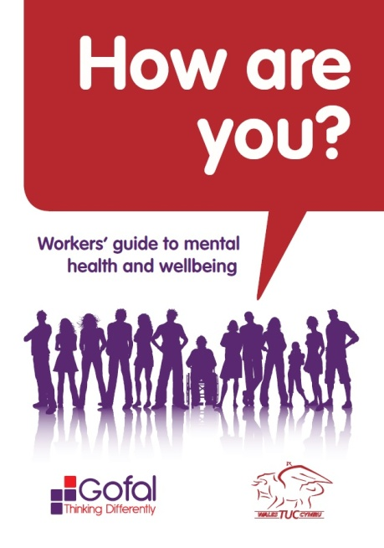     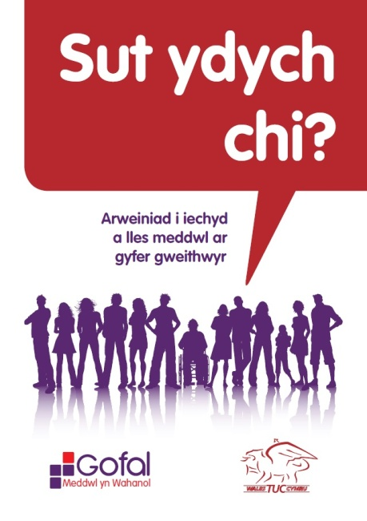[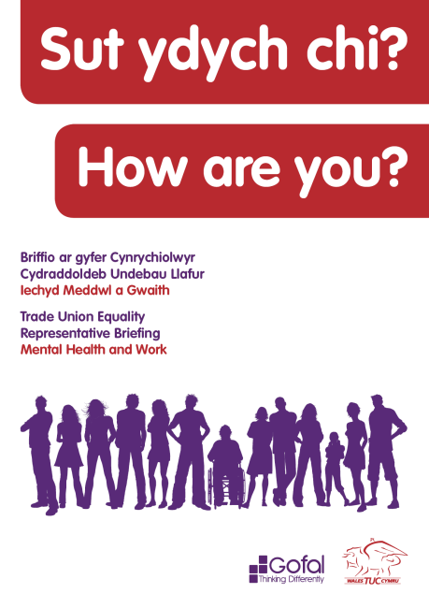](http://www.gofal.org.uk/uploads/Policy_documents/Wales_TUC/Gofal_Wales_TUC_toolkit_-_Eng_-_WEB.pdf)

In September 2014 at the Wales TUC mental health conferences in north and south Wales we launched a comprehensive mental health briefing for trade union representatives.

The toolkit was developed by Gofal in partnership with the Wales TUC and there were several opportunities for trade union representative to feed into this process.

It provides information about mental health, talking tips and how to access help and support. It also includes a number of tools to help trade union reps to improve mental health and wellbeing in the workplace.

The briefing is available in [English](http://www.gofal.org.uk/uploads/Policy_documents/Wales_TUC/Gofal_Wales_TUC_toolkit_-_Eng_-_WEB.pdf) and in [Welsh](http://www.gofal.org.uk/uploads/Policy_documents/Wales_TUC/Gofal_Wales_TUC_toolkit_-_Cym_-_WEB.pdf).

**World Mental Health Day 10th October 2015**

## "Dignity in Mental Health" is the theme for this year's World Mental Health Day, which takes place on 10 October 2015.

## The annual event is focused on global mental health education, awareness and advocacy and we'll soon be announcing a full programme of activities and support.

<http://www.mentalhealth.org.uk/our-work/world-mental-health-day/world-mental-health-day-2015/>

**Courses**

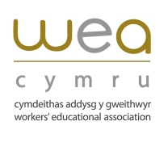

*Workplace Learning – New Course – Now Recruiting For…*

Managing Workplace Stress using Mindfulness Techniques

*Venue:*   WEA Cymru Office,  9 Coopers Yard,  Curran Road,  Cardiff CF10 5NB

*Day & times:*   Wednesday 20th May 2015  9.30am – 4pm

The course will look at:

* Definitions of stress     **\*** Positive and negative stress
* Symptoms: cognitive, physiological, behavioural and emotional
* Issues of control and balance       **\*** Recognising stress in others
* Getting perspective on your life      **\*** Building relaxation into your day
* Looking at Mindfulness Techniques

To enrol please contact:  [William.powell@weacymru.org.uk](mailto:William.powell@weacymru.org.uk)  *tel*: 01495 369869

Course fees: £30 per person  Teas/coffees available (sorry no lunch provided)

***If your workplace is covered by a WULF project you may be eligible for help with course fees.***

‘***On Balance’ Diversifying Democracy in Local Government***, the Diversity in Democracy Project

In response to the Report of the Expert Group ‘***On Balance’ Diversifying Democracy in Local Government***, the Diversity in Democracy Project has been developed with an aim to increasing the diversity of candidates standing at the next local government elections in 2017.

The Diversity in Democracy programme will provide a mentoring, shadowing and training opportunity for people from under-represented groups in Wales for a period of 12 months.

Mentees will be provided with the skills and confidence to stand for election through a programme of one-to-one mentoring with Councillors, and shadowing opportunities with Council Officers.

Anyone over the age of 18 with UK residency, can be a Councillor, whether you work full or part-time, are unemployed or in education.

We are looking for people from across Wales who are interested in working within their community to make a positive difference to the lives of local people.

If you have a keen interest in community issues, along with a passion to represent the views and opinions of individuals, you may be just the person we are looking for!

The Mentoring Programme will begin in July 2015 and is expected to run for a minimum of twelve months.

For further information, click on the following link [**www.gov.wales/diversityindemocracy**](http://www.gov.wales/diversityindemocracy) where you will find various documents, including a guide to Mentoring and a Mentee Application Form, which you can download or complete online.

If you would like an informal discussion regarding the Programme and/or the role of Mentee, please contact Project Co-ordinator, [catherine.kennedy@wales.gsi.gov.uk](mailto:catherine.kennedy@wales.gsi.gov.uk) 02920 801048.

**Cross Party Group on   
Women in the Economy**

**Christine Chapman AM cordially invites you to**

**Who Cares?**

This session will explore caring roles in the family and discuss how workplaces can better support those with caring responsibilities.

Topics will include work-life balance, parental roles and the new shared parental leave legislation.

Carers Wales will join the group to talk about how best to support carers in the workplace and we will be joined by a number of individuals who will share their personal experiences.

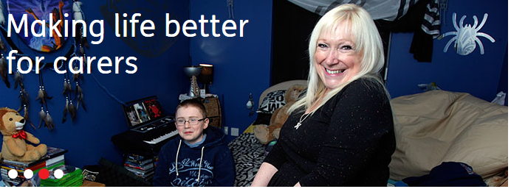 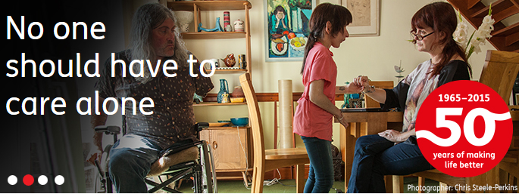

Wednesday, 3rd June 2015

12.15 – 13.30 pm

(Sandwiches will be provided from 12.15 pm)

Conference Room 24, Ty Hywel

Join us to take action on women’s equality in Welsh workplaces

RSVP to Anne Howells at [anne.howells@chwaraeteg.com](mailto:anne.howells@chwaraeteg.com)



 **Shaping the Future   
Equality and Human Rights Exchange Conference June 10th 2015**

**Llandrindod Wells**

**Keynote Speakers:**

Dr. Helen Mott, University of West England and Bristol Fawcett Society will set out her approach to equality and human rights impact assessments.

Sue Bent, Directory Coventry Law Centre will share her experiences of using impact assessments to secure the future of the Law Centre

Kate Clayton-Hathway, Oxford Brookes University asks 'Is the Public Sector Equality Duty making a difference to peoples lives?'

Dr. Kristi Long, NHS Education Scotland will talk about her work to implement the Public Sector Equality Duty in Scotland

**This conference will:**

* explore new approaches to equality, human rights and social justice impact assessments
* consider how impact assessments can lead to positive outcomes
* increase your understanding of how decisions may impact on people
* help you to challenge discrimination and human rights abuses
* help you to protect and promote equality and human rights
* share successful ways to drive change

Attendance at the conference is free. If you would like to reserve a place please download our online form [*here*](https://www.equalityhumanrights.com/about-us/devolved-authorities/commission-wales/equality-and-human-rights-exchange/conference-2015-shaping-future) and email it to us at

[**wales@equalityhumanrights.com**](mailto:wales@equalityhumanrights.com)

If you have any questions or would like to discuss the conference please contact us on **02920 447710.**

**Welsh Women’s Aid**

**Good Practice on delivering Whole Education Approaches to preventing violence against women, domestic abuse and sexual Violence**

 Welsh Women’s Aid has been asked by the Welsh Government to develop a Good Practice Guide on a Whole Education Approach to violence against women, domestic abuse and sexual violence, which will support the Violence against Women, Domestic Abuse and Sexual Violence (Wales) Act 2015.

To inform this guide, Welsh Women’s Aid is gathering examples of emerging or good practice on each element of what's needed to deliver a whole education approach, either from within Wales or from further afield.

*Consultation link:* [***https://www.surveymonkey.com/r/8RDBW2M***](https://www.surveymonkey.com/r/8RDBW2M)

The key aims required from the Good Practice Guide are to:

·         Provide a practical guide for schools and Higher Education/Further Education establishments on how to develop and successfully deliver a whole education approach to promoting gender equality and respect and challenging violence against women, domestic abuse and sexual violence;

·         Outline the rationale for and key elements of the whole education approach; and

·         Identify examples of effective practice already being delivered in Wales and beyond, with reference to specific case studies.

We want to hear from you if you:

·         Attend school, college or university, if you work in education or specialist services, or if you coordinate or fund services locally; **and**

·         You know of, deliver, or have experience of, good practice in education on this issue, that others can learn from.

For the purposes of this guide, we define the term Whole Education Approach as:

*‘Whole-school approaches seek to strategically connect the key components of the school, which will increase the likelihood of prevention becoming embedded across the institution. A whole-school approach can be understood as working across the school community - with students, school staff, parents and the wider community, as well as integrating a focus on violence against women and girls across the school.’* (AVA Digital Prevention Platform, [**www.perventionplatform.co.uk**](http://www.perventionplatform.co.uk/)) We are also including Further Education and Higher Education within, extending the definition above into a whole education approach.

We would be grateful if you could please take a moment to answer the consultation questions.

Please follow this link to take part in the consultation: [**https://www.surveymonkey.com/r/8RDBW2M**](https://www.surveymonkey.com/r/8RDBW2M)

This consultation will close on the **15th of May 2015**.

If you have any comments or questions about this consultation, please contact Tina Reece at Welsh Women’s Aid on [**tinareece@welshwomensaid.org.uk**](mailto:tinareece@welshwomensaid.org.uk) or 02920 541 551.

[](http://unionlearn.us7.list-manage.com/track/click?u=ebd004a8047907dc47d269fd1&id=68f9a6096a&e=4525de02d2)

**Ageing workforce survey**

The TUC is a partner in a study into what makes a great place to work. This will include looking at any major differences between different demographic groups, such as age groups. We would very much appreciate your views and attitudes for supporting an ageing workforce.  
  
Unions have played an instrumental part in supporting equal opportunities and supporting mid-life development and your contribution is vital to the success of this research.  
  
Please would you take 5-10 minutes to complete the following on-line survey [https://www.mercerhcsurveys.com/uc/2015tucstudy](http://unionlearn.us7.list-manage.com/track/click?u=ebd004a8047907dc47d269fd1&id=8af4c56e60&e=4525de02d2)  
  
The survey has 25 questions. It is important that we are able to demonstrate our value to this agenda so we would be grateful if you would share this link with your workplace and union colleagues.  
  
By completing the survey your organisation will be contributing to insights on:

Workplace policies and practices that characterise a desirable workplace

Potential differences between different demographic groups, such as age, gender and ethnicity

By participating in this research, you will receive a copy of the summary report, as well as an invitation to participate in a webinar and local events to discuss the results.  
  
All information will be summarised and results will be consolidated so that individual responses remain anonymised . Thank you in advance for your support!  
  
**This survey will close on 8 May 2015.**

**Women’s Equality Now: The Position in Wales Today**06/05/2015  
  
12.00 – 13.00   
  
The Senedd  
  
Sponsored by the Presiding Officer Dame Rosemary Butler AM   
  
The Presiding Officer has the pleasure of inviting you to attend the launch of the WEN Wales ‘Women’s Equality Now’ research briefing series at the Senedd. The briefings will address the following topics:

Diverse Women

Women and Unpaid Care

Economic Violence

What Devolution Didn’t Do

Cydraddoldeb Menywod Nawr: Y Sefyllfa yng Nghymru Heddiw   
  
06/05/2015  
  
12.00 – 13.00   
  
Y Senedd  
  
Cefnogir gan y Swyddog Llywyddu, Y Fonesig Rosemary Butler AC   
  
Mae’n bleser gan y Swyddog Llywyddu eich gwahodd i lansiad cyfres  sesiynau briffio ymchwil ‘Cydraddoldeb Menywod Nawr’ RhCM Cymru yn y Senedd. Bydd y sesiynau briffio’n ymdrin â’r pynciau canlynol:

Menywod Amrywiol

Menywod a Gofal Di-dâl

Trais Economaidd

Yr Hyn Na Wnaeth Datganoli

**Refreshments will be provided   
Please RSVP by visiting our** [**Eventbrite**](http://wenwales.us8.list-manage1.com/track/click?u=6e5ee9551ab72b3e504505e3f&id=f46382758f&e=590743fdc9) **page**

**Womens Voices – The Pierhead, Cardiff Bay**

**20th May 2015 0930 - 1600**

A Wales TUC event **- sponsored by Jane Hutt AM Minister for Finance and Government Business** - looking at women’s voices – how women gain influence and get their stories heard, women as leaders, women in public life and how to go about building effective networks.

The aim of the day is to bring together key women trade unionists, politicians and academics to discuss how women can progress, influence and lead in their organisations. We will also discuss how we sustain and improve on the recognition, representation and rights that women have already fought for and won. During the morning we will be joined by:

* Frances O'Grady - General Secretary, TUC
* Jane Hutt AM - Minister for Finance and Government Business
* Professor Judi Marshall
* Dame Rosemary Butler AM - Presiding Officer, National Assembly for Wales
* Margaret Thomas - Wales Secretary, UNISON Cymru
* Sheila Bearcroft - President, Wales TUC Cymru

The afternoon will provide an opportunity for delegates to develop their skills and networks in workshop sessions as follows:

* Interacting with Welsh Government - facilitator TBC
* Leadership with Mindfulness (walking workshop) - Pam Heneberry (The Professional Development Centre)
* Career Women Wales workshop (NLP) - Sarah Rees (Career Women Wales)
* First Aid for Self Confidence - Gwenno Dafydd

The day will be relaxed, informative, interactive and an excellent opportunity to extend your networks. Refreshments and lunch will be provided. During lunch there will be an opportunity to enjoy live music from renowned Cardiff singer Adriana Blue.

This event is aimed at women trade unionists. We are only able to offer places to those living or working in Wales. The Wales TUC reserves the right to cancel or amend any reservations at its discretion.

Tickets for this event are offered free of charge. The Wales TUC cannot provide travel expenses for attendees. Please speak to your own union in advance to confirm if they are able to help with these costs (prior authorisation of attendance by your own union will usually be needed before any costs can be claimed). You should also speak to your union if you need advice about getting time off to attend. **Please note, PCS union requires all PCS reps to check with Jayne Smith (PCS Regional Office) to obtain authorisation before applying for any TUC courses or events.**

**Please feel free to register, or to cascade to your members.**

**You can register here:** [**http://bit.ly/1DBptzV**](http://bit.ly/1DBptzV)