ASLEF Monitoring form
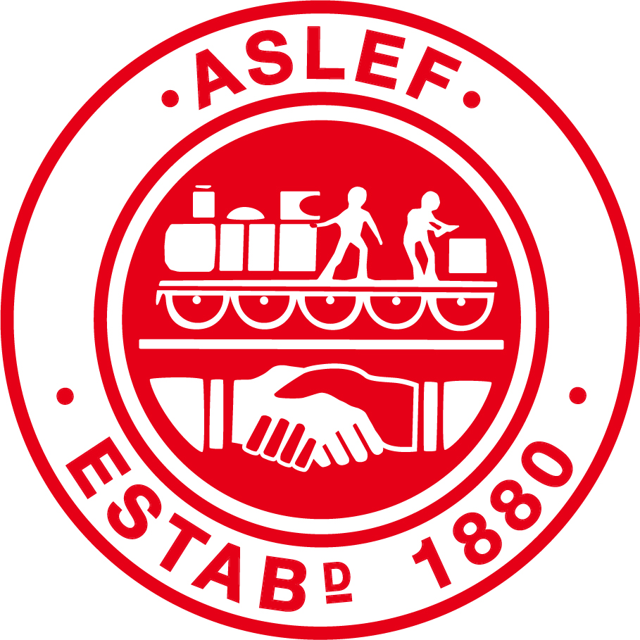

Name of Post :
This information is confidential. It is not linked with your name in anyway, and is not part of the selection process.
ASLEF offers equal opportunities to candidates for employment and to existing staff members in respect of recruitment, training and promotion. We seek to attract a diverse pool of talent and experience and promote an inclusive environment where individual differences are respected and the unique contributions of all staff are valued. To ensure equality of opportunity in our selection procedures we need to check that we are attracting and selecting applicants from all sections of the community, and that we do not discriminate.

RACE AND ETHNICITY
Please look at the descriptions of race and ethnicity listed below and select the one that most accurately describes you.
White – English/Welsh/Scottish/Northern Irish/ British / Irish |  | Black, African, Caribbean or Black British
Romany Gypsy or Irish Traveller |  | Black - other
White – other |  | Dual heritage ; Mixed / multiple ethnic background
Asian or Asian British – Indian / Pakistani / Bangladeshi / Chinese |  | Other ethnic group
Asian - other |  | Prefer not to say

GENDER
Do you identify as | Male |  | Female |  | Other
Is the gender you identify with the same as your gender registered at birth? | Yes |  | No |  | Prefer not to say

SEXUAL ORIENTATION
Do you identify as | Heterosexual: |  | Gay/Lesbian: |  | Bisexual: |  | Other:

DISABILITY
Do you consider that you have a disability? |  |  |  |  |  | YES |  | NO
AGE
 | How old are you?

ADVERTISING
How did you become aware of this vacancy?

