Speakers at Safety Reps Connect Cymru
 | Shelly Asquith, Health and Safety Policy Officer – TUC  Shelly has been responsible for unions' response to Covid, ran a campaign to change the law on maximum workplace temperatures, and works with unions and campaigners for asbestos removal as Chair of the Joint Unions Asbestos Committee.
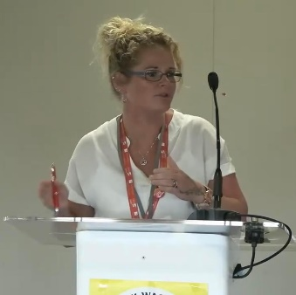 | Vicky Bassett, Health and Safety Rep, BFAWU  Vicky currently sits on the health and safety committee for the Bakers Food and Allied Workers Union (BFAWU) and is a health and safety advisor for Greggs.
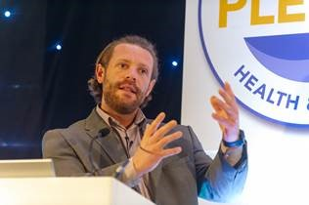 | Luke Collins, National Health and Safety Advisor, Unite  Luke Collins joined Unite the Union in January 2023 as National Health and Safety Advisor. Luke is responsible for supporting the manufacturing, steel, aerospace/shipbuilding, foundry and automotive sectors amongst others.  Luke has served as a Unite health and safety representative for several years before entering Occupational Health and Safety Management as a professional.
Julie Cook, National Officer, TUC Cymru

Julie Cook is a National Officer at the TUC Cymru. She leads the Policy team, including a dedicated Officer for Equality, Digital Communication and Welsh Language team, the Trade Union Education team and TUC Cymru Governance.

She also deputises for the TUC Cymru General Secretary as required. Julie has worked for the organisation for many years and has held a variety of posts, including Education Officer for Wales. She was the lead Officer for negotiating the Wales Union Learning Fund, which celebrates its 25th year this year (her proudest achievement).
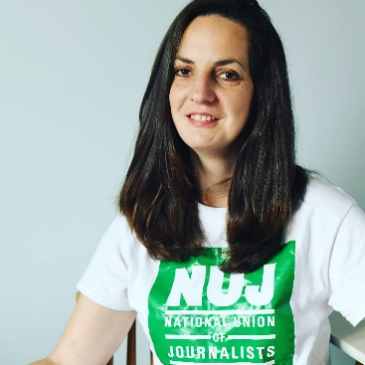 | Dr Natasha Hirst FRSA, NUJ  Dr Natasha Hirst is a freelance photojournalist. She is the president of the National Union of Journalists and is a Health and Safety rep, Equality rep and Union Learning Rep.
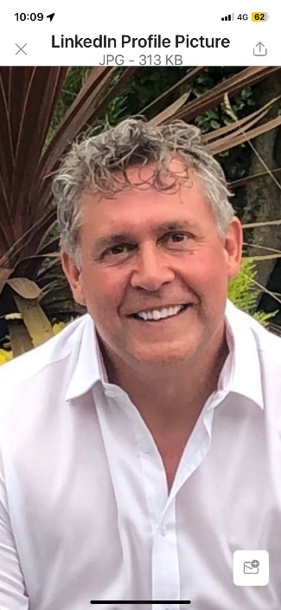 | Mike Jenkins, Chair of the TUC Cymru H & S and Workplace Regulation Committee  Mike has been a trade union lawyer and trade union member since 1992. He is a member of the TUC Cymru General Council and is Chair of TUC Cymru Health Safety & Workplace Regulation Committee.  Mike is also Chair of Unite Wales and Chair of the Unite Wales Health & Safety Committee.
 | Phil Liptrot, Head of Personal Injury, Thompsons Solicitors  Phil Liptrot is a distinguished personal injury specialist serving as the Head of Personal Injury at Thompsons Solicitors, based in Manchester. Qualifying as a solicitor in 1998, he is one of the country’s leading experts on personal injuries on at work, on the road or in other public places, particularly in complex cases where blame is contested.  His case portfolio includes handling matters involving head injuries, amputations, fatal accidents, multiple orthopaedic injuries, psychiatric issues, and chronic pain conditions.

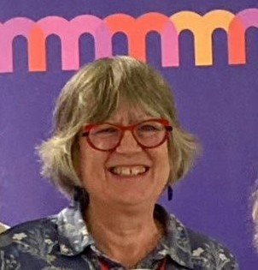 | Janet Newsham, Coordinator - Greater Manchester Hazards Campaign  Janet is responsible for Hazards, the UK wide network of resource centres and campaigners. The Hazards Campaign supports safety at work and has lead work challenging work-related injuries and diseases and has carried out a considerable body of research on safety practices.  Janet has been a trade union activist for more than 40 years, starting work at BAe. In her current role she advises workers and campaigns on occupational health, safety and welfare issues, including delivering a project on Toxic Use Reduction and facilitating TUCAN – Trade Union Clean Air Network.
 | Graham Petersen, Coordinator - Trade Union Clean Air Network (TUCAN)  Graham Petersen is a member of the Greener Jobs Alliance Steering Group which is a coalition of NGOs, trades unions and student organisations. The GJA has worked on a range of initiatives to promote green jobs and skills.  He has written a range of climate change publications for the British and Wales TUC and for his own trade union - the University and College Union. He was previously their Environment Co-ordinator. He has also represented Education International, the global union federation of over 30 million workers in the education sector, at UN climate conference events. He is a founding member of the Trade Union Clean Air Network (TUCAN) and wrote the air quality training modules and the union rep guidance on air pollution.
 | Chloe Rees, Organising and Development Officer, TUC Cymru  Chloe is an organising and development officer specialising in young workers across Wales. She has previously worked for Welsh Labour as an organiser. She has also worked as a senior researcher and communications officer for a Member of Senedd.  Chloe has advocated for more opportunities for women and marginalised communities in trade unions and politics, particularly the barriers associated with childcare and caring responsibilities.
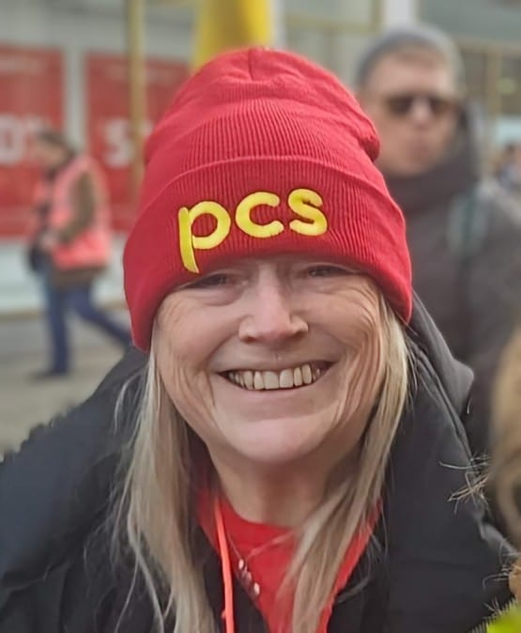 | Carol Revel, Health and Safety Rep and Group Safety Officer, PCS and Co-Chair of TUC Cymru H&S Reps Network  Carol has been a health and safety rep for the Public and Commercial Services (PCS) union for around 25 years. She has been the PCS DWP Group Safety Officer for 10 years and has served as an elected member of the DWP Group Executive Committee for 14 years. Carol has also been active as a trade union tutor, and a union learning rep and received an award from the TUC for her outstanding work as a ULR. Carol co-chairs the TUC Cymru health and safety reps’ network.  Carol has also been chair of Gingerbread, the lone parent charity, where she represented them on the Women’s National Commission, campaigning for improvements for lone parents. She has also recently undertaken additional green rep training and believes it’s important for green and health and safety reps to work together on addressing environmental issues.
 | Dan Shears, National Health, Safety and Environmental Director, GMB  Dan is the National Health, Safety and Environment Director for the GMB Trade Union, a position he has held since October 2015, having been employed by the union since January 2008. Before this he worked in a variety of operational and policy roles for the Health and Safety Executive.  As GMB is a general trade union, Dan provides advice and support to members in industries from the nuclear sector to education, and workplaces from chemical plants to casinos. He leads on HS&E policy development and stakeholder engagement for the union, and he is also responsible for internal health and safety management within GMB.  Dan has been a member of the UK Governments’ Industrial Industries Advisory Council since 2019. He is a member of the TUC’s Union Health and Safety Specialists Committee, and chair of the Asbestos Sub-Group for the TUC. He is a co-opted member of the TUC Cymru Health, Safety and Workplace Regulation Committee. He is also a member of the Ystadau Cymru Buildings Safety Sub-Group for the Welsh Government.
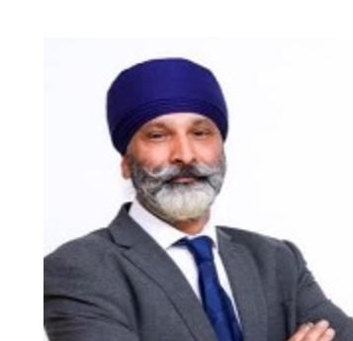 | Amarjite (AJ) Singh, Organising and Development Officer, TUC Cymru  Amarjite Singh (AJ) is an organising and development officer for TUC Cymru. AJ was employed by Royal Mail for over 35 years and was a Branch Secretary for 15 years.  He progressed through the ranks as a CWU rep. He represented CWU at Branch level, regional and on the CWU National Executive level. He also, represented CWU in the wider trade union movement from the TUC, Labour Party and European level.
 | Rebecca Sixsmith-Hughes – TUC  Rebecca leads the TUC’s project to find the movement’s next generation of workplace representatives.  Before joining the TUC, Rebecca was a Unite branch chair representing cabin crew for a major airline at Gatwick before becoming a full time official for UNISON.
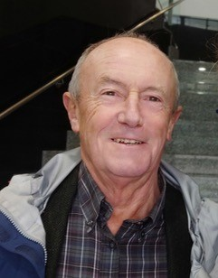 | David Walters, Emeritus Professor, School of Social Sciences - Cardiff University  David Walters is an Emeritus Professor at Cardiff University. Until 2019 when he retired, he was Professor of Work Environment in the School of Social Sciences at Cardiff. He has researched and written widely on social, political and economic relations of work health and safety and contributed to understandings of determinants of policies, practices and outcomes in this field.  David’s work began and continues to focus on the industrial relations of work health and safety, and he has a longstanding interest in the role of worker representation. He has studied health and safety regulation in the UK, other countries and globally., where his interests have included the consequences of fissured and fragmented work organisation, the responsibilities of the heads of supply chains and the challenges posed by micro and small firms, for arrangements to prevent harm to increasingly vulnerable workers in many sectors of employment
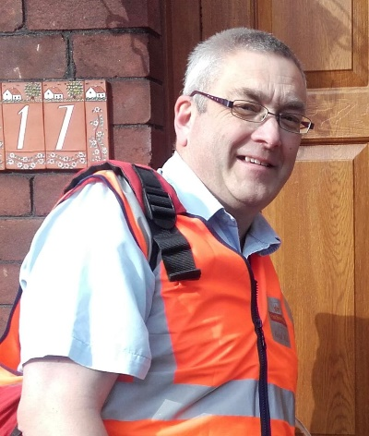 | Mark Williams, Acting Regional Secretary Wales and the Marches, CWU  Mark joined the CWU when he started working at Royal Mail in 1987. He was an office rep in the Port Talbot delivery office from 2008-2022 and was the branch political officer from 2014 to present, becoming branch chair in 2022. He acted was assistant regional secretary from 2014 – 2023 and became acting regional secretary in 2023. Mark also sits as a member of the TULO committee in Wales and as a TUC Cymru general council member.

