**Access statement – guidance**

*The following information has been put together based on advice and information from the conference venue and is an accurate statement of the current venue facilities to the best of our knowledge. If you have any access requirements, please contact the event organiser* [*jrees@tuc.org.uk*](mailto:jrees@tuc.org.uk) *029 2034 7011.*

**Cardiff City Stadium**

Venue address: Cardiff City Stadium, Leckwith Road, Cardiff CF11 8AZ

**Information about the wider surrounding area**

Cardiff City Stadium is located in the Leckwith area of Cardiff. The area is mostly flat and the stadium close to bus and train routes. The stadium is close to a main road and is accessible by car, bike and on foot. It just off the busy B4267, one of the main routes in and out of Cardiff. It is accessed via Ffordd Fred Keenor.

**Travel information**

*Public transport*

By Train: From Cardiff Central, you can travel to Ninian Park or Grangetown local stations. It is then a 10- minute walk to the stadium from Grangetown or 5 minutes from Ninian Park. The areas is largely flat but there are some areas of uneven paving.

By Taxi: Taxis are readily available across the city. You can pre book a ‘Private Hire’ or hail a black and white cab. A trip from the City Centre to the stadium costs between £7 - £10.

By Bus: Service Number 1 and 2 (City centre, Cardiff Bay to Sloper Road) Service numbers 95 and 95A (City centre, Wood St. to Jubilee Park/ASDA Leckwith Road)

You can use [www.traveline.cymru](http://www.traveline.cymru) to plan your journey.

*Cycling and walking*

Cardiff Council provide a free map showing suggested cycling (and walking) routes you can download the map from the Council site here:

<https://www.cardiff.gov.uk/ENG/resident/Parking-roads-and-travel/Walking-and-cycling/Pages/Walking-and-cycling.aspx>

Bike racks are available either side of the main reception entrance.

*Parking*

Free parking is available onsite at the venue, in the Cardiff City Stadium car park including disabled parking. There are 78 marked disabled parking bays at the stadium – disabled visitors to the conference should use the disabled bays closest to the main entrance.

For non-disabled visitors the venue recommend advise to park in C or D, as these are the closest to reception. Traffic is to go both directions throughout the car park

There is no EV charging available in the onsite car park but EV charging is available close by in the neighbouring Capital Retail Park car park near to Costa Coffee. Please check the parking policy of the retail car park as charges may apply and please note fines may apply if you overstay an allotted time in the retail park.

**Arrival**

The main entrance is shown in the image above and highlighted in yellow on the map below. It is accessed on foot from Ffordd Fred Keenor – the pedestrian route is marked in red on the google map below. Access to the car park is marked in blue.

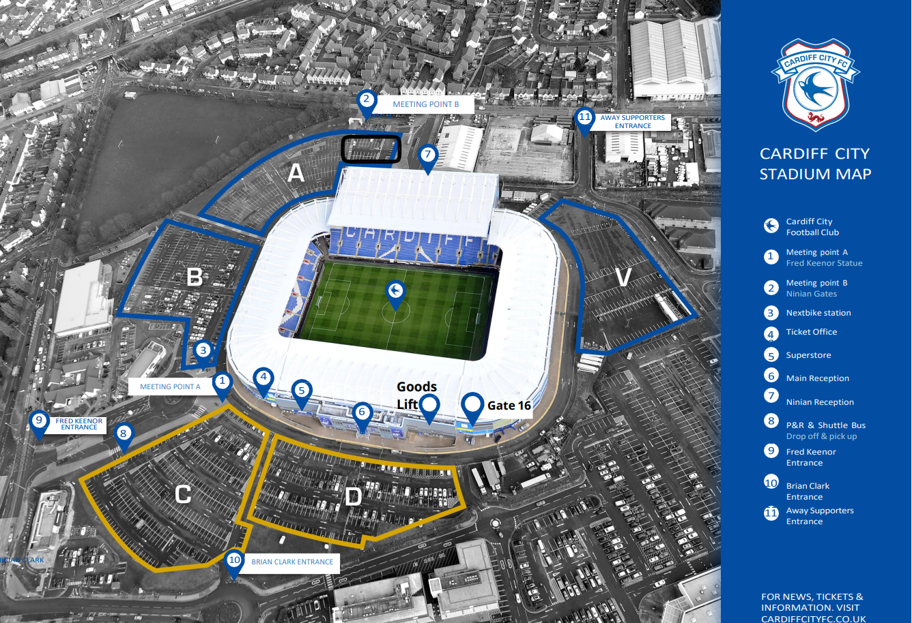

**The venue site map above shows the location of the car park and emergency evacuation assembly area (car park area C). The main entrance is marked no 6.**

**Main entrance**

Access to the main entrance is via double push/pull doors underneath a canopied area. The maximum door width is 190 cm. There is level access. There is a staffed reception inside to the left of the main doors. The flooring in reception is laminate with carpet mats by the main doors.

The main conference room for Safety Reps Connect event is the Premier Suite which is located on the 4th floor. A lift is available in reception which is 89.3 cm wide and 291 cm in length. The lift has a maximum capacity of 13 persons and 1000 kgs. The Premier Suite can also be accessed by the stairs to the right as you enter reception. The stairs are laminate tiled and have handrails on either side.

What additional signage or guidance is available for visually impaired visitors? The venue advise that visually impaired visitors can be verbally directed and assisted if needed, by a member of venue staff on request

**Event registration desk**

The event registration and workshop registration desks will be in the landing area at the top of the stairs on the 4th floor. Access into the conference room is via push/pull doors which are 90cm wide. The flooring is laminate tile. The venue also has a goods lift available via staff entrance if needed, this is 190cm wide.

**Main conference room**

The main conference will be held in the Premier Suite. The flooring is laminate tiles and the lighting is LED. There is a large window overlooking the pitch with natural light and another large window overlooking the car park.

There will be a stage with a screen and cabaret style seating in the conference area.

A loop system will be provided in the main conference area. A speech to text captioning service will be available.

You can view the room here: <https://www.cardiffcityconferenceandevents.co.uk/spaces/premier-lounge/>

There are men’s, women’s and disabled toilets at either end of the Premier Suite. The disabled toilets on the 4th floor have an entrance door width of 90 cm and hand rails. Both disabled toilets have an alarm in event of emergency.

To the far right of the main conference room there will be an area where information stalls and refreshments and lunch will be served. The tables will be 69 cm high.

There is a quiet room located at the far-right end of the Premier Suite towards the WCs this is the Don Murray room.

**Workshop rooms**

Some of the workshops will be held on the 2nd floor. Workshops will be in the Captain’s Lounge, Chairman’s Suite and the Fred Keenor Suite. One workshop will be held in the main conference room.

The workshop rooms on the 2nd floor are accessed by the same lift and stairs from the main stairwell. There is level access to the rooms once on the 2nd floor. Access to the rooms is as follows:

Captains Lounge – door width 90cm

Chairman’s Suite – door width 190cm

Fred Keenor Suite – door width 90cm

The flooring is a mix of laminate tiles and carpeted areas.

There is another quiet room located on the second floor in The Charles Suite.

There are men’s, women’s and disabled toilets on the second floor. The disabled toilet has a door width of 103cm, hand rails. It has an alarm in event of emergency.

**Emergency procedures - fire alarms and evacuation**

Audible and visual fire alarms- flashing lights, are fitted in the building.

In the case of an evacuation, the venue has a designated meeting point for anyone unable to use the stairs, where they will be met by a venue staff who will assist them with their evacuation. This designated area is on the landing on each level.

In the event of fire, do not use the lifts. Please leave your belongings and exit via the main stairwell and out through the main reception doors. Assemble in area C of the car park. Emergency evacuations will be stewarded by venue staff/trained fire wardens.

Staff at the venue are trained in first aid and fire evacuation procedures. A first aid kit is available at main reception.

If you require any advice or assistance, TUC staff can assist you and can be identified by their red lanyards. In the event of a medical emergency please dial 999.