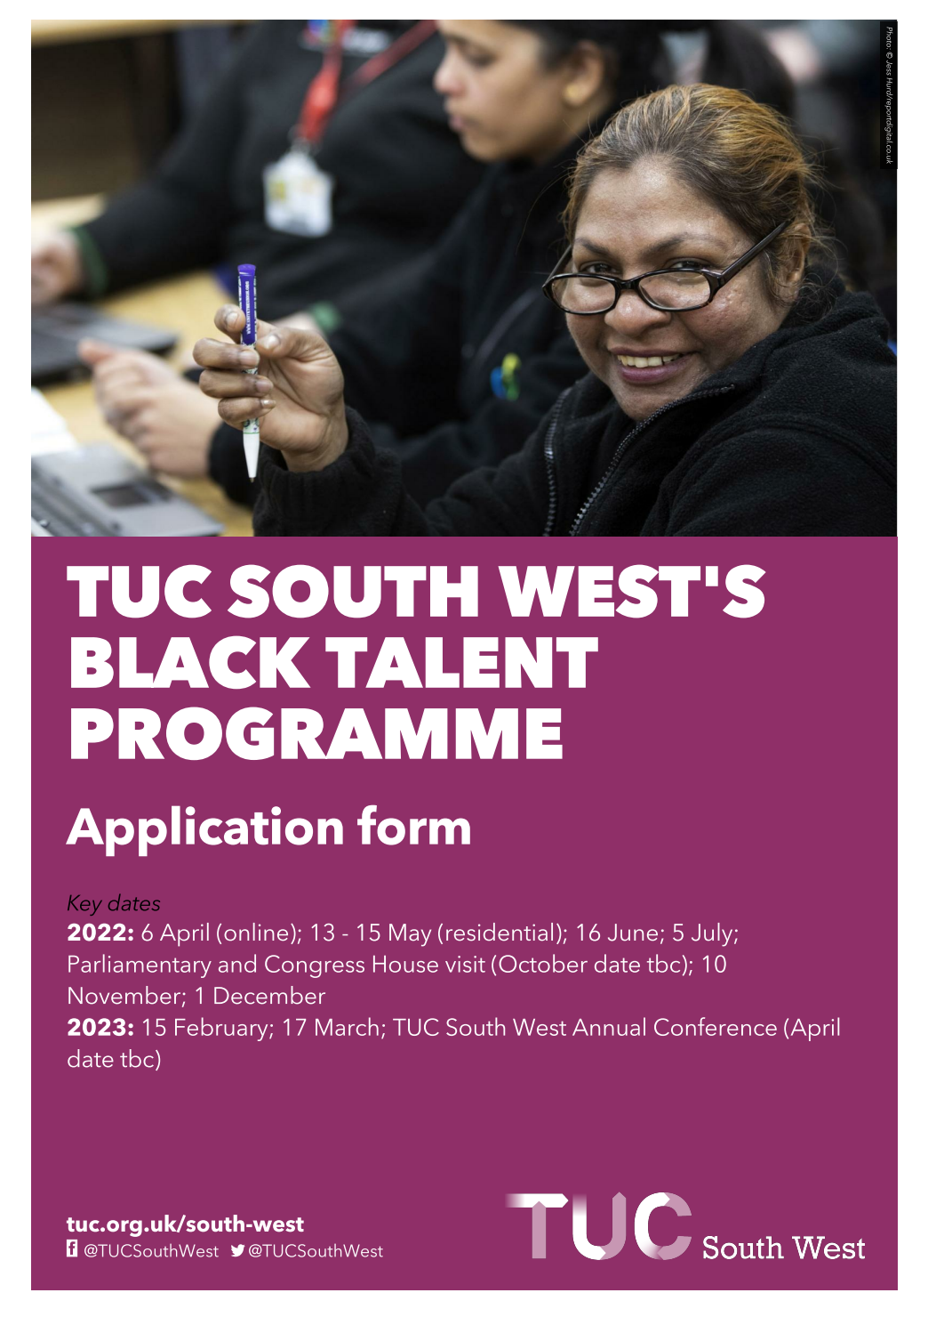
Thank you for expressing an interest in the TUC South West’s Black Talent Programme.
Please use this form to submit your formal application.

Completed applications must be submitted NO LATER than Monday 7 March 2022, midday/12noon.
Nominations or recommendations from union officers must be supported with an individual's application.
For more information please visit www.tuc.org.uk/blacktalent or email southwest@tuc.org.uk TUC South West can also provide alternative formats of this application.

Timetable
The programme will run throughout 2022-23.
Most of the course dates have been set with a few still to be confirmed due to the Covid pandemic, but we will give students as much notice as possible to ensure you can continue to attend and participate in full. We strongly recommend you carefully consider the timetable below and check whether you can fully commit to this year-long course.

Key dates
6 April 2022 - online
13 - 15 May 2022 - residential/in-person
16 June 2022
5 July 2022
Parliament and Congress House visit - October TBC
10 November 2022
1 December 2022
15 February 2023
17 March 2023
TUC South West Annual Conference (April date TBC)

Who can apply?
The TUC welcomes applications from trade union members, activists, reps and officers who work or live in the South West and self-identify as Black, Asian or from any other ethnic minority background. We would like to see applications from trade unionists who are keen to broaden their skills, advance in their roles and union, and help us achieve the changes we need to make the working world fairer, more equal and just.

How much is the programme?
Costs are involved in participating in this programme but should not be borne by the individual participant.

To ensure this, we ask that participant’s speak to their respective trade union and/or branch and confirm they will:
- Cover the travel expenses to and from training dates (including to and from London)
- Agree to pay £500 to the TUC South West which will be used to fund accommodation and food costs during the residential training days.

Some unions may also wish to fund other individual costs if and as required by the student (e.g. IT provision for online sessions, lunch costs, child care, etc). This is at the discretion of the union or branch.
TUC South West will cover all other remaining costs of the programme, including room and surplus accommodation costs, tutor salary, guest speakers, and meals during overnight stays.

We strongly urge interested applicants speak to their union, branch or nominating officer before submitting their application to ensure they will be fully supported, and to avoid disappointment or delays.

This form will also ask you to give contact details of the individual union official who can administer and/or sign off on your financial support.

What if my union refuses to pay/ can’t afford it?
We do not wish for costs to be a barrier. So if you are concerned your union has insufficient funds or won’t support your application, please get in touch with the South West TUC team so we can discuss options.

What will I learn on the course?
The course will include various activities and learning opportunities to enhance the students’ skills. This will include: communicating as a trade unionist, writing motions and speeches, understanding union structures, breaking through barriers, running campaigns, organising for power, leading projects and networking.

This programme will suit any trade union activist looking to step up into a new role or position of influence within their branches and unions. We will also enable networking opportunities with leading union officials, provide support in finding mentors, and invite guest speakers from the trade union, labour and political movement to share tips and tricks with the group.

Students will also be working on a collective project throughout the year that will be presented at the TUC South West’s Annual Conference in 2023 at Croyde Bay, Devon. As a result, additional training can and will be provided to support the participants’ project(s)
Application form
Please answer the questions below. Once completed, send to southwest@tuc.org.uk or print and post to TUC South West, Church House, Church Road, Bristol BS34 7BD to arrive by 12 noon Monday 7th March.

About you

1. Full name

………………………………………………………………………………………………………………………………………

2. Date of birth

………………………………………………………………………………………………………………………………………

3. Your home address, including post code

………………………………………………………………………………………………………………………………………

………………………………………………………………………………………………………………………………………

4. Email address
Please ensure this is an email address you check regularly as links, homework and information about the programme will be sent to this address. We will not share it with anyone without your prior consent.

………………………………………………………………………………………………………………………………………

5. Contact number
We will only use this for emergency purposes or to update you on any last minute changes to the programme.

………………………………………………………………………………………………………………………………………

You and your union

6. What trade union are you a member of?

………………………………………………………………………………………………………………………………………

7. Approximately, how long have you been a member of your trade union?

………………………………………………………………………………………………………………………………………

8. Please describe your involvement in your union.
For example, you can list union roles you hold or have held: any activities or campaigns you have been involved with or helped coordinate; if you sit on any union/branch committees; if you are involved in your local trades union council; and anything else you think might be relevant.

………………………………………………………………………………………………………………………………………

………………………………………………………………………………………………………………………………………

………………………………………………………………………………………………………………………………………

………………………………………………………………………………………………………………………………………

………………………………………………………………………………………………………………………………………

………………………………………………………………………………………………………………………………………

………………………………………………………………………………………………………………………………………

………………………………………………………………………………………………………………………………………

………………………………………………………………………………………………………………………………………

………………………………………………………………………………………………………………………………………

………………………………………………………………………………………………………………………………………

………………………………………………………………………………………………………………………………………
You and your work

9. What is your current job title/role?

………………………………………………………………………………………………………………………………………

10. Where is your workplace located?
If you are currently working from home, please list your ordinary place of work before the Covid pandemic.

………………………………………………………………………………………………………………………………………

11. What is the name of your employer?

………………………………………………………………………………………………………………………………………

Your interest in the Black Talent Programme

12. Please tell us why you are applying to this programme.

Use the space below to explain what you feel you would get from taking part in the year long programme.
This may range from building your rep skills, understanding more about the role you can play in the union movement or because you have a passion to change an injustice at work. Give as much information as you feel able. Please note, we do not expect university level essays! This section is simply here to help us understand who you are and what you hope to achieve.
………………………………………………………………………………………………………………………………………

………………………………………………………………………………………………………………………………………

………………………………………………………………………………………………………………………………………

………………………………………………………………………………………………………………………………………

………………………………………………………………………………………………………………………………………

………………………………………………………………………………………………………………………………………

………………………………………………………………………………………………………………………………………

………………………………………………………………………………………………………………………………………

………………………………………………………………………………………………………………………………………

………………………………………………………………………………………………………………………………………

………………………………………………………………………………………………………………………………………

………………………………………………………………………………………………………………………………………

………………………………………………………………………………………………………………………………………

………………………………………………………………………………………………………………………………………

………………………………………………………………………………………………………………………………………

………………………………………………………………………………………………………………………………………

………………………………………………………………………………………………………………………………………

………………………………………………………………………………………………………………………………………

………………………………………………………………………………………………………………………………………

………………………………………………………………………………………………………………………………………

………………………………………………………………………………………………………………………………………

………………………………………………………………………………………………………………………………………

………………………………………………………………………………………………………………………………………

………………………………………………………………………………………………………………………………………

………………………………………………………………………………………………………………………………………

………………………………………………………………………………………………………………………………………

………………………………………………………………………………………………………………………………………

Your union's support

As this programme will involve costs, we have asked unions to ensure they will financially support successful applicants so that they can fully participate in the course. This support will involve but is not limited to: travel costs, accommodation and any other personal support (E.G. IT access, childcare) as may be required.
Please therefore give details below of the union official who has agreed to this on your behalf. We will get in touch with them to also ensure you are supported in the above manner.

13. Full name of supporting/nominating union official

………………………………………………………………………………………………………………………………………

14. Email address of supporting/nominating union official

………………………………………………………………………………………………………………………………………

15. Telephone number of supporting/nominating official

………………………………………………………………………………………………………………………………………

16. How do you know this union official?

………………………………………………………………………………………………………………………………………

Thank you for taking the time to submit your application to the TUC South West’s Black Talent Programme.

To confirm, the deadline for completed applications is Monday 7 March, 12noon. We will be in touch later that week to let all applicants know whether they have been successful.

If there is anything else you would like to add to support your application, please use the space below.

………………………………………………………………………………………………………………………………………

………………………………………………………………………………………………………………………………………

………………………………………………………………………………………………………………………………………

………………………………………………………………………………………………………………………………………

………………………………………………………………………………………………………………………………………

………………………………………………………………………………………………………………………………………

………………………………………………………………………………………………………………………………………

………………………………………………………………………………………………………………………………………

………………………………………………………………………………………………………………………………………

………………………………………………………………………………………………………………………………………

………………………………………………………………………………………………………………………………………

………………………………………………………………………………………………………………………………………

………………………………………………………………………………………………………………………………………

………………………………………………………………………………………………………………………………………

………………………………………………………………………………………………………………………………………

………………………………………………………………………………………………………………………………………

………………………………………………………………………………………………………………………………………

………………………………………………………………………………………………………………………………………

………………………………………………………………………………………………………………………………………

………………………………………………………………………………………………………………………………………

Equality and diversity monitoring

We promote Diversity and Equal Opportunities and oppose all forms of unlawful or unfair discrimination.
Please complete the following questions. All information provided in this section will be entirely anonymised and will form a confidential statistical record/database to help inform our Equal Opportunities Policy. This section will also be separated from the overall application to ensure a fair decision-making process.

1. Please select your age range

☐ 18 – 29
☐ 30 – 39
☐ 40 – 49
☐ 50 – 59
☐ 60 – 64
☐ 65 +

2. Please select your gender

☐ Man
☐ Woman
☐ Non-binary
☐ In another way
☐ Prefer not to say

3. Do you consider yourself to have a disability according to the terms given in the Equality Act 2010?
The Equality Act 2010 defines a person as disabled if they have a physical or mental impairment, which has a substantial and long term effect (ie has lasted or is expected to last at least 12 months) on the person’s ability to carry out normal day-to-day activities.

☐ Yes
☐ No
☐ Prefer not to say

4. Please select your ethnic group:
☐ Asian or Asian British – Indian
☐ Asian or Asian British - Pakistani
☐ Asian or Asian British - Bangladeshi
☐ Asian or Asian British - Chinese
☐ Any other Asian background
☐ Black, African, Caribbean or Black British - African
☐ Black, African, Caribbean or Black British - Caribbean
☐ Any other Black, African or Caribbean background
☐ White and Black Caribbean
☐ White and Black African
☐ White and Asian
☐ Any other mixed or multiple ethnic background
☐ Other ethnic group – Arab
☐ Any other ethnic group

