CONFIDENTIAL

Merits of UK Coal State Aid Application

REPORT

Prepared for:
The National Unions of Mineworkers and the Trades Union Congress

Prepared by:
Orion Innovations (UK) Ltd

Date: 7 May 2014

IMPORTANT NOTICE
Whilst reasonable steps have been taken to ensure that the information contained within this Report is correct, you should be aware that the information contained within it may be incomplete, inaccurate or may have become out of date. Accordingly, Orion Innovations (UK) Ltd makes no warranties or representations of any kind as to the content of this Report or its accuracy and, to the maximum extent permitted by law, accept no liability whatsoever for the same including, without limit, for direct, indirect or consequential loss, business interruption, loss of profits, production, contracts, goodwill or anticipated savings. Any person making use of this Report does so at their own risk.

Contents
1 Executive summary 4
2 Acknowledgements 6
3 Introduction 7
4 EU Closure Aid and European coal mining 8
5 UK Coal and current closure plans 14
6 The case for an EU Closure Aid application for UK Coal 17

Glossary
BACM-TEAM The British Association of Colliery Management Team
BIS Department for Business Innovation and Skills
CCS Carbon Capture and Storage
CO₂ Carbon dioxide
CoalPro Confederation of UK Coal Producers
CPF Carbon Price Floor
DECC Department of Energy and Climate Change
EBT Employee Benefit Trust
EU ETS EU Emissions Trading Scheme
EU European Union
EURACOAL European Association for Coal and Lignite
GMB National Union of General and Municipal Workers
GVA Gross Value Added, the value of goods and services produced in an area, industry or sector of an economy
GW Gigawatts
GWh Gigawatt hours
IED Industrial Emission Directive
MW Megawatts
MWh Megawatt hours
NACODS National Association of Colliery Overmen, Deputies and Shotfirers
NUM National Union of Mineworkers
TUC Trades Union Congress
Unite Unite Trade Union

Executive summary
UK Coal is the largest coal mining business in the United Kingdom. It operates two of the remaining three deep coal mines, along with several surface mines. Faced with the threat of insolvency, UK Coal has put in place plans for the managed closure by autumn 2015 of their two deep mines, Kellingley in Yorkshire which employs 720 people, and Thoresby in Nottinghamshire which employs 585 people. This report, produced for the National Union of Mineworkers (NUM) and the Trades Union Congress (TUC), examines the merits of a UK state aid application in support of these mines.
Mining and energy unions and TUC affiliates, NUM, BACM-TEAM, NACODS, Unite and the GMB, are working together to press the government to apply for EU State Aid in order to maintain the UK energy security that comes from continued domestic coal production, and to secure a longer term future for in excess of 2,000 jobs in the coal mines and their supply chains.
Faced with similar pressures, a number of competitor European countries, including Germany, Spain, the Czech Republic, Poland, Hungary, Romania Slovenia and Slovakia have sought and secured State Aid for their coal mining operations. Germany’s closure plans are designed to address the social impact of job losses, and specifically to allow sufficient time to enable direct and indirect supply chains to adjust. Spain’s State Aid has supported mines which have now become viable and the Government is actively lobbying for a review of the European Commission Council Decision which states that mines in receipt of State Aid must close by 2018 or repay the aid.
The current regulation of ‘State aid to facilitate the closure of uncompetitive coal mines’ (2010/787/EU), incorporates operating aid for the closure of mines (Article 3), and aid for exceptional closure costs (Article 4), including inherited liabilities, pensions, redundancy payments, supply of free fuel, and re-training.
As with all State Aid, Member States must notify the Commission in advance of proposed state aid in order to ensure compliance. Although this process can take from 6-9 months, following direct discussions with the European Commission, the NUM and TUC understand that fast track processing could ensure that decisions are taken much more rapidly. This notification must include a closure plan which identifies the coal production units, together with production costs and estimated closure aid per coal year.
To date the UK has made little use of state-aid provisions for the sector. There are good reasons for suggesting that this situation should change.
Based on information available to us today, the Kellingley and Thoresby mines would appear to offer the prospect of a cash neutral outcome if operations were to continue through to 2018, with development costs of £63 to £74 million, and operating profits in excess of £80 million.
The challenge faced by UK Coal is one of cash flow and commercial returns. Given the size and nature of their business, and current international coal prices, they are unable to secure the cash needed for investment in the development of the mines on commercial terms. In the absence of this investment, they are forced to close the mines in 2015. Were the UK Government to secure EU Closure Aid for these mines, it could provide this cash and based on the initial high-level estimates, the net cost to the UK tax payer is likely to be zero.
However, failure to maintain these mines will result in significant and tangible costs for the UK tax payer. Over the three years from 2016 to 2018 this is likely to include ~£75 million loss in income tax and national insurance, and significant unemployment-related benefits associated with ~2600 man-years of lost employment.
There will be significant costs to be paid by the mining communities themselves, with £163 million cumulative loss of employee income, £1.0 billion loss in revenues and £640 million loss of value-add, coupled with significant social impacts.
There are also strategically significant energy security issues for the government to consider. Greater reliance on imported coal would needlessly compromise our national energy security, not least given the high reliance on Russian coal in a time of troubled relations between Europe and Russia.
The UK's ambitions to become a world leader in cost effective carbon capture technology suddenly make much less sense if we rely on coal imports alone, with an even heavier carbon footprint from the increased land and sea transport of coal.
Taken together, these factors provide a strong economic, strategic, social and environmental case for the government to seek State Aid Approval for UK Coal, in the context of a wider strategy for coal with carbon capture and storage within a balanced low carbon energy system.

Acknowledgements
This study was commissioned by the National Union of Mineworkers (NUM) and the Trades Union Congress (TUC). We would like to express our appreciation for the support provided to us by these two organisations and by CoalPro, the Confederation of UK Coal Producers; Euracoal the European Association for Coal and Lignite; and UK Coal in drafting this report. We would also like to acknowledge the multiple sources of information and prior research that we have depended upon, which are referenced throughout the document.

Introduction

What is the context for this report?
UK Coal is the largest coal mining business in the United Kingdom. It operates two of the remaining three deep coal mines, along with several surface mines. Faced with the threat of insolvency, UK Coal has put in place plans for the managed closure by autumn 2015 of their two deep mines, Kellingley in Yorkshire which employs 720 people, and Thoresby in Nottinghamshire which employs 585 people.
Faced with similar pressures, a number of competitor European countries, including Germany, Spain, the Czech Republic, Poland, Hungary, Romania Slovenia and Slovakia have sought and secured State Aid for their coal mining operations. The TUC and its affiliates have argued that the UK government should seek similar recourse to State Aid, in order to maintain the UK energy security that comes from continued domestic coal production, and to secure a longer term future for in excess of 2,000 jobs in the coal mines and their supply chains.

What issues is this report looking to address?
This report outlines the case for a UK state aid application for UK Coal’s Kellingley and Thoresby coal mines. It look at the nature of state aid available to European coal mines and its use in other countries.
The report examines at a very high level, the economic, social, environmental and strategic costs and benefits associated with continued operation of these mines to 2018.

How has it been prepared?
This report is based on desk based research and discussions with representatives from UK Coal, trade unions, trade associations and selected industry analysts during the latter half of April 2014.

Report structure
This report is structured as follows:
- Section 4: Introduction to EU Closure Aid and its application in European coal mining.
- Section 5: Introduction to UK Coal and current closure plans for Kellingley and Thoresby mines.
- Section 6: Analysis of the economic, social, environmental and strategic implications of an EU Closure Aid application for UK Coal.

EU Closure Aid and European coal mining

Introduction
This section provides an overview of the status of coal production and consumption in Europe, together with an introduction to current State-aid regulations and their use by our European competitors.

European coal mining
Coal continues to play an important role in the European economy, supplying >25% of electricity across the continent, and employing >200,000 people in the sector and closely related industries.
The European Union is the world’s third largest coal-using region, after China and North America. Each year, around 130 million tonnes of hard coal is produced and a further 210 million tonnes imported.
Within Europe the highest producing countries are Germany, Poland, Greece, Czech Republic and the UK. Based on comparative EU statistics for 2011, Poland had the highest production of hard coal, contributing 61% (76 million tonnes) to the EU total. The UK was the second largest EU hard coal producer accounting for 14% (17.3 million tonnes) of total EU production (124 million tonnes). Other EU countries, such as Germany, have higher lignite and brown coal production.
In 2011, the UK was the third largest consumer of coal among the EU countries for the eleventh year running, accounting for 16 per cent of the 316 million tonnes total coal consumption in the EU. The top two consumers were Poland and Germany, accounting for 26 per cent (84 million tonnes) and 18 per cent (58 million tonnes) respectively. Other important consumers are the Czech Republic, Italy, France, Greece, Spain, the Netherlands, Bulgaria and Romania.
In 2012, across the EU, it is estimated that more than 240 000 people were employed in coal production, some at integrated mine and power plants. In greater Europe, including Turkey and Ukraine, this number rises to almost 600 000 people. Adding the indirect jobs supported by coal mining leads to a total of well over one million people whose livelihoods depends on the coal industry.
According to Euracoal (European Association for Coal and Lignite), The annual value of EU coal and lignite production, based on its calorific value and on international hard coal prices at the beginning of 2013, was >€25 billion. If the quantity of coal mined in the EU were to be replaced by natural gas, then the annual cost would be almost €60 billion. The EU has insufficient indigenous natural gas production to meet its existing gas needs and, in 2011, was approximately 67% dependent on imports, compared with 41% for solid fuels.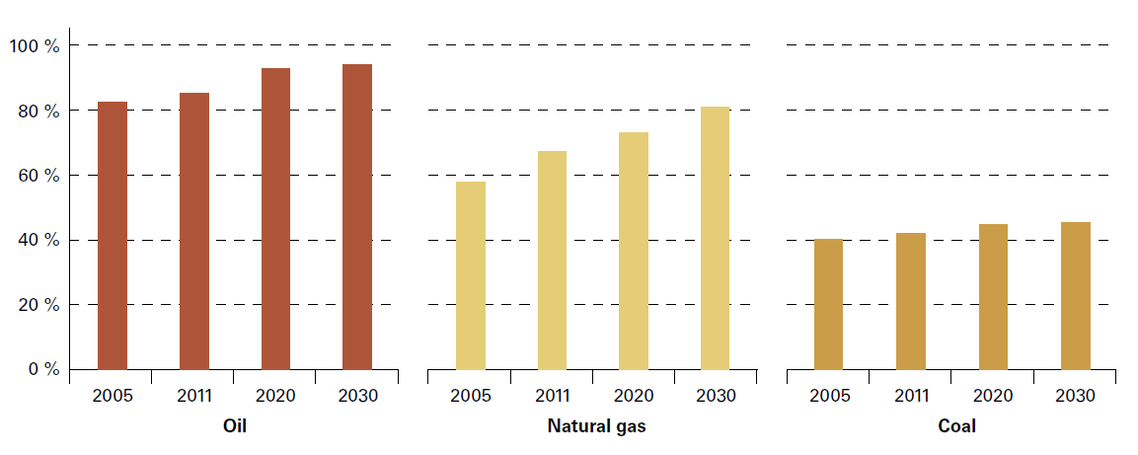Figure 1. EU Energy Import Dependence, 2005/2011, with Projections for 2020/2030.
The coal sector is influenced by a number of complex and sometimes conflicting drivers. Energy policies are currently guided by the now widely accepted need to reduce greenhouse gas emissions, adjust to a new economic climate following the crisis in 2008, and address global competition for resources and fears over energy security. As a result:
- The coal sector and its primary customer (electricity generation), are subject to carbon reducing policies (primarily the EU Emissions Trading Scheme: ETS), as well as the new air pollution limit coming into force in 2016 (via implementation of the Industrial Emission Directive) which is anticipated to result in the closure of many coal-based power generation plants.
- Coal-based generation with carbon capture & storage (CCS) technology has the potential to combat greenhouse gas emissions and to enable fossil fuels to continue to contribute to a clean and secure energy mix. CCS is a critical part of the world’s future low carbon energy portfolio. However, there needs to be an immediate and ambitious roll out of CCS projects to ensure CCS plays an effective part in a lower carbon energy mix.
- Demand for coal has recently risen across Europe as it has become widely recognised as essential in providing a secure electricity supply, and as the rise of fracking in the US and the extraction of large quantities of shale gas has both lowered the price of gas and resulted in cheap coal flooding the global marketplace.
The European coal sector is therefore tasked with finding a way to:
- Maintain coal production in the medium to long term to meet Europe’s energy security needs, and to ensure that indigenous coal supply can be secured to meet future demand for clean coal generation.
- Implement managed wind down of those plants that are scheduled to close in the absence of sector-specific State Aid, and penalties imposed by the environmental directives.
The latter is supported by EU Closure Aid, which came in to force in 2011, in order to mitigate against the social and regional impact of mine closures, in particular to ensure that the workforce could be properly supported and retrained over a reasonable period of time, and rehabilitation procedures would be implemented in full.

EU Closure Aid
Between 2002 and 2010, State Aid to the coal industry was governed by the sector specific Council Regulation (EC) No 1407/2002. This regulation expired at the end of December 2010 on the basis that the small contribution of subsidised coal to the overall energy mix and the European Union’s policy of support for renewable energy sources meant that extensive subsidies were no longer justified.
It was recognised, however, that in the absence of sector-specific State aid rules, uncompetitive coal mines would no longer be eligible for aid and could be forced to close, and that Member States should be able to take measures to alleviate the social, economic and regional consequences of such closures.
From January 2011, the regulation was therefore replaced by ‘State aid to facilitate the closure of uncompetitive coal mines’ (2010/787/EU), incorporating two categories of aid:
- Operating aid for the closure of mines (Article 3)
- Aid for exceptional costs (Article 4), including inherited liabilities (rehabilitation and costs for safety work etc.), pensions, redundancy payments, supply of free fuel, and re-training.
The new regulation will apply until 31 December 2018, although there have been recent discussions around extension of that deadline to 2020 and beyond.
There are a number of conditions that must be met for State-aid applications to be eligible under the new regulations. The most important of these are:
- The aid is only provided to coal production units that have a clear and irreversible closure plan.
- The subsidy is degressive: subsidies must be lowered by at least 25% per year until 2013, by 40% until 2015, by 60% by 2016 and by 75% by 2017.
- The price of coal is determined by the world market and cannot therefore be lower than for coal of a similar quality from elsewhere.
- A plan mitigating the environmental impact of the use of coal is put in place, for example in the field of energy efficiency, renewable energy or CCS.
- Operational aid (Article 3) is expected to cover production losses (i.e. must not exceed the difference between foreseeable production costs and revenue for a coal year).
If governments subsequently decide for energy strategic reasons that the coal production units are not closed, the subsidy is expected to be repaid in full.
As with all State aid, Member States must notify the Commission in advance of proposed state aid in order to ensure compliance. Although this process can take from 6-9 months, following direct discussions with the European Commission, the NUM and TUC understand that fast track processing could ensure that decisions are taken much more rapidly. This notification must include a closure plan which identifies the coal production units, together with production costs and estimated closure aid per coal year.

Competing coal producers take advantage of European State aid
Under the previous EU State-aid regulation, subsidies for coal production were paid in Germany, Spain, Poland, Romania, Hungary, Slovenia and Slovakia, with Germany representing 60% of all aid at €1.7 billion out of a total €2.87 in 2010. The next highest subsidy was paid out in Spain (€0.8 billion) No aid was paid in Bulgaria, the Czech Republic, UK (or Norway).
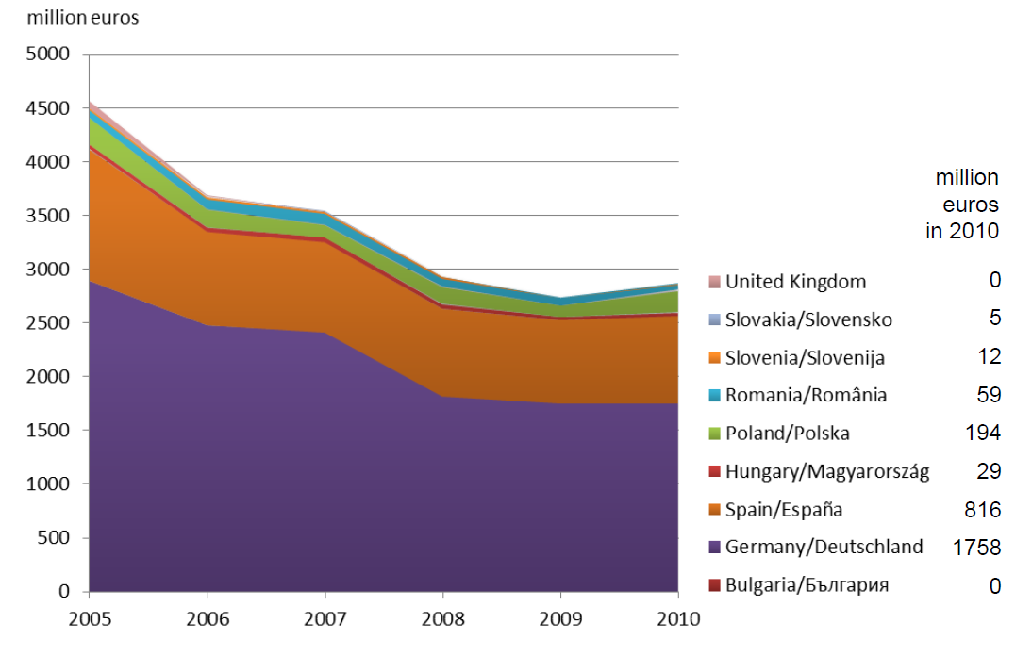
Figure 2. State-aid to the coal sector, 2005 - 2010
Germany
In Germany, all production of hard coal is carried out by RAG Deutsche Steinkohle AG (DSK AG), a wholly owned subsidiary of Ruhrkohle AG (RAG). In 2007, the shareholders, including E.ON and RWE, transferred their shares for a symbolic EUR 1 to the RAG Stiftung (foundation). In 2011, DSK AG operated five deep coal mines at sites in the Ruhr and Saar regions and in Ibbenbüren in North Rhine-Westphalia.
In 2011, Germany produced 12.9 million tonnes of hard coal and imported a further 47 million tonnes. As hard coal production costs remain well above revenues, the company gets substantial government subsidies, and although these have been declining steadily, the total still stood at €1.9 billion in 2011.
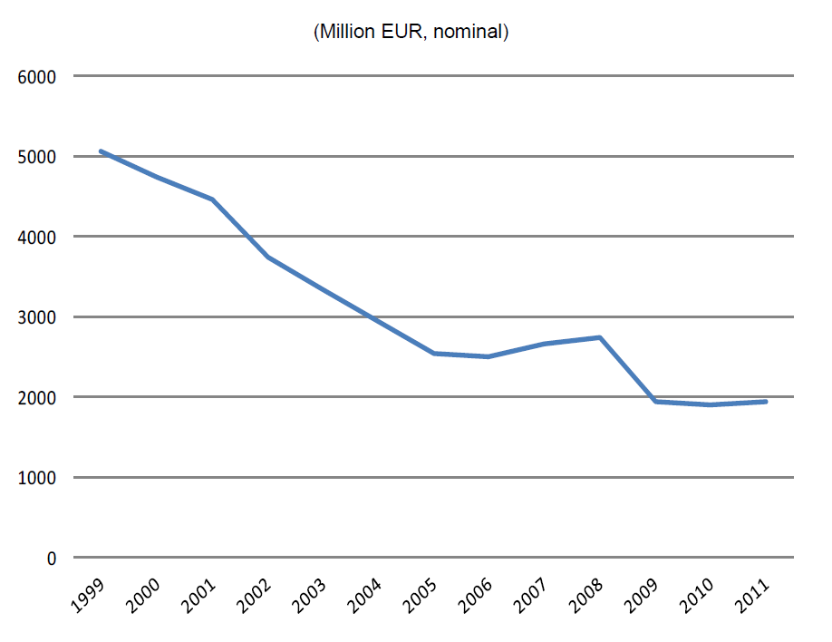
Figure 3. Total Producer Support Estimates for Coal, Germany 1999-2011

In mid-2007 the federal government, the governments of the states with mines, the unions and RAG agreed on a detailed road map to end all subsidies in a socially acceptable manner by the end of 2018.
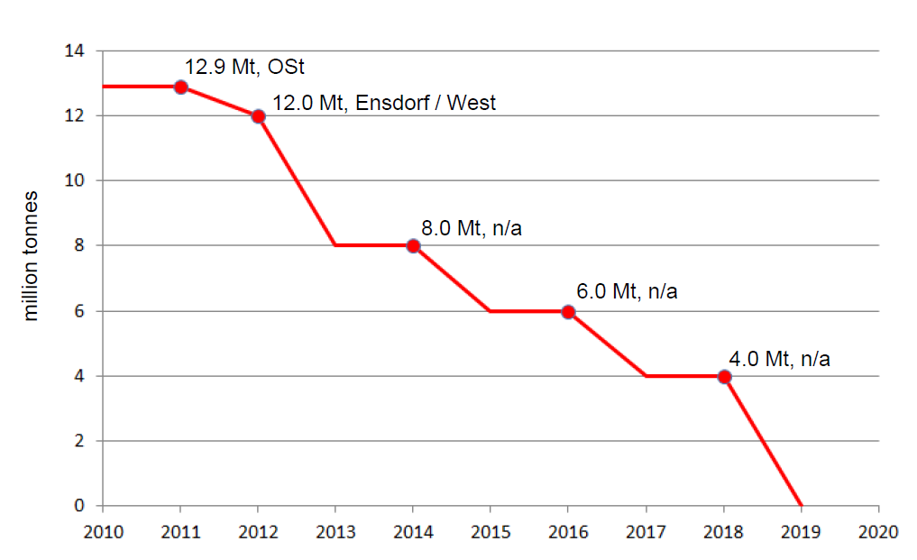
Figure 4. German hard coal production forecast
As of 2013, coal production in Germany will be undertaken in three remaining active coal mines. Under the deal, production is being gradually scaled back, limited by the retirement dates of miners. Subsidies for production will continue to be paid jointly by the federal government and the coal-producing states until 2014, after which time the federal government will assume payment of all production subsidies. Subsidies for closing down mines will be paid jointly until 2018.
The European Commission approved a closure plan with associated closure aid for Germany in 2011, for the period 2008-2018. The closure plan will last until 2018 because this is considered by Germany the earliest date at which the mines can be closed without lay-offs. Avoiding lay-offs is a key element of the framework agreement (in the Ruhr the regional unemployment rate was 12% in January 2011, i.e. still significantly above the national average). According to the German government, this transitional period will also give the power and steelmaking sectors (the main purchasers of German hard coal) sufficient time to adapt their equipment and supply structures to the new situation. The plan incorporates the following forecast subsidies (Table 1).

 | 2011 | 2013 | 2015 | 2017 | 2018
Aid for current production (article 3) | 1150 | 862 | 690 | 287 | 287
Aid for exceptional costs (article 4) | 806 | 899 | 813 | 895 | 804
Total | 1956 | 1761 | 1503 | 1182 | 1091
Table 1. Granted (2011) and forecast aid under Germany’s notification of aid for coal.

Under the plan, employee numbers will be reduced gradually from 18,739 workers in 2011 to 5,310 in 2018. Older workers will benefit from early retirement measures. Additional measures will be necessary to help younger staff find new jobs. State-aid will also cover production losses and inherited liabilities.
Mining costs that remain after the closure of the pits will primarily be paid out of a fund, which will be filled with the proceeds of a public sale of the equity-investment assets of RAG, now directly owned by the RAG Stiftung. However, if financing by the foundation falls short, the states of North Rhine-Westphalia and Saarland will guarantee two-thirds of the costs, and the federal government one-third (a process that was accepted by the European Commission in the 2011 submission for State-aid).
In addition, another programme provides older coal miners with early retirement payments until they become eligible for regular pension payments. Funding is split between the federal government and the states that possess mines.
Germany also has substantial brown coal (lignite) reserves and produces 170 million tonnes annually without subsidy (making it the world’s largest producer).
Spain
In 2012, 14 companies mined 6.1 million tonnes coal (including 2.2 million tonnes of sub - bituminous coal 21.5 million tonnes of imports to meet domestic demand. More than 60% of the domestic hard coal is mined in opencast mines, making indigenous hard coal competitive compared with imported coal. CARBUNIÓN, the Spanish confederation of coal producers, is seeking to maintain such competitive indigenous coal production, even after the expiry of state aid in 2018. There are now coal mines operating without state aid and these represent the first element of a competitive mining industry in Spain.
Government aid to support coal production has been substantial and relatively constant between 2005 and 2010 (see Figure 2) at approximately €0.8 billion annually. In line with the changed regulations on coal sector State Aid, these subsidies have since been maintained but in a reduced form, declining from €300 million in 2011 to €55 million in 2013.
The Spanish Government is frustrated by the pressure applied by the new State Aid approach to close viable mines and in September 2013, reiterated that it is seeking a review of the 2010 European Commission Council Decision, in order to allow viable and competitive mines to continue to produce coal after 2018 without having to repay past state aid.
Other examples
Recently, there have also been a number of authorisations of State Aid for Eastern European production units.
- In January 2013, the European Commission authorised approximately €140 million of public funding for the closure of an uncompetitive coal mine in Hungary, the Márkushegy Mine. The Commission found the measure to be in line with EU state aid rules because production aid will decrease over time and Hungary committed to carry out accompanying measures to mitigate the social and environmental impact of the closure.
- The European Commission has also authorised approximately €270 million of public funding for the closure of three uncompetitive coal mining units owned by National Hard Coal Company JSC Petrosani (CNH SA). The Commission found the measure to be in line with EU state aid rules because production aid will decrease over time and Romania committed to carry out accompanying measures to mitigate the social and environmental impact of the closure. One of the mines would close by the end of 2015 (Petrila Colliery) and the other two by the end of 2017 (Uricani and Paroşeni Collieries).
- After a period of uncertainty, the Czech Government has announced provision of State aid to keep New World Resources’ (NWR) unprofitable Paskov mine running until 2017. The mine is currently running up losses of approximately EUR 58 million a year. The government will contribute 600 million Czech crowns (EUR 22 million) in social programmes for miners that lose their jobs.

Conclusions
It can be seen that our European competitors are taking a strategic decision to support their coal industry during managed wind down of uncompetitive coal mines, and are providing substantial sums under European State Aid regulations. As an example, Germany’s closure plans are designed to address the social impact of job losses, and specifically to allow sufficient time to enable direct and indirect supply chains to adjust. To date the UK has made little use of state-aid provisions for the sector, either under the previous regulations or current Closure Aid.
Nevertheless there are good reasons (the subject of the rest of this document) for suggesting that this situation should change, and that the UK should join other European producers in implementing extensions of mining operations involving the gradual and fully supported mine closures out to 2018.

UK Coal and current closure plans

Introduction
This section provides an introduction to UK Coal and its current production, together with a brief look at the challenges faced by the company, the existing closure plan and the implications this has both for the workforce, and for the wider sector.

UK coal
Following the privatisation of the UK coal mining industry in 1994, UK Coal plc acquired some of British Coal's former mines. More recently, the company has undergone a number of complex restructuring processes. In December 2012, UK Coal’s parent company (Coalfield Resources plc) split its operating business into two separate units, property and mining: 75% of the property business (Harworth Estates Property Group Limited) was gifted to the trustees of the mining business pension fund; whilst control of the mining division passed to an Employee Benefit Trust (EBT).
Following a serious fire (February to May 2013), their largest deep mine, Daw Mill was forced to close, and UK Coal underwent further restructuring (July 2013), with UK Coal Production Ltd taking over the operating division.
Today UK Coal Production operates two deep mines (Kellingley and Thoresby) and several surface mines. The deep mines and surface mines produce 3.2m and 1.8 tonnes of coal per year respectively, representing approximately 15% of the total amount of coal burned in the UK, and equivalent to the energy needed to provide 3-4% of the country’s electricity requirements. Over 95% of the coal is supplied to the power generating sector (including Drax, EDF, E.ON and Scottish & Southern), with the remainder sold to the domestic, industrial and coking markets.
UK Coal also owns one mothballed mine (Harworth Colliery), and the company employs around 2000 highly skilled workers in a wide range of jobs from mining engineers to ecologists.
Thoresby Deep Mine
Thoresby colliery is located at Edwinstowe, Nottinghamshire, and dates back to 1925, when two shafts were sunk 691 metres and 688 metres below ground to the Top Hard seam by the Bolsover Colliery Company. Current operations in the 'Deep Soft' coal seam are approximately 750 metres below ground and, in theory, the mine’s reserves could last until 2019. The mine employs around 600 workers. Thoresby’s main customer is EDF Energy.
Kellingley Deep Mine
Kellingley colliery is located in Knottingley, Yorkshire and began production in April 1965. Up to 900 tonnes of coal an hour can be brought to the surface through one of two 800 metres deep shafts. The 'Beeston' coal seam, which is currently being mined, will last until at least 2015. Development of the second Silkstone seam has also begun, with UK Coal investing £40 million to date, and existing plans enabling extraction until 2019. Significant additional economic reserves could be available beyond this. The mine employs around 700 workers.
Kellingley is located just a few miles from Drax, Europe’s largest coal-fired power station, the mine’s main customer. Drax has recently been given the go-ahead for development of the first commercial demonstration of carbon capture and storage (CCS) in the UK, at the new oxyfuel coal-fired power plant station, White Rose. The plant is expected to require approximately 1.2 million tonnes of coal and 300,000 tonnes of biomass per annum (assuming the combustion of 15% biomass). Should supply from Kellingley cease, Drax is likely to have to increase its import of coal from Russia or the US.

The coal mining challenge
The TUC and its affiliates in the mining and energy unions are committed to securing a future for UK coal mining allied to the rapid development of CCS technology.
Coal production in the UK in 2013 was just under 13 million tonnes against a total coal demand of around 61 million tonnes. Imports of coal, at 49.4 million tonnes, were 10.1% higher than 2012, the highest value since 2006. The majority of this (43 million tonnes) is steam coal of which >44% came from Russia, and 26.5% and 22% from Colombia and the US respectively.
The biggest market in the UK is power generation at just over 50 million tonnes per annum. Other markets include household coal and coal-derived fuel (approximately 900k tonnes) and specialist industrial applications (e.g. metallurgical processes).
As with the rest of Europe (Section 4.3), coal production in the UK is facing significant challenges. In addition to the pressure imposed by the European Industrial Emissions Directive, companies in the UK have been faced with the recently introduced Carbon Price Floor (CPF), a UK-specific carbon tax on fossil fuels used to generate electricity which came into effect on 1 April 2013. The CPF was set at £15.70/tCO₂ in 2013 with a proposal for a linear increase to £30/tCO₂ in 2020, rising to £70/tCO₂ in 2030 (real 2009 prices).
Until very recently, the tax was seen to be encouraging power generators to maximise their 17,500 IED opt-out running hours whilst the tax remained relatively low, and to close relatively early on as a result. However, in the March 2014 Budget, the Chancellor announced that the CPF would be frozen at £18/t from 2016-17 up to the end of the decade. Commentators suggest that this will significantly improve the economic case for coal-based generation, with the short-run marginal cost much lower than previously expected in the later years of this decade.
Nevertheless, the economic pressure imposed by the influx of cheap coal from the US is also hitting UK companies hard, and since UK coal generators are required to buy a significant portion of their coal on the international market (and therefore to trade in dollars), the strength of the pound against the dollar is also reducing the competitiveness of domestic coal.
It is a source of great frustration that, despite the quantity of coal imported, the UK has been estimated to hold a reserve base of almost 4.6 billion tonnes of coal, enough to last over 70 years at 2012 demand levels. Clearly, the future extraction of these reserves would need to be allied to the development of CCS technology.
Accessing these reserves, on the other hand, is another matter, requiring extremely high levels of investment, which are very unlikely to be achieved in the current economic climate and without much greater certainty in the future of the UK coal power generation sector.
Under the circumstances described above, it is not surprising that UK Coal has reached the point at which it has been unable either to meet the stringent commercial terms associated with substantial investment sums needed to continue mine development and operation, or to find a buyers for the mines. As a result it faces a choice between immediate insolvency or a proposed plan for a controlled wind down over the next 18 months, based on repayable commercial loans from both Government and the private sector. Although this plan, described in Section 5.4 below, is clearly preferable to immediate closure, there are strong arguments in favour of an approach similar to European competitors of managing closure in strategic manner.

The Managed Closure Programme
The proposed plan for managed closure provides for a controlled end for the business on a phased basis over the next 18 months. Under the plan, Hargreaves Services and Harworth Estates would both invest £5 million, with a further £10 million coming from Government in the form of a fully repayable interest bearing commercial loan.
The programme requires an immediate end to development work at both mines, with the exception of work being carried out at Kellingley’s Beeston Seam. Unfortunately, there will therefore be no further development of the Silkstone Seam at Kellingley or the Deep Soft faces at Thoresby.
Mining would subsequently cease at the final panels at Thoresby and Kellingley by October and December 2015 respectively.
The company will also begin immediate production and redundancy consultations with Union Representatives. An estimated surplus of £8m may be generated at the end of the period, on which creditors such as the PPF would have first call. On April 22nd 2014, faced with the possibility of the immediate insolvency of UK Coal, miners at Kellingley Colliery voted for the “managed closure” of the pit in autumn 2015, with 79.9% in favour.

Implications
The Managed Closure Programme will avoid insolvent liquidation, but will nevertheless result in loss of all 1300 skilled jobs by the end of 2015, without provision for enhanced redundancy. Only one deep pit mine (Hatfield Colliery) will remain in Britain.
The potential impact of mine closure is wide ranging, not only involving economic effects, but also social, environmental and strategic consequences. These are examined in Section 6 below.

The case for an EU Closure Aid application for UK Coal

Introduction
This section examines the merits of an EU Closure Aid application for UK Coal’s Kellingley and Thoresby mines including the economic, social, environmental and strategic costs and benefits.

Costs associated with keeping the mines open
There are significant costs associated with the development and continued operation of underground coal mines. For example, in order to create a panel of coal in preparation for mining, two parallel tunnels are driven through a coal seam and joined together at the end via a third tunnel to create a coal face which can be over 300 metres long. A piece of heavy duty cutting equipment, called a ‘shearer,’ is then installed to move along the coal face in strips, breaking the coal which falls onto a conveyor belt and is transported out of the mine.
In Thoresby, current closure plans assume that the existing DS5 coal face will be mined to completion at the end of September 2015. In the event of securing EU Closure Aid, development of DS6 and future Deep Soft coal seam faces will be continued. UK Coal’s estimate is that these costs will amount to £19.32 million, including labour materials and equipment.
At Kellingley, closure plans assume that the existing 504B and 505B Beeston Seam coal faces will be mined to completion in December 2015. The company has sunk approximately £40 million into the development of the new Silkstone coal seam. In the event of securing EU Closure Aid, development of the Silkstone coal seam will continue. UK Coal’s estimate is that these costs will amount to between £33.69 and £44.89 million, including labour materials and equipment.
Allowing for £10 million in contingency, development costs needed to allow both Thoresby and Kellingley mines to continue through 2018 amount to between £63 and £74 million.
The outlook for the two coal mines is very dependent upon assumptions about coal volumes, coal prices, currency exchange rates and supply contracts.
UK Coal has shared their volume forecasts with us for their five year plan, which would apply if state aid were granted, and the planned-run-down of the mines to autumn 2015. UK Coal five year plan production forecasts are given in Table 2 below. The run-down plan assumes a 20% lower output from Kellingley and 10% from Thoresby in 2014 and 2015, prior to closure.
 |  | 2014 | 2015 | 2016 | 2017 | 2018
Thoresby colliery | Million tonnes | 1.351 | 1.275 | 1.249 | 1.242 | 1.097
Kellingley colliery | Million tonnes | 1.936 | 2.081 | 2.058 | 1.774 | 1.978
Table 2. Forecasts coal production volumes.
UK Coal has three contracts in place with Eon, EDF and Drax. We understand that the former two reflect floating international coal prices. The Drax contract is fixed price and due for renewal in 2015. It is possible to hedge both coal prices and currency exchange rates for the period to 2018. UK Coal has shared their price forecasts with us. These reflect very closely current hedge rates for both currency exchange and coal and are as given in Table 3.
 |  | 2014 | 2015 | 2016 | 2017 | 2018
Coal forward prices (29/4/14) | $/tonne | 78.88 | 84.25 | 87.25 | 92.00 | 95.50
Currency forward prices (29/4/14) | $/£ | 1.65 | 1.65 | 1.65 | 1.65 | 1.65
Table 3. Forecasts prices for coal and currency exchange rates.
Based on the volumes given in Table 2, prices and currency exchange rates given in Table 3, and UK Coal cost forecasts, a state aid closure plan will enable the mines to make a positive cash contribution of £86.2 million over the period to 2018. This includes £52.8 million additional revenue in 2014 and 2015, and a contribution net of operating costs of £33.4 million in 2016 to 2018. Based on these figures, these mines will make a positive contribution net of investment costs of ~£12.1 to £23.3 million, without allowing for the cost of capital (see Table 4 below).
 | £ million | Comment
Development costs: Thoresby | £19.32 | As advised by UK Coal
Development costs: Kellingley | £33.69 to £44.89 | As advised by UK Coal
Contingency costs | £10.0
Total development costs | £63.0 to £74.2
Additional revenues 2014-2015 | +£52.8
Cumulative operating profit (excl. development costs and any 2015 closure plan cost savings): Thoresby | -£5.0 | Production volumes, costs, prices and currency exchange rates as shown in Tables 2 and 3 and advised by UK Coal
Cumulative operating profit (excl. development costs and any 2015 closure plan cost savings): Kellingley | +£38.4
Total operating contribution | £86.2
Net benefit | +£12.1 to +23.3
Table 4. Net costs associated with keeping the mines open to 2018

Economic impacts
The economic impacts of the closure of Kellingley and Thoresby mines in 2015 are significant and can be divided into the following, each of which is examined below:
- Loss of employment, both within the mines their supply chains.
- Loss of aggregate personal income and the induced employment associated with household expenditures.
- Loss of business output, both in terms of coal and the materials, equipment and services consumed in its production.
- Loss of value add associated with the mines and their supply chains.
- Loss of tax revenues, including income tax, national insurance, corporation tax and energy taxes.
In addition, there are economic impacts that are more difficult to assess without much more detailed analysis. For example the UK has historically been a centre of excellence for underground mining equipment such as roof supports and coal conveyors. The companies in question are now almost all part of multi-national foreign-owned concerns. The continued operation of these exporting businesses in the UK is not clear once there is no domestic market to serve.
Loss of domestic coal production, and any knock-on effects to the supply chain will also have balance of payment implications.
Employment:
Kellingley and Thoresby mines employ 720 and 585 staff respectively and a further 50 to 75 underground contractors. The current closure plans assume the immediate loss of 340 staff from mine development activities and UK Coal headquarters, with the remainder losing employment in autumn 2015.
Closure of these mines will also have an impact on:
- Companies up the supply chain that have historically supplied raw materials, equipment and services to the mines;
- Companies that share supply chains or infrastructure, notably Hatfield Colliery, the only other operational deep coal mine in the UK;
- Other companies within the sector, in particular those that share physical and human resources or are reliant on critical mass to sustain services, training, education and innovation, most notably UK Coal surface mines.
Without a detailed survey, it is difficult to accurately assess the employment implications for these companies of the closure of Kellingley and Thoresby mines. The Scottish Government’s Input Output multipliers (2009), and a recent survey of the Scottish Coal Industry suggest that for every individual employed in coal mining, it is reasonable to assume that there are 0.81 people employed in the coal mine supply chains. A further 0.37 jobs result from induced employment associated with household expenditures.
The scale and durability of employment impacts will depend upon how many people seek and secure new employment, and how quickly this happens. A key feature of the German coal industry Closure Aid plans is the managed closure through redeployment and retirement.
There is a dearth of information on the long term impacts of mine closure on employment. Insights can be gleaned from research undertaken into the closure of the MG Rover plant in Longbridge in 2005. Although this was a particularly large-scale closure (~6000 employees), a considerable amount of work was done to prepare for the anticipated redundancies and to minimise damage. It also happened at a time of relative national economic prosperity. Key findings include the following:
- >90% of workers found work within three years;
- In part, these displaced less skilled workers in the market place, resulting in sustained long-term unemployment
- Those that found new employment reported a £5,600 (20%) a year average fall in income;
- >40% saw their job as worse than at MG Rover;
- 15-20 % had seen a GP or been in hospital;
- Costs of closure fell most heavily on those unable to move to new locations.
Applying these factors suggests that approximately 3,000 people will be impacted by the closure of Kellingley and Thoresby coal mines. As indicated in Table 5 below, there will be sustained unemployment after 3 years of approximately 600.

 | Number | Comment
Employees: Thoresby | 585 | As advised by UK Coal
Employees: Kellingley | 720 | As advised by UK Coal
Underground contractors | 50 - 75 | As advised by UK Coal
Supply chain employment | ~1100 | Based on Scottish Government input/output employment multipliers
Induced employment | ~500
Total employment | ~3000
Unemployment after 3 years | ~600 | Assumes 90% find employment but that 10% of employment displaces less skilled staff
Cumulative man-years lost employment 2016 - 2018 | ~2600 | Assumes 40% unemployment year 1, 15% year 2 and 10% year three; 10% of employment displaces less skilled staff
Table 5. Estimated impact on employment

Aggregate personal income:
A good measure of the economic impact of loss of employment in a region can be gleaned from loss of aggregate personal income. Based on the employment numbers outlined above, unit labour costs, and the likely fall in income evidenced by the MG Rover case study, immediate annualised loss of income is estimated to be ~£158 million, with £56 million sustained after three years (See Table 6.)
 | £ million | Comment
UK Coal employee income | £76 | Assumes average income of £63,000 per employee at Kellingley and £54,000 at Thoresby as advised by UK Coal
Contractor income | £4 | Assumes average income of £65,000 per contractor as advised by UK Coal
Supply chain income | £65 | Assumes average income as per UK Coal employee
Induced income | £13 | Assumes UK average income of £26,500
Total income | ~£158
Income loss after 3 years | ~£56 | Assumes 20% loss of income amongst those that secure employment and unemployment as outlined in Table 5.
Cumulative loss of income 2016 - 2018 | ~£163
Table 6. Estimated impact on aggregate personal income
Business output:
Over the period 2014 to 2018, a Closure State Aid programme would ensure that the two mines facing closure would produce in excess of 10 million tonnes of indigenous coal, over that in current closure plans.
The cumulative value of these outputs based on the coal prices and currency exchange rates presented in Table 3 is in excess of £0.5 billion. Cumulative supply chain and induced output add a further £0.5 billion as outlined in Table 7 below.

 | £ million | Comment
Additional coal revenues 2014 | ~£25 | Coal volumes and prices as advised by UK Coal and shown in Tables 2 and 3
Additional coal revenues 2015 | ~£28
Coal revenues 2016 | ~£175
Coal revenues 2017 | ~£168
Coal revenues 2018 | ~£178
Cumulative coal revenues | ~£574
Cumulative supply chain revenues 2016 - 2018 | ~£350 | Based on Scottish Government output multipliers. Applied to 2016 to 2018 numbers only.
Cumulative induced revenues 2016 - 2018 | ~£106
Cumulative additional revenues 2014 - 2018 | ~£1,030
Table 7. Estimated impact on business output

Value add:
Loss of value add, the sum of wage income and corporate profit/loss, is considered a good measure of the economic impact of a new investment or plant closure. The value add associated with Kellingley and Thoresby mines, excluding the development costs outlined in Section 6.2 above, is estimated to be ~£91 million per annum. This figure is identical to that derived from the Scottish Coal industry average value add of £70368 per employee. With supply chain and induced values, total value add is ~£220 million or £660 million over the three years 2016 to 2018 (see table 8). Including mine development costs, and additional revenues in 2014 and 2015, this declines to ~£644 million.

 | £ million | Comment
Annual Kellingley and Thoresby value add | ~£91 | Excludes £63 million to £74 million development costs outlined in Section 6.2
Annual supply chain value add | ~£93 | Based on Scottish Government input/output GVA multipliers
Annual induced value add | ~£36 | Based on Scottish Government input/output GVA multipliers
Total annual value add | ~£220
Cumulative value add 2016 - 2018 | ~£660
Additional revenues 2014 - 2015 | ~£53
Kellingley and Thoresby development costs | ~£69
Cumulative value add 2014 – 2018, including mine development costs. | ~£644
Table 8. Estimated impact on business value add
Tax revenues:
Lost income tax and national insurance revenues, based on employment and income numbers outlined above, amount to ~£75 million over the three years 2016 to 2018 (see Table 9). Further lost income to HMRC will result from reduced corporation and energy and emissions-related taxes. There will also be unemployment benefits and social security-related costs.
 | £ million | Comment
Annual Kellingley and Thoresby employee and contractor income tax and employer and employee NI | ~£37 | Assumes average income tax of 20%, employee NI of 10% and employers NI of 11%
Annual supply chain related income tax and NI | ~£30 | Based on Scottish Government input/output GVA multipliers
Annual induced employment related income tax and NI | ~£6 | Based on Scottish Government input/output GVA multipliers
Total annual income tax and NI | ~£73
Annual loss of income tax and NI after 3 years | ~£26
Cumulative loss of income tax and NI from 2016 - 2018 | ~£75
Table 9. Estimated impact on HMRC income tax and NI revenues

Social impacts
Less tangible than economic impacts, but equally important to the lives of local people are social impacts, including the price of housing in the region, which is often reduced in association with depletion of the local population, and likely physical and mental health deterioration amongst those who cannot find re-employment or take on less skilled work.
Findings from research into the effects of MG Rover closure at Longbridge showed that many ex-employees were forced to accept lower status jobs due to an absence of skilled work. This had a profound effect on physical and mental health and there was compelling evidence to suggest that ‘less skilled’ employees were more prone to mental illness, coronary heart disease and gastrointestinal conditions. Major life changes were seen in other members of the household, including partners who had taken up work, and children whose education had been affected.

Environmental impacts
Coal fired power plant continue to play a crucial role in the UK generation portfolio with around 40% of the UK's electricity fuelled by coal in 2013. The Committee on Climate Change in its Fourth Carbon Budget assumes a continued significant role for coal-powered generation, with CCS, in 2030.
Domestic coal supplied 17% of coal burnt in UK power stations in 2013 and closure of Kellingley and Thoresby will result in an increase in imports. This will be exacerbated if their closure has a knock-on effect on the viability of the remaining Hatfield deep coal mine or UK Coal’s surface mines.
From an environmental perspective, the import of coal results in greater carbon emissions associated with transport. Kellingley and Thoresby both serve local power stations. The distance between Thoresby and Kellingley, and Cottam and Drax power stations respectively, is less than 20 miles. By contrast it has been estimated that the emissions associated with transporting coal from Russia, the primary source of imports, are 65 times higher than from the UK.

Strategic impacts
There are numerous strategic impacts associated with the loss of domestic coal production. These include:
Security of supply
Most of the coal used in the UK at present is imported from Russia, Columbia and the USA. Increased imports and transport of coal over long distances offers greater potential for disruption through global political unrest or extreme weather events.
Recent developments in Russia and Ukraine are a case in point. At worst they might result in a disruption to supply; at best they might result in an increase in international coal prices with ensuing loss of value to the UK.
Exposure to international price volatility
Domestic production has in the past offered healthy stockpiles of coal for emergency deliveries during peak times and has acted as a buffer against international price volatility in both the coal and gas markets. This will become more difficult to guarantee.
Risk to CCS leadership
In addition, there is strong evidence that coal and gas based carbon capture and storage (CCS) will play an essential role in enabling the UK to meet its binding carbon reduction targets by 2050. The UK is in a uniquely advantageous position (both in terms of available skills and physical resources) to become a world leader in CCS and tap in to the significant anticipated growth in the global market. The economic benefits of CCS, a report from the TUC and Carbon Capture and Storage Association (CCSA), set out the employment and energy price benefits of CCS for energy and industry in the UK.
Deployment of CCS for electricity generation will also help to secure transport and storage networks for industry CCS in key industrial regions, securing the future of energy-intensive manufacturing, and associated large-scale employment in the UK.
The Coal Forum has recently proposed a UK strategy for coal that will allow a managed transition to CCS, thereby ensuring that clean coal (coal-fired power + CCS) can contribute to the security, affordability and diversity of the UK’s energy supply whilst sustaining highly skilled employment for some 10,000 employees across the sector. In anticipation of full commercialisation of CCS technology from 2020, it is essential that investment in the domestic coal supply chain is maintained, alongside implementation of policies that discourage premature closure of the current fleet of coal-fired power stations. Failure to do this will materially add to power price and security pressures over the coming years and will destroy jobs, whilst limiting the UK’s long term energy options and security of supply. It will also prevent the UK from reaping the benefits of the global development of the CCS sector.

Conclusions and recommendations
Based on information available to us today, the Kellingley and Thoresby mines would appear to offer the prospect of a cash neutral outcome if operations were to continue through to 2018, with development costs of £63 to £74 million, and operating profits in excess of £80 million.
The challenge faced by UK Coal is one of cash flow and commercial returns. Given the size and nature of their business, and current international coal prices, they are unable to secure the cash needed for investment in the development of the mines on commercial terms. In the absence of this investment, they are forced to close the mines in 2015.
Were the UK Government to secure EU Closure Aid for these mines, it could provide this cash. Based on the initial high-level estimates presented in this report, the net cost to the UK tax payer is likely to be zero.
However, failure to maintain these mines will result in significant and tangible costs for the UK tax payer. Over the three years from 2016 to 2018 this is likely to include ~£75 million loss in income tax and national insurance, and significant unemployment-related benefits associated with ~2600 man-years of lost employment.
There will be significant costs to be paid by the mining communities themselves, with £163 million cumulative loss of employee income, £1.0 billion loss in revenues and £640 million loss of value-add, coupled with significant social impacts.
There are also environmental and strategic impacts associated with a greater reliance on imports and increased transport of coal.
The merits of an EU Closure Aid application would seem significant, and we would recommend that this is explored immediately.

https://www.gov.uk/state-aid.
Digest of United Kingdom Energy Statistics, 2013 (DUKES).
Euracoal (European Association for Coal and Lignite), Coal Industry Across Europe, 5th Edition, 2013.
Euracoal (European Association for Coal and Lignite), Coal Industry Across Europe, 5th Edition, 2013.
Euracoal (European Association for Coal and Lignite), Coal Industry Across Europe, 5th Edition, 2013.
https://www.gov.uk/state-aid.
Coaltrans Geneva, 1-2 March 2012, Euracoal Presentation, Prospects for European Domestic Hard Coal Production Post Subsidies.
Data from OECD, GERMANY: INVENTORY OF ESTIMATED BUDGETARY SUPPORT AND TAX EXPENDITURES FOR FOSSIL-FUELS – 2013, unless otherwise stated.
Coaltrans Geneva, 1-2 March 2012, Euracoal Presentation, Prospects for European Domestic Hard Coal Production Post Subsidies.
European Commission, State aids SA.24642(N 708/2007) – DE – State aid for the closure of hard coal mines and SA.33766 – notification of aid to coal for 2011, Brussels, 07/12/2011.
http://europa.eu/rapid/press-release_IP-13-35_en.htm.
http://www.econet-romania.com/en/single-news/233/commission-approves-aid-for-closure-of-three-coal-mines-in-romania.html.
http://af.reuters.com/article/commoditiesNews/idAFP7E8LP00Z20140428
http://www.bbc.co.uk/news/uk-england-coventry-warwickshire-24775163.
http://www.ukcoal.com.
http://www.whiteroseccs.co.uk/your-questions-answered/fuel.
DECC Energy trends section 2: Solid fuels and derived gases, Supply and Consumption of coal (ET 2.1).
DECC Energy trends section 2: Solid fuels and derived gases Coal Imports (ET 2.4).
Energy Spectrum, Issue 415, 3 March 2014.
http://www.bbc.co.uk/news/uk-england-york-north-yorkshire-27112750.
UK Coal
HIS McCloskey for Coal and Bloomberg for currency
http://www.scotland.gov.uk/Topics/Statistics/Browse/Economy/Input-Output/Downloads/IO1998-2009latest
Scottish Coal Industry Economic Impact Assessment, PBA, November 2012
Scottish Coal Industry Economic Impact Assessment, PBA, November 2012
http://www.theccc.org.uk/publication/fourth-carbon-budget-review/
www.ukcoal.com.
The Economic Benefits of CCS in the UK, http://www.ccsassociation.org/press-centre/reports-and-publications/.
A Strategy for Coal in the UK 2013, www.coalpro.co.uk.

