TUC contributions to the official
Book of condolences
13 December 2013
Honouring Nelson Mandela
On Friday 13 December, TUC General Secretary Frances O’Grady, President Mohammed Taj and International Development spokesperson Gail Cartmail visited South Africa House to sign the official book of condolence for Nelson Mandela.
These are their messages:

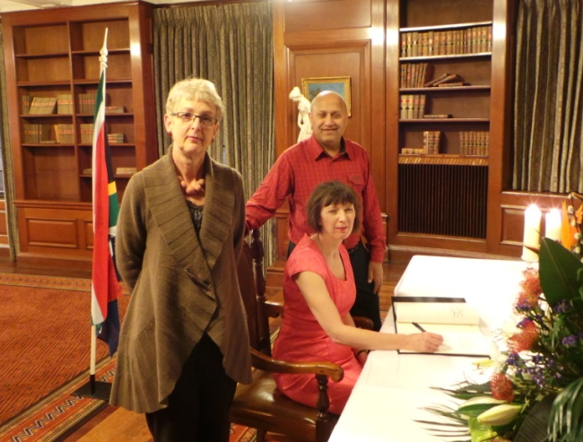
Frances O’Grady, TUC General Secretary
In memory of Nelson Mandela. To honour your legacy, we will rededicate our commitment to the cause of justice, equality and freedom.

Mohammed Taj, TUC President
Men die, legends live forever. Across the world we have lost a brother, but we can still strive to follow his example: he never gave up.

Gail Cartmail, TUC international development lead
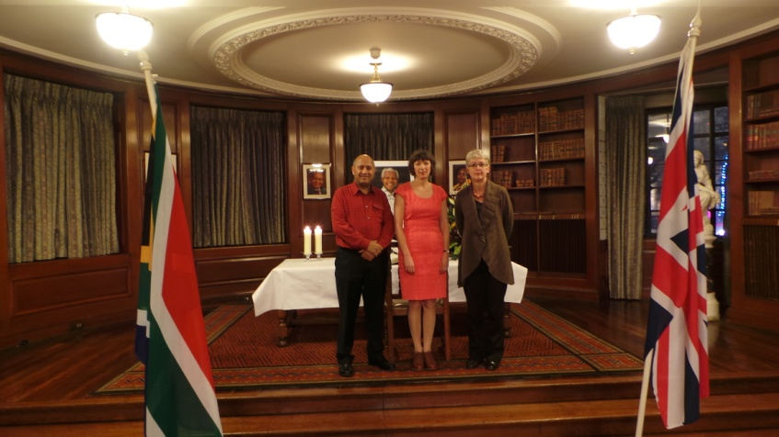
‘Free Nelson Mandela’! Our dream was realised and the goal of freedom from apartheid. So rest now, dear comrade, and in your honour we will carry the flame against exploitation and oppression. Amandla!

