Women 'Reclaim the Night' as march against violence and sexual assault comes to Newcastle
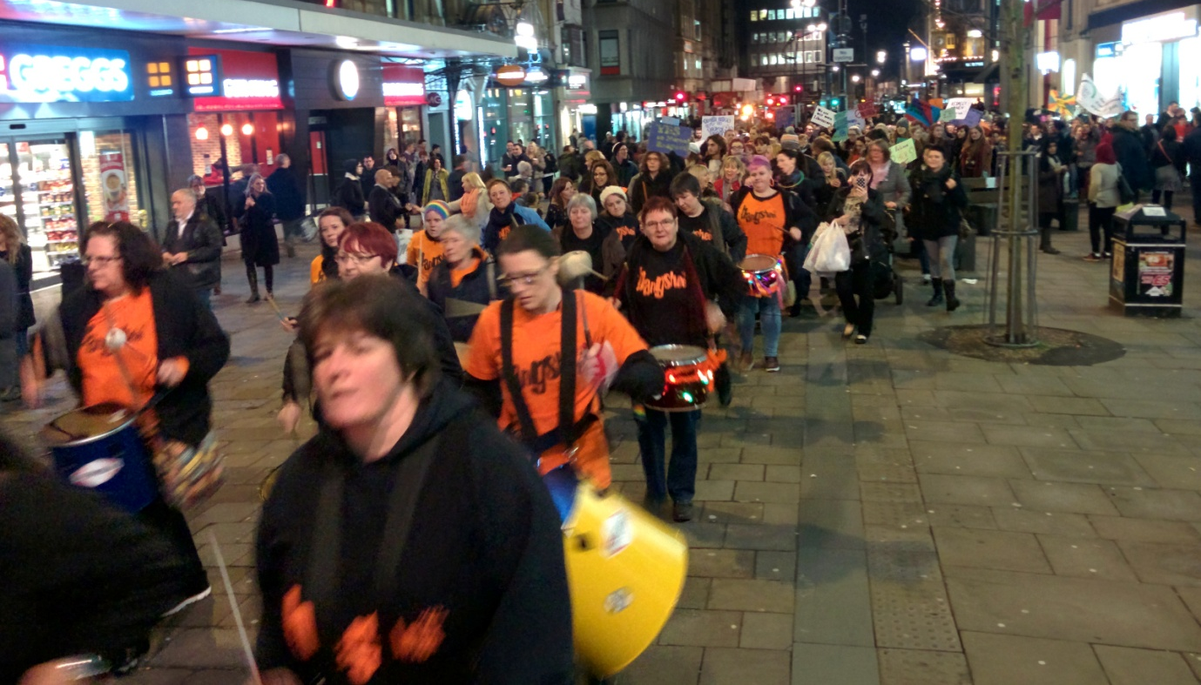
More than 150 women, men and children turned out to support the eighth annual Reclaim the Night event organised by the Northern TUC Women’s Group on Saturday 22nd November.

Once again the march was led by the fantastic Bangshees all –women drumming group who really got the crowd moving as the procession made its way up Northumberland Street gathering a few extra supporters on the way. Sharon Hodgson MP and Labour’s Shadow Minister for Women and Equalities joined the marchers – along with Becky Rogerson of My Sister’s Place and Dawn Bowman from Rape Crisis Tyneside and Northumberland – to mark the United Nations International Day to End Violence Against Women.

Arriving at Sports Central for refreshments attendees were welcomed by Pat Heron, Chair of Unison’s Women’s Network. In her opening remarks Pat urged people to sign up to The Cost of Safety campaign and end means testing for women in need of safety.

In her contribution Sharon Hodgson began by saying it was a sad indictment that there is still a need for this kind of event, 37 years after the first Reclaim the Night march took place in Leeds. She went on to say we have made some progress in terms of Clare’s Law and Jane’s Law but there is still much more that needs to be done. Each year around 750,000 children witness domestic violence in the home and one in three 16-18 year old girls experience some form of unwanted sexual attention. Schools need to take a lead and she is pressing for sex and relationships education to be a key theme. Labour is committed to improving access to justice for the victims of abuse. We need to make our towns and cities safer for all women and reclaim every day, every home, every public space and every private space.

Chairing the event Pat Heron gave a warm welcome to Becky Rogerson of My Sister’s Place, a ‘One Stop Shop’ specialist domestic violence service based in Central Middlesbrough. Becky said that during times of austerity women often bear the brunt in terms of pay and reduced hours and many are struggling to keep their jobs and family together. More and more women using their services are in employment and facing financial barriers to access the help they need. There is a clear inequality issue that needs addressing – it should not be a case of whether you can afford safety. She asked everyone to support and promote The Cost of Safety campaign and if they have any stories to share to please get in touch.

Our final contribution came from Dawn Bowman of Rape Crisis Tyneside and Northumberland (RCTN), a specialist feminist organisation run by women for women who have experienced sexual violence. One in four women experience sexual violence in their lifetime. There are still Local Authority areas that have no specialist sexual violence provision. In her comments Dawn said that we need to support services like theirs, maintain their specialism and carry on fighting to keep them open (she also added RCTN face a deficit every year).

The Chair thanked all contributors adding that we are being heard. Public pressure forced Sheffield United to withdraw their offer for convicted rapist Ched Evans to train with the club.

The event also received good coverage including articles in the Newcastle Chronicle and Journal http://www.chroniclelive.co.uk/news/north-east-news/women-reclaim-night-march-against-8160188

